

Peer Assisted Teaching Scheme

2015
Final Report
Developing Excellence in Learning and Teaching through a Peer Assisted Teaching Scheme

National Senior Teaching Fellowship
Associate Professor Angela Carbone
Monash University

www.monash.edu/pats




Support for the production of this report has been provided by the Australian Government Office for Learning and Teaching. The views expressed in this report do not necessarily reflect the views of the Australian Government Office for Learning and Teaching.

With the exception of the Commonwealth Coat of Arms, and where otherwise noted, all material presented in this document is provided under Creative Commons Attribution-ShareAlike 3.0 Unported License (http://creativecommons.org/licenses/by/3.0/au/).
The details of the relevant license conditions are available on the Creative Commons website (accessible using the links provided) as is the full legal code for the Creative Commons Attribution-ShareAlike 3.0 Unported License (http://creativecommons.org/licenses/by/3.0/au/legalcode).
Requests and inquiries concerning these rights should be addressed to the Australian Government Office for Learning and Teaching at learningandteaching@deewr.gov.au

2015

ISBN 978-1-76028-321-6 PRINT
ISBN 978-1-76028-322-3 PDF
ISBN 978-1-76028-323-0 DOCX

Acknowledgements
Peer Assisted Teaching Scheme (PATS) participants and co-ordinators
Special thanks to academics who engaged in PATS as a participant and/or co-ordinator from the following institutions: Charles Sturt University, Edith Cowan University, Griffith University, Kaplan Higher Education, Macquarie University City Campus, Monash University, RMIT, Think Education, The University of Newcastle, University of South Australia, University of the Sunshine Coast, University of Tasmania and University of Wollongong.
Champions of PATS
In particular the team would like to express thanks to the following colleagues and champions of the PATS program, who have not only embedded the philosophy of the program in their courses, faculties and institutions but who have extended the program and undertaken it as a scholarly activity enriching the lives of the teachers and students within their sphere.
Thank you Mrs Katherine Lindsay, Dr Liam Phelan, Ms Kylie Readman, Ms Caroline Cottman, Professor Sue Stoney, Dr Steve Drew, Dr Jo-Anne Kelder and Dr Sara Booth.
2012 Office Learning and Teaching (OLT) Reference Group
The reference group has been instrumental in shaping the program and steering the direction of the fellowship. Special thanks to:
Ms Sally Rogan University of Wollongong
Emeritus Professor Alan Robson The University of Western Australia
Professor Roger Hadgraft formerly RMIT University, now CQUniversity Australia
Professor Jane Long La Trobe University
Associate Professor Mark Freeman The University of Sydney
Professor Sally Kift James Cook University
Mr Paul Denny The University of Auckland, New Zealand
Mr Ben Knight Monash University
Dr Dora Constantinides Monash University
Dr Peter Coolbear Massey University, New Zealand
External evaluator
The team couldn’t have asked for a more engaged external evaluator, Associate Professor Ian Solomonides, Director of the Learning and Teaching Centre at Macquarie University who attended all reference group meetings, the National Symposium and interviewed both participants and co-ordinators.
Council of Australian Directors of Academic Development (CADAD) members
A special thanks to the then president of CADAD, Winthrop Professor Denise Chalmers and the CADAD executive for providing me with a small grant to develop and trial some resources that seeded the proposal for a full OLT National Senior Teaching Fellowship. Other particularly supportive members who have provided valuable input to the program are Professor Heather Smigiel (Flinders University), Professor Sue Stoney (Edith Cowan University), Ms Kylie Readman (University of the Sunshine Coast), Ms Karen Whelan (Queensland University of Technology) and Associate Professor Natalie Brown (University of Tasmania).
Australian Learning and Teaching Fellows (ALTF) Fellow Mentor
A heartfelt thankyou to Professor Les Kirkup (University of Technology, Sydney) who has mentored me through my fellowship, provided me with endless advice and shared his extensive experience. His valuable insights assisted me in shaping my fellowship to achieve the best possible outcome.
Australian Learning and Teaching Fellows
The ALTF have been an invaluable network of people to help bounce ideas, support the program and give me insights into what a national fellowship should aim to achieve. Every fellow deserves a mention, but I particular need to express my gratitude to Professor Sally Kift (James Cook University), Professor Dawn Bennett (Curtin University), Professor Geoff Crisp (RMIT University), Professor Betty Leask (La Trobe University), Associate Professor Keith Wiley (University of Technology, Sydney), Associate Professor Rachel Field (Queensland University of Technology), Associate Professor Heather Alexander (Griffith University) and Associate Professor Sandy O’Sullivan (Batchelor Institute of Indigenous Tertiary Education).
Monash University’s Office of the Vice-Provost (Learning and Teaching) (OVPLT) Academic Team
Mr Jason Ceddia, Dr Phil Dawson, Associate Professor Robert Nelson, and Dr Hariz Halilovich, led by the Vice-Provost (Learning and Teaching) Professor Darrell Evans, have all be instrumental in supporting my fellowship program and encouraging me to developing the program further.
Website Developer
Tri Le Nguyen, my former Master’s student from the Faculty of Information Technology, at Monash University for designing the PATS website, ensuring its functionality and advising the team on the various technical intricacies. He collaborated with the PATS team to produce an online workbook so that our data could be collected for analysis. Tri did an amazing job with my website. I still love looking at it!
Monash Promoting Excellence Team
My Promoting Excellence team from Monash University (Ms Kerry Allison, Ms Joy Whitton, Ms Anicca Main, Ms Rachel Saffer and Mr Matt Hall) have been nothing short of exceptional throughout the whole fellowship program. They have helped with the logistics of organising various events related to my fellowship and have been supportive of my program and my time away from the office.
Office for Learning and Teaching
I am particularly grateful for the ongoing support and advice from the staff from the Australian Government’s Office for Learning and Teaching. Thank you enormously Ms Suzi Hewlett and Ms Siobhan Lenihan (better known as the ALTF’s national treasure).
Project Team Members
The success of this fellowship program would not have been possible without the dedication, professionalism and hard work from some very special people: Mr Dan Tout, Dr Bella Ross, Ms Joanne Rae and Dr Julia Camm-Evans.
Mr Dan Tout, my former research officer, who only stayed for a short while before being offered a fulltime doctoral scholarship. I am particularly grateful for the persistence and dedication Dan showed to ensure that Monash could host the PATS website, and for the tremendous effort involved in undertaking the surveys described in Chapter 3 of this report.
Dr Bella Ross, my latter research officer, not only supported the research aspect of my fellowship, but viewed every challenge as an opportunity. We brainstormed ideas and shared many laughs and at the same time published in many conferences and journals outlets. Bella was instrumental in drafting this documented and her hard work is acknowledge through a fairly recent appointment, in a full time role as a researcher at another university.
Ms Joanne Rae, Project Officer, my wing-woman, she ensured all timelines were met, all project meetings went ahead, the reference group was kept informed and up-to-date with the intricacies of the project, the website was updated and the scheme went abroad. She assisted with all my PATS workshop travels, reimbursements and ensured the running of the project was smooth and thoroughly enjoyable – just how a fellowship should be! I sincerely appreciate all her passion and interest in the fellowship. Joanne has been a treasure and she remains working at Monash, now assisting me with organising one of the most prestigious, international learning and teaching conferences in the world – The 12th Annual Conference of the International Society for the Scholarship of Teaching and Learning (ISSoTL 2015 http://issotl2015.com.au/). I hope to see you all there.
Dr Julia Camm-Evans, my third research assistant, for supporting the PATS follow up activities, such as: revisions to the final report, supporting future partnerships at Monash University, drafting further publications, keeping the website current, supporting the PATS extension grant offered to the University of Tasmania, and showcasing PATS as a Mentoring pillar for adoption by the newly formed Monash Education Academy (2015). I am deeply grateful for Julia’s energy, passion and the quality of her contributions. She brought many new insights and ideas into the project and deeply connected with the philosophy of PATS and with the benefits it generates to our academics. I wish her all the very best in her new appointment and would without a doubt of hesitation reappoint her to join me in future research projects.

List of abbreviations and acronyms
ACU | Australian Catholic University (VIC)
ADEs | Associate Deans (Education)
AHRI | Australian Human Resources Institute
ALTC | Australian Learning and Teaching Council
ALTF | Australian Learning and Teaching Fellows
ART | Arts
BE | Business and Economics
BL | Business and Law
BPS | School of Biomolecular and Physical Sciences
BS | Business School
CADAD | Council of Australian Directors of Academic Development
CHS | Computing, Health and Science
CSIT | School of Computer Science and IT
CSU | Charles Sturt University
DEEWR | Department of Education, Employment and Workplace Relations (federal)
DIISRTE | Department of Industry, Innovation, Science, Resources and Tertiary Education (federal)
DoAD | Directors of Academic Development
EA | Education and Arts
ECDF | Early Career Development Fellows
ECU | Edith Cowan University (WA)
ED | Education
FIT | Faculty of Information Technology, Monash University
Griffith | Griffith University
HERDSA | Higher Education Research and Development Society of Australasia
HLTH | Health
HoS | Head of School
IT | Information Technology
ITMS | School of Information Technology and Mathematical Sciences
JCU | James Cook University (QLD)
LTC | Learning and Teaching Committee, Monash University
MS | School of Medical Science
MUCC | Macquarie University City Campus
NSTF | National Senior Teaching Fellowship
OLT | Office for Learning & Teaching (part of Department of Education and Training since 2014)
OVPLT | Office of the Vice-Provost (Learning and Teaching), Monash University
PAL | Peer Assisted Learning
PASS | Peer Assisted Study Scheme
PATS | Peer Assisted Teaching Scheme
PELTHE | Promotion of Excellence in Learning and Teaching in Higher Education
PPS | Pharmacy and Pharmaceutical Sciences
QILT | Quality Indicators for Learning and Teaching, replacement for MyUniversity website
RMIT | Royal Melbourne Institute of Technology University (VIC)
SAWS | School of Agricultural and Wine Sciences
SEET | Science, Environment, Engineering and Technology
SETU | Student Evaluation of Teaching and Units
SHEE | Science, Health, Education and Engineering
SIT | Science and Information Technology
TEQSA | Tertiary Education Quality and Standards Agency
TSF | Teaching Standards Framework
UEC | University Education Committee
UniSA | University of South Australia (SA)
UoN | The University of Newcastle (NSW)
UoW | University of Wollongong (NSW)
UQ | The University of Queensland (QLD)
USC | University of the Sunshine Coast (QLD)
UTas | University of Tasmania (TAS)

Executive summary
- This fellowship program extends an initial fellowship program that introduced a Peer Assisted Teaching Scheme (PATS), initially to improve student evaluations in the ICT discipline at one Australian institution. The program was then trialled across different disciplines in the same institution. The purpose of the National Senior Teaching Fellowship was to trial PATS across a variety of Australian institutions aimed at improving teaching quality.
- PATS is a form of professional development that is aimed at enhancing unit quality. It provides a structured framework for academics to reinvigorate their units. The scheme is organised around collegial engagement, guidance and mentoring in an informal yet structured process where partners are required to complete set tasks before, during and after a teaching semester.
- PATS builds on the current research that highlights the benefits of peer-assisted learning (PAL) programs and draws on Vygotsky’s sociocultural theory (1978) and Lave’s situated learning (Lave, 1988) but applies it to academic teaching staff.
- All Australian universities have as one of their major responsibilities the assurance of educational quality for its students. A universal way to define and measure teaching quality is not apparent, yet most universities use student evaluation as a proxy measure.
- A 2010 survey of 20 Australian institutions estimated that nearly 65% of Australian academics have not undertaken a form of teacher preparation and development, such as inductions or short courses on specific teaching topics (Bexley, James & Arkoudis, 2011, p.26). These numbers are even lower for formal qualifications in university teaching, as the 2010 survey determined that less than 15% of academics hold a Graduate Certificate in University Teaching, or equivalent (ibid, 2011, p.26). As a result, many academics learn to teach as they go, by trial and error (McInnis 1999).
- Faculty management determine which courses need improvement. This is mainly done through Student Evaluation of Teaching and Units (SETU) scores and student feedback. However, there are no forms of learning and teaching development support that are specifically targeted at, or for, those with low SETUs.
- Most programs that are available are designed in a way that don’t reflect the context and culture of the discipline, and often neglect the needs of non-early career teaching staff that have performed poorly on their unit evaluations and need help.
- PATS offers an alternative to centrally delivered programs and embeds Brookfield’s (1995) four lenses to provide a different perspective on teaching: self-reflection; reflecting on student feedback; engaging in peer observation; and learning from scholarly literature. Two further key components of PATS are mentoring by a colleague and peer assisted learning to develop and enhance learning.
- PATS was trialled in semester 2, 2012 and semesters 1 and 2, 2013. In 2012, PATS was trialled across five Australian higher institutions. In semester 1, 2013, PATS was trialled across an additional four Australian higher institutions, one a private provider (Think Education). In semester 2, 2013 an additional four institutions, including a private provider joined the PATS community of practice. Changes in unit evaluations were recorded where possible, but in 2013 the focus was on understanding the data and drawing insights arising from the PATS tasks.
- The PATS Fellowship has produced a wide range of positive results which include positive changes to SETU scores and valuable insights into the types of issues and challenges faced by teaching academics. Five universities trialled PATS in 2012 and the results in unit improvements are presented in chapters 4 and 5.
- Teaching standards need to be informed by different perspectives: the student voice, the academic voice and the research literature. From these perspectives it is possible to create a framework toward building effective units.

Key Recommendations

Recommendation 1: Senior leaders in higher education should consider PATS (or adaptions of PATS) as a strategic program aimed at improving units and teaching quality. PATS can be promoted as a form of teaching quality support that is endorsed within the faculty and centrally within the institution. Underlying this is the need to train staff and performance supervisors in mentoring techniques and how to establish educational/teaching goals that are specific, measurable, attainable, relevant and timely. PATS tasks require discussion and support around how goals would be achieved and measured.
Recommendation 2: A distributed leadership approach is recommended to ensure the longevity of the scheme. This requires a healthy mix of senior manager support through policy reform and implementation, an appointed PATS Co-ordinator to ensure the momentum continues and quality is ensured, and participants to engage and benefit from the scheme.
Recommendation 3: Higher education institutions should adopt a multi-lens approach to measuring improvements in unit quality, teaching excellence and scholarly teaching. Student feedback should not be the only lens in which teaching is evaluated. Institutions need to support a multi-lens approach, which includes peer observation and ongoing student feedback. Peer observation needs reconsideration, and in-flow peer review should be considered and applied to multiple deliverables and stages as teaching is still in progress. Student feedback should not be left to the end of semester. Student comments and ideas should be captured and closed off (closing the feedback loop) within the teaching semester timeframe.
A list of outcomes and deliverables
- PATS Co-ordinator’s kit
- PATS Mentor’s Kit
- PATS Instructional workbook
- PATS Decision making resource for executive
- PATS Sample policy for management
- PATS Course quality attributes
- PATS Videos of participants experiences
- PATS Conference and journal publications
- PATS Newsletters
- PATS Website

All deliverables can be found on www.monash.edu/pats

Table of Contents
Acknowledgements ii
List of abbreviations and acronyms v
Executive summary vii
Table of Contents ix
Tables xii
Figures xiii
1 Introduction 1
1.1 Fellowship aims 2
1.2 Fellowship team members 2
1.3 People involved 3
1.4 Dissemination methods 4
1.5 PATS resources 4
1.6 Related OLT/ALTC projects 5
2 Background 6
2.1 Overview 6
2.2 Teaching quality 6
2.2.1 What is teaching quality? 6
2.2.2 How is teaching quality measured? 6
2.3 Fostering teaching quality 7
2.3.1 Current methods 7
2.3.2 The Peer Assisted Teaching Scheme 8
2.4 Summary 11
3 What support is available to enhance teaching quality? 12
3.1 Overview 12
3.2 Survey 1: PATS Management Survey 12
3.2.1 Survey purpose and distribution 12
3.2.2 Demographics 12
3.2.3 Current and additional forms of support to improve teaching quality 13
3.3 Survey 2: PATS Participant Survey 17
3.3.1 Survey purpose and distribution 17
3.3.2 Demographics 17
3.3.3 Accessed forms of support and its value 17
3.4 Limitations 20
3.5 Summary 20
4 Is the Peer Assisted Teaching Scheme suitable to develop quality teaching? 21
4.1 Overview 21
4.2 University engagement 21
4.2.1 PATS Trials in 2012 and 2013 21
4.2.2 Reasons for participation 22
4.3 Changes in SETU results 24
4.3.1 Four years of PATS in the Faculty of Information Technology at Monash University 24
4.3.2 PATS across the broader higher education community in 2012 25
4.4 PATS across the broader higher education community 2013 31
4.4.1 Barriers to teaching improvement – PATS Task 2 31
4.4.2 Classification of educational goals and strategies – PATS Task 3 32
4.4.3 The value of mid-semester student feedback – PATS Task 4 33
4.4.4 Peer observation instruments - PATS Task 5 34
4.4.5 Challenges in change management in higher education 34
4.5 Unexpected outcomes 35
4.5.1 Teaching awards 35
4.5.2 Grants and Awards 35
4.5.3 Teaching innovation and extended experience 36
4.5.4 PATS goes abroad 36
4.5.5 Emergent flavours of PATS: qPATS, sPATS, ePATS 36
4.5.6 Scholarship of Learning and Teaching 37
4.6 Summary 38
5 How can faculty plans and processes meet national teaching standards? 39
5.1 Overview 39
5.1.1 Revisiting teaching quality 39
5.1.2 Aspects of teaching that matters to students 39
5.1.3 Towards a framework for unit effectiveness 40
5.2 Building teaching quality - management plans and processes 43
5.3 Summary 46
6 Engagement and Dissemination 48
6.1 Overview 48
6.2 Participant engagement 48
6.3 Dissemination strategies 48
6.3.1 Seminars and workshops 49
6.3.2 Refereed journal and conference papers 52
6.3.3 Monash Memo 53
6.3.4 Informational flyers 54
6.3.5 Online PATS workbook 54
6.3.6 PATS newsletters 55
6.3.7 The OLT NSTF PATS Symposium 56
6.3.8 Reference group meetings 57
6.3.9 Reporting to Monash University’s Learning and Teaching Committee 57
6.3.10 Reporting to TEQSA – Provider registration 58
6.3.11 Social media 59
6.4 PATS resources 59
6.4.1 PATS Co-ordinator Starter Kit 60
6.4.2 PATS Mentor Starter Kit 60
6.4.3 PATS Participant Instructional Workbook 60
6.4.4 PATS website 60
6.4.5 PATS resources for faculty executive 62
6.4.6 PATS ongoing support 62
7 Conclusion and Future Work 63
7.1 Overview 63
7.2 Reflections 63
7.2.1 Reflections from the National Senior Teaching Fellow (Associate Professor Angela Carbone) 63
7.2.2 Reflections from Project Officer (Ms Joanne Rae) 65
7.2.3 Reflections from Research Officer (Dr Bella Ross) 66
7.3 Future work 66
7.3.1 Research directions 67
7.4 Lessons Learnt 68
7.4.1 Measuring the impact of PATS 68
7.4.2 Website hosting – externally or internally? 69
7.4.3 Gathering data from busy academics over the duration of the semester 70
7.4.4 Planning considerations for senior management 70
8 Recommendations 71
Appendix A: Survey 1, PATS Management Survey 72
Appendix B: Survey 2, PATS Participant Survey 79
Appendix C: Progress Results for the PATS 2013 Trial 85
Appendix D: PATS Overview Postcard 87
Appendix E: PATS Symposium Program 88
Appendix F: PATS Senior Management Decision Points 89
Appendix G: FIT PATS Policy 90
Appendix H: The PATS Website Homepage 91
Appendix I: Task 3 from the PATS Workbook 92
References 93

Tables
Table 1 Four types of PATS partnerships 10
Table 2 Job title of survey respondents 13
Table 3 Where respondents were faculty or centrally based 13
Table 4 Current forms of support to improve teaching quality 14
Table 5 Teaching quality support for different staff demographics 15
Table 6 Additional forms of support requested 16
Table 7 Methods of identifying units in need of improvement 16
Table 8 Awareness of current forms of support by PATS participants 17
Table 9 Accessed forms of support by PATS participants 18
Table 10 Ratings of the availability and effectiveness of teaching support 19
Table 11 Additional forms of support requested by PATS participants 19
Table 12 Institutions participating in PATS in 2012 21
Table 13 Institutions participating in PATS in 2013, Semester 1 22
Table 14 Institutions participating in PATS in 2013, Semester 2 22
Table 15 Institutions' reasons for engagement in PATS 23
Table 16 FIT unit evaluation results 2008-2012 24
Table 17 SETU scores for Monash University for the 2012 PATS trial 25
Table 18 SETU scores for The University of Newcastle for the 2012 PATS trial 26
Table 19 SETU scores for Griffith University for the 2012 PATS trial 27
Table 20 SETU scores for Edith Cowan University for the 2012 PATS trial 28
Table 21 SETU scores for University the Sunshine Coast for the 2012 PATS trial 29
Table 22 Eduational focus areas 30
Table 23 A framework for setting development goals in higher education 33
Table 24 Management structures in place that support teaching quality 43
Table 25 Incorporation of quality teaching practices into strategic planning 44
Table 26 Resources to support teaching quality 44
Table 27 Policies and procedures to support quality teaching 45
Table 28 Sharing of quality teaching practice 46
Table 29 Recognition of quality teaching 46
Table 30 PATS events October 2012- December 2014 49
Table 31 Outline of the PATS website structure 61

Figures
Figure 1 The PATS process 9
Figure 2 Emergent barrriers to teaching improvement from the PATS 32
Figure 3 Four phases in PATS to transform student comments into feedback 34
Figure 4 Teaching areas most in need of improvement 40
Figure 5 A framework for unit effectiveness 42
Figure 6 Example of a co-ordinator's view of their participants' task progress 55
Figure 7 Locations where the PATS website has been accessed (as at 7 August 2015) 61

Introduction
This Australian Government Office for Learning and Teaching (OLT) National Senior Teaching Fellowship contributes to the national discourse on standards in learning and teaching, in particular, the plans, practices and policies of faculties to support teaching standards. This fellowship builds on a previous Australian Learning and Teaching Council (ALTC) Teaching Fellowship in 2010 which introduced a new form of academic development across one higher education institution – Monash University. The aim of this fellowship is to adapt and extend the Peer Assisted Teaching Scheme (PATS) across a variety of disciplines and several higher education providers across Australia.
PATS is a form of professional development that is aimed at enhancing unit quality. It provides a structured framework for academics to reinvigorate their units. The scheme is organised around collegial engagement, guidance and mentoring in an informal yet structured process where partners are required to complete set tasks before, during and after a teaching semester.
Recommendations from the ALTC Teaching Fellowship report (Carbone, 2011, p.36) included: opening the scheme to all units, establishing a list of faculty mentors, capturing the history and context of a unit, embedding PATS into teacher preparation programs, allocating workload relief for participants, devising qualitative measures of success, appointing a central and faculty liaison person to support the program and allowing alternative modes of operation. All these recommendations were considered and adopted for the revised version of PATS.
Following the completion of the ALTC Fellowship, the ALTC Fellow was invited to give a presentation about the fellowship scheme to the Council of Australian Directors of Academic Development (CADAD). The presentation led to initial support and provided the necessary interest from a variety of Australian universities for the development of a National Senior Teaching Fellowship proposal. The interest partly arose from a need for new forms of professional academic development in learning and teaching. In most Australian institutions, the most common form of teacher preparation in higher education is through centrally delivered programs. These programs often neglect the needs of non-early career teaching staff that received low unit evaluations, and/or are strugglingly to keep up with advances in technology and delivery mode and an increasingly diverse student body. Despite these programs being offered, a study from Australia suggests that 37 per cent of academics have never undertaken any form of training in university teaching (Bexley, James, & Arkoudis, 2011). Furthermore, with the expanding numbers of sessional staff across the sector and a move towards education focused positions, universities require better support for capacity building and mentoring to develop teaching excellence.
PATS offers an alternative to centrally delivered programs and can be tailored to suit any academic teacher’s needs. PATS embeds Brookfield’s (1995) four lenses to engage teachers in a process of critical reflection to improve their teaching practice. Each of these lenses provides a different perspective on teaching: self-reflection; reflecting on student feedback; engaging in peer observation; and learning from scholarly literature. Two further key components of PATS are mentoring by a colleague and peer assisted learning to develop and enhance learning.

The mentoring component offers a way for both participants to develop their teaching success. Leidenfrost, Straddnig, Schabmann and Carbon’s (2011) study of mentoring styles concludes that mentoring programs in higher education show positive effects for mentees, mentors and universities. Mentors can lead improvements in learning and teaching within their schools and institutions, a key recommendation of Israel’s Fellowship report (2011). Positive relationships develop from mentoring schemes (Gratch, 1998) and contribute positively to academic success (Hall, Smith, Draper, Bullough Jr. & Sudweeks, 2005). Mentoring contributes significantly to the professional development of mentee teachers and mentor, and hence the quality of the teaching force itself (Tang & Choi, 2005).
Peer learning takes place where participants facilitate the learning of other participants. The benefits of peer learning programs have been widely researched with positive outcomes reported for both instructors and participants. Ashwin (2003) suggests that the role of a peer facilitator is more social than the traditional role of learner where the focus is on self-learning. Topping (2001) defines peer assisted learning as the acquisition of knowledge and skills though active support among status equals or matched companions. Boud (2001) argues that peer assisted learning (PAL) may allow participants to articulate their understandings about a subject, to negotiate their new directions and to present their ideas and arguments as they develop. In addition to these benefits, the social interactions and responsibilities associated with PAL programs have considerable potential for enhancing leadership skills among peer tutors (Jacobs, Hurley & Unite, 2008). Research suggests that PAL can be situated across the broad spectrum of the higher education system (Cheng & Walters, 2009; Hodgson, 2009; Loke & Chow, 2007), and across a range of disciplines (Arendale, 2004).

Fellowship aims
The fellowship had as its aim to answer the following questions:

- What support is available to enhance curriculum and teaching quality?
- How do faculty plans and processes align with national teaching standards, in particular the Teaching Standards Framework developed at Macquarie University?
- How can the Peer Assisted Teaching Scheme be adapted to enhance the curriculum and improve teaching quality across a variety of contexts?

Fellowship team members
The fellowship team consisted of:
- Associate Professor Angela Carbone, OLT National Senior Teaching Fellow, Associate Director of the Office of the Vice-Provost (Learning and Teaching)
- Ms Joanne Rae, Project Officer, Office of the Vice-Provost (Learning and Teaching), part-time
- Dr Bella Ross, Research Officer, Office of the Vice-Provost (Learning and Teaching), part-time
- Mr Dan Tout, Research Officer, Office of the Vice-Provost (Learning and Teaching), part-time

People involved
The fellowship reference group consisted of:
- Professor Roger Hadgraft, ALTC Discipline Scholar, RMIT University
- Ms Sally Rogan, Director of Peer Learning and National Centre for Peer Assisted Study Sessions (PASS), University of Wollongong
- Professor Sally Kift, Deputy Vice-Chancellor (Academic), James Cook University
- Associate Professor Mark Freeman, ALTC Discipline Scholar, The University of Sydney
- Professor Jane Long, Deputy Vice-Chancellor and Vice-President (Academic), La Trobe University
- Emeritus Professor Alan Robson, Chair, Higher Education Standards Panel, The University of Western Australia
- Mr Paul Denny, University of Auckland, New Zealand
- Associate Professor Arnold Pears, Uppsala University, Sweden
- Mr Ben Knight, Student Association, Monash University
- Dr Dora Constantinides, sessional staff, Monash University
- Dr Peter Coolbear, critical friend, Director of Ako Aotearoa hosted by Massey University, New Zealand
External evaluator:
- Associate Professor Ian Solomonides, Macquarie University
PATS Co-ordinators:
- Dr Nell Kimberley, Monash University
- Ms Margaret Evans, Monash University
- Ms Margot Schuhmacher, Monash University
- Dr Kris Ryan, Monash University
- Ms Joy Reid, Charles Sturt University
- Professor Sue Stoney, Edith Cowan University
- Dr Steve Drew, Griffith University
- Dr Jacinta Ryan and Ms Jacqui O’Toole, Kaplan Higher Education
- Mr Justin Devlin, Macquarie City Campus, Macquarie University
- Dr Liam Phelan, The University of Newcastle
- Mrs Kate Lindsay, The University of Newcastle
- Ms Ann Applebee, Think Education
- Ms Caroline Cottman, University of the Sunshine Coast
- Dr Jo-Anne Kelder, University of Tasmania
- Ms Melanie Greenwood, University of Tasmania
- Dr Grant Wigley, University of South Australia
- Dr Grace McCarthy, University of Wollongong

Other support provided by:
- Ms Kirsty Mallitt, Griffith University
- Ms Diana Pascoe, Griffith University
- Dr Daryl D'Souza, RMIT University
- Ms Ellen Enevers, University of Tasmania
PATS Participants:
- PATS attracted over 100 participants from a variety of disciplines across the thirteen institutions. Names of the participants are not listed to ensure confidentiality.

Dissemination methods
The fellowship team used a variety of strategies to disseminate the findings and output of the fellowship. These strategies are detailed in Chapter 6 of this report and included:
- Seminars and workshops
- Refereed journal and conference papers
- University memos
- Informational flyers
- PATS website, which includes live Twitter feed and videos (www.monash.edu/pats)
- Online PATS workbook
- PATS newsletters
- The OLT National Senior Teaching Fellowship PATS Symposium
- Reference group meetings
- Reporting to Monash University’s Learning and Teaching Committee
- Social media, including Twitter (www.twitter.com/EduPATS) and YouTube

PATS resources
- Website (including promotional video, online workbook)
- PATS instructional workbook
- PATS Mentor Starter Kit
- PATS Co-ordinator Starter Kit
- Acknowledgement letters
- Invitation letters
- Decision points for senior management
- Sample policy for management
- Fellowship consultancy started

Related OLT/ALTC projects
The fellowship drew on findings from the following OLT projects:
2014, OLT Discussion paper 2: Why scholarship matters in higher education, Discussion Paper 2 by Professor Belinda Probert (Probert, 2014).
2012, Influence Factor: understanding outcomes from Australian learning and teaching grants by Academic Secondee Ms Tilly Hinton (University of the Sunshine Coast) (Hinton, 2013).
2012, Academic workforce 2020: Framing a National Agenda for Professionalising University Teaching by Professor Richard James (The University of Melbourne, Project Leader), Dr Chi Baik, Professor Kerri-Lee Krause, Professor David Sadler, Dr Sara Booth, Professor Marnie Hughes-Warrington, Dr Emmaline Bexley and Associate Professor Gregor Kennedy (James, Baik, Krause Sadler, Booth, Hughes-Warrington, Bexley & Kennedy, 2013).

2011, Peer Assisted Teaching Scheme (PATS) ALTC Fellow report by Associate Professor Angela Carbone (Carbone, 2011).

2011, The Key to the Door: Teaching Awards in Australian Higher Education ALTC Fellowship report by Professor Mark Israel (Israel, 2011).
2011, Evidence-based benchmarking framework for a distributed leadership approach to capacity building in learning and teaching by Professor Sandra Jones (RMIT University, Project Leader), Professor Roger Hadgraft, Dr Marina Harvey, Associate Professor Geraldine Lefoe and Dr Kevin Ryland (Jones, Hadgraft, Harvey, Lefoe & Ryland, 2014).
2010, Professionalisation of the Academic Workforce by Professor Richard Cummings (Murdoch University, Project Leader), Winthrop Professor Denise Chalmers, Professor Susan Stoney, Associate Professor Anthony Herrington and , Associate Professor Sofia Elliott (Cummings, Chalmers, Stoney, Herrington & Elliott, 2012).
2010, Measuring and Reporting Teaching Quality by Professor Marnie Hughes-Warrington (Monash University, Project Leader), Dr Margaret Bearman, Associate Professor Angela Carbone, Dr Chi Baik, and Professor Kerri-Lee Krause (Hughes-Warrington, Bearman, Carbone, Baik & Krause, 2010). Associate Professor Carbone is a member of the project group and drew on the findings for her fellowship.

2010, Identification and Implementation of Indicators and Measures of Effectiveness of Teaching Preparation Programs for Academics in Higher Education by Winthrop Professor Denise Chalmers (The University of Western Australia, Project Leader), Dr Allan Goody and Ms Veronica Goerke, Professor Sue Stoney, and Assistant Professor Di Gardiner (Chalmers, Stoney, Goody, Goerke & Gardiner, 2012).

2009, Lessons learnt: identifying synergies in distributed leadership projects by Associate Professor Sandra Jones (RMIT University, Project Lead), Dr Marina Harvey, Associate Professor Geraldine Lefoe and Dr Kevin Ryland (Jones, Harvey, Lefoe & Ryland, 2012).

Background

Overview
In this chapter we provide background to the context of the fellowship by exploring the literature surrounding teaching quality and how it has been measured traditionally. We then continue with an investigation of how teaching quality is currently fostered in higher education institutions and then discuss the ways in which PATS is appropriate for this purpose.

Teaching quality

What is teaching quality?
Teaching quality is an elusive term and there is currently no common definition that is widely used and shared in higher education. This makes it difficult for educators to argue that they are indeed improving teaching quality, as both a definition and a fixed measure of teaching quality are lacking. Much of the literature and documented reports talk about teaching effectiveness (Devlin, Kift, Nelson, Smith & McKay, 2012), teaching excellence (OLT teaching awards criteria), teaching quality (Ramsden, 1991; Richardson, 2005; Hughes-Warrington, Bearman, Carbone, Baik & Krause 2010) and more recently teaching scholarship which is distinct from scholarly teaching (Probert, 2014 ).
Quality can be defined as the totality of service or product features and characteristics that determine its ability to satisfy or meet stated or implied objectives (Canadian Council on Learning, 2006). Teaching can be defined as purposeful and planned instruction in an educational setting with defined content, directed learning activities, specifically employed resources and considered learning outcomes. Therefore, one definition of teaching quality may be described as the degree to which student achievement of educational goals have been facilitated (Stehle, Spinath, & Kadmon, 2012). Another definition may be that students simply have a better experience and want to continue to engage in learning.

How is teaching quality measured?
The most commonly used method of evaluating teaching quality in higher education is through Student Evaluations of Teaching and Units (SETUs). The validity, however, of using student ratings as a measure of teaching effectiveness continues to be debated as some argue that these say more about student characteristics than teacher competencies (Dowell & Neal, 1983). SETUs assume that students are able to evaluate the effectiveness of the teaching to which they are exposed. It is important to note that there is not one generally accepted definition of teaching effectiveness or quality, nor is there a known valid universal criterion measure; rather there is a variety of criteria depending on course function, purpose and objectives (Stehle et al., 2012).
Student feedback on teaching or subjects has been sought in higher education for several decades, where the collection of feedback has evolved from a largely informal and formative practice to become more formalised over time (Richardson, 2005). In the past, student feedback was mainly used to inform the ongoing development and improvement of teaching or subjects.

More recently, student surveys have been developed to target student perceptions of entire degrees or institutions. Many countries are now considering using such systematic surveys to gather data across multiple institutions to indicate teaching quality (Cummings et al., 2012, Cummings, Chalmers, Elliott, Stoney, Tucker, Wicking & de St Jorre, 2014).
In many institutions the instruments used to obtain student feedback have been constructed and developed in-house, with the result that they may not have been subjected to peer review or external scrutiny. Findings of these systems suggest that students’ evaluations of teaching reflect the person who is teaching the course rather than the unit that is being taught. Evaluations of the same teachers given by successive student cohorts are highly stable over extended periods of time (Marsh & Hocevar, 1991; Richardson, 2005).
Results from a systematic review of how teaching quality has been measured to date (Hughes-Warrington et al., 2010) reveal that most measures looked at teacher characteristics and clarity of course outcome and expectations. Out of the total of 533 items analysed, 352 were targeted at teacher characteristics, 310 at teaching characteristics and skills, 42 at personal characteristics or personality traits, 21 at peer assisted learning, 46 at course structure and content, 90 at learning outcomes and assessment, 25 at facilities and resources and 21 at a global satisfaction rating. These findings show that many of the preferred teacher characteristics were personal or personality traits while others were what could be considered learned abilities or skills that could be acquired.
The quality of teaching has been shown to affect student learning experiences (Pascarella & Terenzini, 1991; Trigwell & Michael, 1991), and although the link between positive student experiences of learning and their learning outcomes have not been overwhelmingly shown to correlate (Dowell & Neal, 1983; Sitzmann, Brown, Casper, Ely & Zimmerman, 2008; Galbraith, Merrill, & Kline, 2012;), a positive student experience is a preferred outcome. For this reason, many Australian universities are now using student course experience evaluations as a measure of teaching quality and associated goals. For example, at The University of Newcastle, the 2011-2015 Strategic Plan (The University of Newcastle, 2013) prioritises student satisfaction of teaching quality, with the policy goal to achieve a level of 70% of courses scoring at least four and no courses scoring less than three on SETUs.

Fostering teaching quality

Current methods
Excellent teachers are made, not born; they become excellent through investment in their teaching abilities. Leaving teachers to learn from trial and error is a waste of time, effort and university resources (Pleschová, Simon, Quinlan, Murphy, Roxa & Szabó, 2012, p. 6).
The types of opportunities currently available for academics responsible for teaching and supporting student learning include workshops, certificates and peer programs, however none of these are required training for a teaching academic. This was made evident in a 2010 survey of 20 Australian institutions where it was estimated that nearly 65% of Australian academics have not undertaken a form of teacher preparation and development, such as inductions and short courses on specific teaching topics (Bexley, James & Arkoudis, 2011, p.26).
These numbers are even lower for formal qualifications in university teaching, as the 2010 survey determined that less than 15% of academics hold a Graduate Certificate in University Teaching, or equivalent (ibid, 2011, p.26).
These results have been attributed to a variety of factors, such as academics not aware of available teacher training (Edwards, Blexley & Richardson, 2011); lack of time to undertake development and working in isolation, as opposed to collaborating with peers and not receiving feedback on opportunities for improvement (Norton, Sonnemann & Cherastidtham, 2013). Voluntary, self-nominated participation in short courses appear to be more common than a mandatory requirement (Norton, Sonnemann & Cherastidtham, 2013) and this may be attributed to how a university reflects their attitude toward teacher preparation and development (Chalmers, 2007).
Universities are increasingly focussing on improving staff teaching, via the professional development of university educators, both through formal qualifications and less formalised training (Cummings et al., 2012, Cummings et al. 2014). These include certificates, diplomas, workshops, and peer assisted learning programs. However none of these are mandated, except in a few institutions in which academics new to teaching are required to complete such a course as part of their probation. The two principle concerns often with centralised programs are firstly, programs are designed in a way that don’t reflect the context and culture of the discipline, and secondly these programs often neglect the needs of non-early career teaching staff that have performed poorly on their unit evaluations and need help. Studies have shown that teacher preparation programs are more effective when they involve ‘participation in communities of practice, mentoring, reflective practice, and action learning’ (Chalmers, Stoney, Goody, Goerke & Gardiner, 2012, p. 4). In addition to this, there is the concern of how to measure quality teaching. A universal way to define and measure teaching quality is not apparent, yet most universities use student evaluation as a proxy measure.
PATS builds on the findings from the projects and work listed above to provide assistance in improving teaching practice. It does so using a knowledgeable peer through collegial collaboration with a department. As such, learning about teaching happens on the job in social situations in authentic contexts. PATS is a peer assisted learning program that offers assistance to academics that teach regardless of their level of experience. The scheme is outlined in the following section.

The Peer Assisted Teaching Scheme
Aims of Peer Assisted Teaching Scheme
PATS was established with three very clear goals in mind:
- To improve the quality of student satisfaction.
- To improve the quality of teaching.
- To build educational leadership capacity in teaching staff, to help them advise others on how to make improvements to their units.

The theoretical foundation behind the PATS process
PATS follows a structured framework for improving and reinvigorating teaching practice, through peer partnerships, to provide academic teachers with input, support and guidance to assist in their teaching. PATS builds on current research highlighting the benefits of peer assisted learning programs directed at students (Topping, 2001), but applies it to academic teaching staff. PATS is informed by Lave’s situated learning literature (1988, 2009), and Vygotsky’s socio-cultural theory (1978). Lave’s theory of situated learning (1988) proposes that learning is constructed in social situations and takes place in authentic contexts such as on the job. Vygotsky's socio-cultural theory suggests that social interaction plays a fundamental role in the development of cognition (1978), using the idea of a ‘zone of proximal development’ stating that the range of skills that can be developed with a ‘knowledgeable other’ exceeds that which can be attained alone.
The PATS process
The process of the scheme (Carbone, 2011) is outlined in Figure 1.
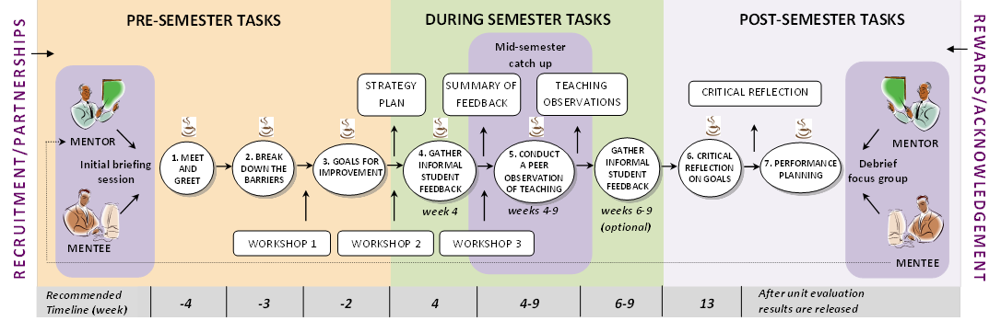
Figure 1 The PATS process

There are three critical players in the PATS process:
Faculty or school executive
The faculty or school executive plays a significant role in deciding how the scheme will be supported and implemented. Management plays a critical role in planning for the scheme by selecting which units and staff members will participate, by shaping the policies and procedures of implementing the scheme (for example, recruitment and incentives), by providing resources (for example, time release, coffee vouchers) and finally by monitoring and evaluating the scheme. Some critical decisions to be considered by the executive team are found in Appendix F.
PATS co-ordinator
A PATS co-ordinator is required to liaise with the PATS participants and senior management. The PATS co-ordinator holds briefing sessions with participants to clarify the roles and expectations of the mentor and mentee.
Co-ordinators are responsible for outlining the policies and procedures of their faculty, and distributing faculty-funded coffee vouchers as an incentive to encourage partners to meet regularly and to promote discussion. During the semester, the PATS co-ordinator meets with the partners to ensure that the partnership is working successfully as well as offering ongoing support. Post semester, a debriefing session is held where the participants reflect on the PATS process, discuss ways they improved their teaching practice and manage the distribution of incentives and acknowledgement letters.
PATS partners
PATS is open to all academics wishing to improve or reinvigorate their unit. PATS is based on a partnership arrangement, in which all partnerships may consist of two or more participants. The relationships between partners may comprise either reciprocal peers or a mentee and mentor. There are four modes of operation for partnerships as described in Table 1.
Table 1 Four types of PATS partnerships
Partnership Types | Mentor-mentee | Reciprocal
Two-person partnership | In this partnership, both mentor and mentee focus on the mentee's unit. The mentor provides support and guidance to the mentees to reinvigorate their individual units. | In this partnership, the two participants work together providing support and mentorship to each other in reinvigorating their individual units.
Group partnership | In this form of partnership of three or more participants, a group of mentees works with one mentor. The mentor provides support and guidance to the mentees to reinvigorate their individual units. | In this form of reciprocal partnership of three or more participants, a small group of reciprocal peers works together to provide support and mentorship to each other in reinvigorating their individual units.

PATS partners are usually, but not necessarily, selected from the same faculty and work together on a set of tasks as outlined below.
The tasks
There are seven structured tasks that an academic works through with a knowledgeable peer/partner before, during and after the completion of a semester. Participants meet with their peers throughout the process to discuss the seven tasks involved. Three of these tasks occur before semester starts, two occur during semester, and two after the completion of semester. The purposes of the tasks are briefly described below:
- Task 1 Meet and Greet is for participants to establish the partnership.
- Task 2 Break down the Barriers is used to focus on the barriers participants perceive are standing in the way of making improvements to their teaching.
- Task 3 Goals for Improvement is for participants to set goals and strategies to reinvigorate their teaching practice.
- Task 4 Informal Student Feedback is for participants to gather feedback from their students informally, analyse the feedback and feedback any changes to students.
- Task 5 Peer Review invites both participants to complete a peer observation of teaching.
- Task 6 Critical Reflection asks that mentees critically reflect on their teaching and course with respect to the goals set in Task 3.
- Task 7 Performance Planning requests that participants capture both the qualitative and quantitative changes in their performance as it relates to teaching improvement, educational leadership and education standing.
The tasks have been specifically designed to help academics reflect on their teaching and make improvements. The process is grounded in Brookfield’s (1995) four lenses of reflection. The four ‘lenses’ to engage teachers in critical reflection on their practice are: systematic self-reflection; reflecting on student feedback; drawing on peer observation; and learning from scholarly literature. Tasks 3 and 6 strongly align with the self lens which invites teachers to focus on their experiences as a teacher and a learner in order to reveal aspects of their pedagogy that may benefit from adjustment or strengthening.
Task 4 aligns with the student lens, which encourages teachers to engage with the student feedback and become more responsive teachers. Task 5 aligns with the peer lens and calls on teachers to liaise with colleagues to produce innovative solutions to teaching problems. Participation in centrally-provided training workshops aligns with the scholarly literature lens exposing academics to other ideas about teaching practice, offering alternative perspectives on teaching. Participants are also encouraged to engage in the literature on higher education and participate in conferences. As such, PATS engages academics in all four elements of Brookfield’s reflective processes, with varying degrees of importance, yet extends Brookfield’s (1995) framework by grounding the critical reflective process in a collegial relationship with a peer over informal meetings throughout the process.

Summary
As discussed in detail in Section 2.2 above, teaching quality is an elusive term. There is not one generally accepted definition of teaching effectiveness or quality, nor is there a known valid universal criterion measure. Instead a variety of criteria can be used which depend on course function, purpose and objectives (Stehle et al., 2012).
With the casualisation of the academic workforce, universities are increasingly focussing on improving staff teaching via the professional development of university educators. Professional development may be in the form of formal qualifications as well as less formalised training. PATS provide a new form of academic development, which furthers teaching practice using a knowledgeable peer in social situations and authentic contexts. PATS is a peer assisted learning program that offers assistance to teaching academics regardless of their level of experience.

What support is available to enhance teaching quality?

Overview
In order to address the question ‘What support is available to enhance teaching quality?’ the fellowship carried out two surveys with the aim of identifying the existing institutional support mechanisms offered to early career and non-early career teachers alike, and the level of uptake.
The first survey (Survey 1, Appendix A: PATS Management Survey) was targeted toward deans, heads of schools and directors of academic development at participating institutions and aimed to determine what formal forms of support are currently made available to teaching staff at both an institutional and faculty level.
The second (Survey 2, Appendix B: PATS Participants Survey) surveyed present and past PATS participants regarding their awareness of existing institutional and faculty-level support mechanisms and asked them to rate their perceptions of both the availability and effectiveness of those programs.

Survey 1: PATS Management Survey

Survey purpose and distribution
The purpose of Survey 1 (Appendix A: Survey 1, PATS Management Survey) was to investigate the forms of support on offer to enhance teaching and learning and whether these were directed at certain demographics. It was devised and developed via SurveyMonkey and distributed to deans, heads of schools and directors of academic development at participating institutions. It was sent via a distribution list that included academic networks, such as the Vic-Tas Promoting Excellence Network, Australian Council of Deans (Science & ICT), Australian Learning and Teaching Fellows, Council of Australian Directors of Academic Development (CADAD), Higher Education Research and Development Society of Australasia (HERDSA), Deputy Vice-Chancellor’s (Academic), and ALTC Discipline Scholars.
The response rate was considerably low, with only 65 responses received in total. Target audiences were followed up via email approximately three times over the space of three months, and strategies to increase response rates were discussed with the reference group team. Reference group members felt that since senior managers have many competing priorities, further responses would be unlikely.

Demographics
The job titles of the 65 academic staff members who completed the survey are shown in Table 2. Survey 1, Questions 1 to 3 sourced data as to participant role, institution and whether they were based centrally or in a faculty. The majority of these respondents include professors, associate professors and lecturers in addition to PATS co-ordinators.

Table 2 Job title of survey respondents
Group | Number
Lecturer | 15
Professor/Associate Professor | 14
PATS co-ordinators | 9
Pro-Vice Chancellor/Deputy Vice-Chancellor | 6
Dean/Associate Dean | 4
Academic/education developer | 4
Directors | 3
Manager | 2
Researcher | 2
Support officer | 1
Academic co-ordinator | 1
Administrative officer | 1
Project advisor | 1
Unspecified | 2
Total | 65

Table 3 shows that respondents were situated in faculty and central units almost equally, with six cases where participants were situated in other or both areas.
Table 3 Where respondents were faculty or centrally based
Location | Number
Faculty | 27
Central | 23
Other/both | 6
Unspecified | 9
Total | 65

Current and additional forms of support to improve teaching quality
Survey 1 participants were asked which forms of support their universities currently provide to teachers to improve their teaching quality at an institutional and faculty level. Respondents were asked ‘What forms of support does your institution currently offer teachers?’ and they were required to select one option (as outlined in Table 4). Not all 65 participants responded to the question, as outlined in ‘total responses’.

Table 4 Current forms of support to improve teaching quality
Forms of support | Both Institutional and Faculty | Institutional level | Faculty level | Not offered | Unsure | Total responses
Seminars | 41 | 5 | 2 | 4 | 1 | 53
Workshops | 38 | 8 | 5 | 2 | 0 | 53
Forums | 34 | 5 | 4 | 5 | 4 | 52
Learning and Teaching grants/projects | 33 | 12 | 4 | 4 | 0 | 53
Planning events/activities | 31 | 4 | 3 | 5 | 8 | 51
Resources | 31 | 7 | 8 | 3 | 3 | 52
Induction/foundation program | 17 | 21 | 9 | 5 | 1 | 53
Communities of practice | 16 | 9 | 10 | 10 | 8 | 53
Peer observation/review | 11 | 9 | 16 | 12 | 5 | 53
Direct supervision | 10 | 2 | 16 | 13 | 11 | 52
Peer mentoring | 10 | 7 | 18 | 13 | 5 | 53
Graduate certificate program | 4 | 37 | 3 | 7 | 2 | 53

Table 4 reveals that the most available form of support to improve teaching quality is via a combination of faculty and centrally delivered forums, seminars and workshops. Findings show that peer mentoring, direct supervision and peer review are more often supported via the faculty, while teacher preparation programs such as graduate certificates and induction programs are provided by central units.
Respondents were asked (Survey 1, Question 4) whether the forms of support provided (outlined in Table 4) were aimed at particular groups of staff - early career academics, teachers with low-scoring units in terms of student satisfaction, ‘others’ based on a specific institutional requirements, or whether they were aimed at all staff. Not all 65 participants responded to the question, as outlined in ‘total responses’.

Table 5 Teaching quality support for different staff demographics
Forms of support | All staff | Early career | Teachers with low SETUs | ‘Others’ | Not applicable | Total responses
Workshops | 47 | 0 | 0 | 0 | 1 | 48
Learning and Teaching grants/projects | 45 | 1 | 0 | 0 | 2 | 48
Seminars | 44 | 0 | 0 | 0 | 5 | 49
Resources | 42 | 0 | 0 | 1 | 3 | 46
Forums | 41 | 0 | 0 | 0 | 7 | 48
Planning events/activities | 39 | 0 | 0 | 0 | 7 | 46
Communities of practice | 35 | 0 | 0 | 0 | 11 | 46
Peer observation/review | 29 | 0 | 2 | 4 | 10 | 45
Graduate certificate program | 28 | 11 | 0 | 2 | 6 | 47
Peer mentoring | 27 | 3 | 2 | 1 | 14 | 47
Induction/foundation program | 22 | 20 | 0 | 3 | 4 | 49
Direct supervision | 21 | 1 | 3 | 0 | 16 | 41

Results reveal that general learning and teaching workshops are available to all staff, with seminars and forums also rating highly. Learning and teaching grants and resources rated highly in regards to providing support for quality teaching. However other forms of support are targeted towards different demographics. For example, the Graduate Certificate and the foundation programs are typically aimed at the early career academics. What is noteworthy here, however, is that there are few programs or forms of support that are directed specifically for units with poor evaluations.
Participants were then asked (Survey 1, Question 8) which additional forms of support they would like to see at their university at an institutional and faculty level. This was an opened-ended question that was analysed for themes and only 33 of the total 65 participants responded to this question. The responses in Table 6 reveal that peer review, time relief, workshops, forums and seminars are those additional forms of support most sought after institutionally and at a faculty level.

Table 6 Additional forms of support requested
Additional forms of support | Institutional level | Faculty level
Peer review | 4 | 5
Time/workload relief | 3 | 1
Staff support/help | 3 | 4
Mentoring | 2 | 3
Online resources | 2 | 1
Seminars/workshops/forums | 2 | 4
Funding/grants | 2 | 1
All forms listed | 2 | 3
Communities of practice | 1 | 2
Rewards/incentives | 1 | 0
Recognition | 1 | 1
Leadership | 1 | 2
Other | 9 | 6
Total | 33 (59% total respondents) | 33 (59% total respondents)

In addition, the survey asked (Survey 1, Question 4) whether there were any particular groups that would benefit from additional forms of support. Replies included every demographic: early career staff, sessional, senior/experienced teaching staff, as well as staff responsible for units with low scores.
Responses to the question (Survey 1, Question 14) of how units in need of improvement were identified at both institutional and faculty level (Table 7), largely included formal student evaluations (SETUs) and feedback as well as formal unit reviews. This was an opened-ended question that was analysed for themes and not all participants responded to this question.
Table 7 Methods of identifying units in need of improvement
Methods of identifying units in need of improvement | Institutional level | Faculty level
Student Evaluation of Teaching and Units (SETU) | 15 | 17
Formal unit/annual review | 9 | 8
Student feedback | 6 | 8
Peer review | 1 | 1
Enrolment numbers | 1 | 1
Other | 5 | 7
None | 6 | 3
Total | 43 (77% of respondents) | 45 (69% of respondents)

Survey 2: PATS Participant Survey

Survey purpose and distribution
The second survey was devised (Appendix B: Survey 2, PATS Participant Survey) and distributed to current and past PATS participants from Monash and other Australian universities totalling approximately 60 people. Target audiences were followed up via email approximately three times over the space of three months.

Demographics
Of the 60, only 24 responses (40% response rate) were received in total. A brief summary of responses is outlined below. Nine of the respondents were early-career teachers.

Accessed forms of support and its value
PATS participants were asked which forms of support they were aware of in their university. Respondents were asked ‘What form of support for teaching staff are you aware of at your institution?’ and to select one option (as outlined in Table 8). Not all 24 participants responded to this question.
Table 8 Awareness of current forms of support by PATS participants
Forms of support | Both Institutional and Faculty | Institutional level | Faculty level | Not offered | Unsure | Total responses
Peer mentoring | 11 | 4 | 3 | 3 | 2 | 23
Peer observation/review | 10 | 2 | 6 | 2 | 2 | 21
Seminars | 10 | 6 | 1 | 2 | 2 | 21
Planning events/activities | 9 | 2 | 5 | 1 | 3 | 20
Resources | 8 | 4 | 3 | 1 | 5 | 21
Learning and Teaching grants/projects | 8 | 11 | 0 | 0 | 2 | 21
Workshops | 7 | 8 | 4 | 1 | 2 | 22
Forums | 7 | 6 | 1 | 2 | 6 | 22
Induction/foundation program | 5 | 10 | 3 | 1 | 2 | 21
Communities of practice | 4 | 7 | 4 | 1 | 5 | 21
Direct supervision | 3 | 1 | 6 | 6 | 6 | 22
Graduate certificate program | 2 | 15 | 1 | 4 | 1 | 23

Findings reveal that the forms of support which academics were most aware of at their university were peer mentoring, peer observation and seminars (at both institutional and faculty levels), with Graduate Certificate and induction programs and involvement in learning and training grants/projects (mainly at the institutional level).

PATS participants were asked (Survey 2, Question 3) which of these forms of support they themselves had accessed. The results in Table 9 reveal that the most accessed forms of support are workshops, peer observation and review and peer mentoring. Generally, learning and teaching support is more likely to be provided at the institutional level rather than at the faculty level. Participants were subsequently asked to rate their satisfaction in the forms of support they accessed. The greatest levels of satisfaction were found with workshops (89% combined ‘very satisfied’ and ‘satisfied’ results from 18 responses), peer observation and review (83% combined ‘very satisfied’ and ‘satisfied’ from 18 responses) and peer mentoring (82% combined ‘very satisfied’ and ‘satisfied’ from 17 responses).
Table 9 Accessed forms of support by PATS participants
Accessed forms of support | Yes | No | N/A | Total Responses
Workshops | 18 | 2 | 0 | 20
Peer observation/review | 16 | 2 | 2 | 20
Peer mentoring | 15 | 5 | 2 | 22
Seminars | 15 | 3 | 2 | 20
Resources | 14 | 2 | 1 | 17
Planning events/activities | 13 | 4 | 0 | 17
Learning and Teaching grants/projects | 10 | 9 | 1 | 20
Graduate certificate program | 9 | 12 | 2 | 23
Communities of practice | 9 | 9 | 2 | 20
Induction/foundation program | 9 | 8 | 2 | 19
Forums | 7 | 9 | 3 | 19
Direct supervision | 6 | 7 | 4 | 17

PATS participants were asked (Survey 2, Questions 4 to 6) to rate out of five (with 1 the lowest and 5 the highest) the availability and effectiveness of learning and teaching support, as well as the moral commitment to supporting teaching quality. The results in Table 10 reveal that academics (23 responses from the total 24 completed surveys) rate these aspects the highest at an institutional level rather than at the faculty level. The average takes into consideration the ranking of the response and the number of responses.

Table 10 Ratings of the availability and effectiveness of teaching support
 | Very Good | Good | Average |  | Poor | Very Poor |  | N/A |  | Average
Availability of support
Institutional Level | 6 | 5 | 6 | 5 |  | 0 | 1 |  |  | 3.6
Faculty Level | 3 | 4 | 4 | 6 |  | 6 | 0 |  |  | 2.7
Effectiveness of support
Institutional Level | 7 | 3 | 7 | 5 |  | 0 | 1 |  |  | 3.6
Faculty Level | 3 | 4 | 5 | 6 |  | 5 | 0 |  |  | 2.7
Moral commitment to support teaching quality
Institutional Level | 9 | 3 | 4 | 4 |  | 1 | 2 |  | 3.7
Faculty Level | 4 | 1 | 5 | 7 |  | 5 | 1 |  | 2.6

PATS participants were asked (Survey 2, Question 7) which additional forms of support they would like to see. This was an opened-ended question that was analysed for themes. The results in Table 11 show a range of answers , including rewards, recognition and communities of practice at both institutional and faculty levels.
Table 11 Additional forms of support requested by PATS participants
Additional forms of support | Institutional level | Faculty level
Communities of practice | 3 | 1
Time/workload relief | 2 | 1
Recognition | 2 | 2
Mentoring | 1 | 1
Seminars/ workshops/ forums | 1 | 2
Funding/grants | 1 | 0
Rewards/incentives | 1 | 1
Leadership | 1 | 0
Peer review | 0 | 0
Staff support/help | 0 | 1
Other | 1 | 3
None | 2 | 1
Total | 15 (63% of respondents) | 13 (54% of respondents)

PATS participants were asked whether there were any particular groups that would benefit from additional forms of support. Replies included every demographic: early career staff, sessional staff, senior/experienced teaching staff, all staff, as well as staff responsible for units with low scores.

Limitations
The survey results have been impacted by two factors – a poor response rate assumed to be due to competing priorities and time constraints, and reliance on the institutions to promote and communicate the surveys to their members and network. These limitations need to be taken into consideration when analysing the results.

Summary
The findings from Survey 1 - PATS Management Survey of managers in higher education presented in Table 2 to Table 7 reveal the following:
- Faculties provide direct supervision and some mentoring (that is, peer observation) as a way of supporting their academics to develop learning and teaching;
- Most of the training is left in the hands of central (that is, institutional) learning and teaching (academic) units, that includes various teacher preparation programs, forums, workshops and establishing communities of practice;
- Most of the training is directed at all staff or early career teaching staff and not those with specific needs, such as low SETU scores;
- SETU and using student feedback are the main methods of identifying whether a unit needs improvement; and
- From the sample 65 respondents, 59% of senior management would like to see additional forms of support offered centrally and within the faculty.
The findings from Survey 2 – PATS Participants Survey presented in Table 8 to Table 11 reveal the following:

- Generally, academics are aware of current forms of support and many have accessed the different forms of support available;
- Support provided at the institutional level (that is, central units) was rated higher in terms of availability, effectiveness and moral commitment, than that provided from faculties; and
- The 24 PATS participants who completed the survey stated they would like to see additional forms of support offered centrally and within the faculty.
What is noteworthy here is that the way that university management determines which courses need improvement is mainly done through SETU scores and student feedback. Despite this, however, there are no forms of learning and teaching development support that are specifically targeted at, or for, those with low SETUs.

Is the Peer Assisted Teaching Scheme suitable to develop quality teaching?

Overview
In order to examine whether PATS is suitable for developing teaching quality, we will first outline the different ways that PATS was adopted by the participating institutions. Examining the different ways PATS was seeded and adopted at multiple universities provides a better understanding of how to influence change effectively at an institutional level. Then we report on both quantitative and qualitative findings from seeding PATS in a unit, trialling it across multiple institutions and embedding PATS across programs.

University engagement
In this section, we investigate the ways in which universities engaged with the scheme. We first outline which institutions engaged in PATS followed by their reasons for involvement.

PATS Trials in 2012 and 2013
In semester 2, 2012, PATS was trialled across five Australian institutions. Table 12 highlights the name of the institution, its state, the partnership type as described in section 2.3.2, the form of participation, and the premise in which partners participated.
Table 12 Institutions participating in PATS in 2012
Institution | State | Partnership types | Participation
Monash University | VIC | Mentor/mentee, Reciprocal | Voluntary, Low UE, compulsory
Griffith University | QLD | Mentor/mentee, reciprocal | Voluntary, Low UE
The University of Newcastle | NSW | Mentor/mentee | Voluntary, Low UE
Edith Cowan University | WA | Mentor/mentee, reciprocal | Voluntary
University of the Sunshine Coast | QLD | Mentor/mentee | Voluntary

In semester 1, 2013, PATS was trialled across seven Australian institutions and one private provider (Think Education). In semester 2, 2013 an additional four institutions joined the PATS community of practice. Table 13 and Table 14 provide details for PATS engagement in semesters 1 and 2 respectively.

Table 13 Institutions participating in PATS in 2013, Semester 1
Institution | State | Partnership types | Participation
Charles Stuart University | NSW | Reciprocal | Voluntary
Edith Cowan University | WA | Reciprocal - Did not complete
Griffith University | QLD | Mentor/mentee, reciprocal | Voluntary
Monash University | VIC | Mentor/mentee, reciprocal | Voluntary, Low UE
RMIT University | VIC | Reciprocal | Voluntary
Think Education | VIC | Reciprocal | Voluntary
University of South Australia | SA | Mentor/mentee | Low UE
University of the Sunshine Coast | QLD | Mentor/mentee | Voluntary

Table 14 Institutions participating in PATS in 2013, Semester 2
Institution | State | Partnership types | Participation
Kaplan Higher Education | VIC | Mentor/mentee | Compulsory
Macquarie University City Campus | NSW | Reciprocal | Voluntary
Monash University | VIC | Mentor/mentee, reciprocal | Voluntary
University of the Sunshine Coast | QLD | Mentor/mentee | Voluntary
University of Tasmania | TAS | Mentor/mentee | Voluntary
University of Wollongong | NSW | Reciprocal | Voluntary

The 2012 and 2013 offerings of PATS were taken up by 13 higher education institutions in total, including two private education providers. However, two partnerships, one from ECU and the other from Kaplan Higher Education did not complete the workbook activities. Hence only 11 institutions are counted as having engaged in the PATS process sufficiently. The states represented comprise Victoria, Tasmania, New South Wales, South Australia, Queensland and Western Australia. Both partnership types were used across the institutions with most partnerships taking part on a voluntary basis.

Reasons for participation
In the section that follows we briefly outline reasons why PATS coordinators from different institutions participated in PATS. Table 15 provides the participating institutions’ name, the position of the PATS co-ordinator from that institution and their reasons for introducing PATS in the institution.

Table 15 Institutions' reasons for engagement in PATS
Institution | Faculty/School | Reason for engagement in PATS
Edith Cowan University | Director, Centre for Learning and Teaching | - To improve teaching evaluations.  - To provide targeted professional development.  - To integrate into an e-portfolio approach together with PebblePad.  - To embed PATS into the Graduate Certificate in Higher Education.
Griffith University | Academic developer | - To improve student satisfaction with courses.  - To improve the quality of teaching.  - To build leadership capacity amongst academics.  - To provide peer assistance for teaching which has potential for both academics and managers.
Kaplan Higher Education | Discipline Head, Management | - To better integrate the entire teaching team following the recent merger of the organisation.  - To provide check points throughout the merger process.  - To improve the student experience.  - To improve the learning environment by embracing collaborative teaching and learning projects.
Monash University | Director Education Quality, Information Technology | - To improve student satisfaction with courses.  - To decrease the number of units needing critical attention – in response to pressure from senior managers in the Faculty.  - The initial trial was successful and therefore the Faculty supported the continuation of the process.
RMIT University | Senior lecturers, School of Computer Science & Information Technology | - To provide the collegial support and perspectives needed to make considerable changes to courses in light of significantly reduced contact hours, and a diverse cohort with little prior exposure to material.
Think Education | Head, Academic Professional Development | - To build on the existing online peer review program.  - To both share and embed changes to support greater student engagement.  - To support a collegial approach to sharing and trialling new ideas.
University of the Sunshine Coast | Director and Academic Developer, Centre for Support and Advancement of Learning and Teaching | - To build relationships with other academic development colleagues.  - To increase opportunities to benchmark and develop from cross-institutional comparison and conversations.  - To encourage course improvement.  - To assist professional growth through peer partnering relationships.  - To assist academics in gathering evidence of their teaching practice – from both students and peers.

Changes in SETU results
In this section we provide the quantitative effects of PATS on student evaluation scores for participating courses in two different contexts. The first looks at courses that have employed PATS in the Faculty of IT at Monash University over a period of four years from 2008 to 2012. This provides an overview of the longitudinal effects of the scheme. The second context is the 2012 trial of PATS across five universities Australia-wide and reveals that the positive effects of PATS on SETU scores can be achieved at a range of different institutions.

Four years of PATS in the Faculty of Information Technology at Monash University
PATS was piloted in the Faculty of Information Technology (FIT) at Monash University in 2009. A study of changes in the SETU scores for participating IT courses at Monash from 2008 to 2012 reveals the longitudinal impacts of the scheme within a faculty. Student experiences improved with considerable increases in student satisfaction scores after PATS was implemented for a semester (Table 16). Of the 15 courses (FIT 1 to 15 in Table 16) with before and after data, 14 show an average increase of +0.8 points, ranging from +0.2 to +1.9. The pre-PATS student enrolment is a different cohort to the post-PATS enrolment. The students that participated in units during the PATS process ranked the overall quality of the unit as being better than its previous offering.
In the following tables, coloured indicators as a display of the measure of overall satisfaction in unit evaluations are used. Any unit coloured RED means that it is in need of critical attention; ORANGE means the unit is in need of improvement; GREEN means the unit is meeting aspirations and PURPLE means the unit is outstanding.
Table 16 FIT unit evaluation results 2008-2012
Year | Unit | Pre-PATS |  |  | Post-PATS |  |  | Change
Year | Unit | UW-Item 5 Median | Enrolment | Responses | UW-Item 5  Median | Enrolment | Responses | Change
2008-2009 | FIT-1 | 2.9 | 59 | 42% | 4.3 | 20 | 80% | +1.4
2008-2009 | FIT-2 | 2.1 | 38 | 53% | 3.5 | 30 | 40% | +1.4
2008-2009 | FIT-3 | 3.0 | 57 | 40% | 3.6 | 49 | 51% | +0.6
2008-2009 | FIT-4 | 2.5 | 24 | 29% | 3.7 | 30 | 16% | +1.2
2008-2009 | FIT-5* | New unit |  |  | 4.4 | 25 | 64% | N/A
2009-2010 | FIT-6 | 3.0 | 48 | 16% | 2.9 | 40 | 43% | -0.1
2009-2010 | FIT-7 | 3.0 | 167 | 38% | 3.3 | 131 | 35% | +0.3
2009-2010 | FIT-8 | 2.5 | 70 | 23% | 4.3 | 40 | 25% | +1.8
2010-2011 | FIT-7* | 3.3 | 131 | 35% | 3.9 | 60 | 32% | +0.6
2010-2011 | FIT-9 | 3.6 | 70 | 27% | 3.8 | 60 | 43% | +0.2
2010-2011 | FIT-10 | 3.6 | 114 | 33% | 3.8 | 152 | 37% | +0.2
2011-2012 | FIT-11 | First time teaching the unit |  |  | 4.0 | 37 | 68% | N/A
2011-2012 | FIT-12 | 2.0 | 43 | 56% | 3.9 | 108 | 50% | +1.9
2011-2012 | FIT-13 | 3.0 | 135 | 62% | 3.9 | 52 | 65% | +0.9
2011-2012 | FIT-14 | 3.0 | 142 | 40% | 3.5 | 32 | 44% | +0.5
2011-2012 | FIT-15 | 3.3 | 289 | 38% | 3.6 | 353 | 31% | +0.3
 |  |  |  |  | Total students | 1519 | Average change | +0.8

*FIT-5 was a new unit and therefore there was no previous data to compare with.
*FIT-7 participated in PATS in both 2010 and 2011
The faculty executive in the Faculty of IT developed a policy to implement and embed PATS which included time relief to recognise 30 hours’ commitment to the program during the semester, ten coffee vouchers supplied to both mentees and mentors, and academic funding of $500 per partner. Their policy was targeted at specifically reducing the number of units needing critical attention. In 2008, the number of units in the ‘red’ (approximately 15%) far exceeded the university’s then target of ‘red’ units (less than 5%). In an attempt to reduce this number the Faculty endorsed its PATS policy, found in Appendix G. This work is discussed and reported in several papers (Carbone, Ross & Ceddia, 2013; Carbone, Wong & Ceddia, 2011).

PATS across the broader higher education community in 2012
In 2012 there were a total of 40 units at five universities that participated in PATS: nine units from Monash University, nine from The University of Newcastle, 12 from Griffith University, eight from ECU and three from USC. Of these 40 units, 23 resulted in an increased unit evaluation rating of overall quality satisfaction. In many cases units moved out of needing critical attention, to reaching aspirations, and in some cases good units moved into the outstanding category.
Monash University Trial
The codes given in the unit titles in Table 7 show which department or school the units belonged to. For example, the Faculty of Information Technology (FIT) had four units: 1-FIT, 2-FIT, 3-FIT and 4-FIT, the Faculty of Arts (ART) had two units: 8-ART, ART-9 and there were two units from the Faculty of Education (ED) being 6-ED and 7-ED. Explanations are given in the list of abbreviations and acronyms on page v.
Table 17 SETU scores for Monash University for the 2012 PATS trial
Unit | Pre-PATS |  |  | Post-PATS |  |  | Change
Unit | UW-Item 5 Median | Enrolment | Responses | UW-Item 5  Median | Enrolment | Responses | Change
1-IT | No previous data to compare with |  |  | 4.0 | 37 | 68% | N/A
2-IT | 2.0 | 43 | 56% | 3.9 | 108 | 50% | +1.9
3-IT | 3.0 | 135 | 62% | 3.9 | 52 | 65% | +0.9
4-IT | 3.0 | 142 | 40% | 3.5 | 32 | 44% | +0.5
5-IT | 3.3 | 289 | 38% | 3.6 | 353 | 31% | +0.3
6-ED | 1.5 | 57 | 40% | 2.9 | 51 | 41% | +1.4
7-ED | No previous data to compare with |  |  | 3.7 | 35 | 31% | N/A
8-ART | 4.0 | 103 | 45% | 3.9 | 102 | 34% | -0.1
9-ART | 4.0 | 120 | 38% | 4.0 | 226 | 44% | 0
 |  |  |  | Total students affected | 996 | Average change | +0.7

Of the nine units at Monash University, seven had before and after data. In all but two instances, increases were recorded ranging from +0.3 to +1.9, with an average change in student course evaluation scores of +0.7. In one instance, a slight decrease was recorded (−0.1), and in one instance no change was registered. In reviewing the number of opportunities for improvement from previous student evaluations for this particular unit, only one issue was selected for the PATS partners to address. The post-PATS student evaluation raised new and similar issues to the previous data that were not specifically addressed through the PATS partnership. This accounts for the slight decrease.
Dr Kris Ryan, Associate Dean (Education) in the Faculty of Engineering at Monash University implemented PATS in his faculty. On the impact of the scheme, he states:
We’ve had some wonderful successes with the unit evaluations. Our unit evaluations are ranked at five. We’ve had improvements from two to over four between successive teaching sessions by the same academics.
The University of Newcastle Trial
In this trial, seven units from Business and Law (BL), one unit from Education and Arts (EA) and one from the Science and Information Technology (SIT) were selected. Results are presented in Table 18.
Table 18 SETU scores for The University of Newcastle for the 2012 PATS trial
Unit | Pre-PATS |  |  | Post-PATS |  |  | Change
Unit | UW-Item 5 Median | Enrolment | Responses | UW-Item 5  Median | Enrolment | Responses | Change
1-BL | 3.3 | N/A | N/A | 4.3 | 111 | 42% | +1.0
2-BL | 3.3 | 65 | 26% | 3.7 | 92 | 19% | +0.4
3-BL | 3.4 | 61 | 23% | 3.9 | 64 | 20% | +0.5
4-BL | 2.8 | 61 | 13% | 3.3 | 63 | 14% | +0.5
5-BL | 2.8 | 146 | 25% | 3.4 | 143 | 13% | +0.6
6-BL | 4.2 | 104 | 38% | 3.9 | 102 | 34% | -0.3
7-BL | 3.1 | 52 | 42% | 4.3 | 56 | 14% | +1.2
8-EA | 4.1 | 44 | 25% | # | 20 | 20% | N/A
9-SIT | No previous data to compare with |  |  | 4.1 | 40 | 40% | N/A
 |  |  |  | Total students affected | 691 | Average change | +0.6

At The University of Newcastle, the average increase in student satisfaction scores was +0.6 points. Of the 7 units with before and after data, 6 increased, with student satisfaction scores ranging from +0.4 to +1.2 points. One unit showed a decrease of -0.3 points, which requires further investigation by the institution as it falls outside the scope of this project. Dr Liam Phelan, Online Teaching & Learning Coordinator and Senior Lecturer, GradSchool and Conjoint Lecturer, School of Environmental & Life Sciences, The University of Newcastle stated that:
I think there’s some genius in PATS in two ways: one is that it really reinvigorates that idea of collegiality in tertiary teaching…which in a contemporary setting sometimes is hard to find, people are always feeling so time pressured…; the second part is that it allows for that collegial activity to be recognised formally because it is a formal scheme. I think that’s fantastic because it gives an opportunity for institutions to really get behind the scheme.’
Griffith University Trial
Griffith University selected two units from their Business School (BS), two from Health (HLTH) and six from Science, Environment, Engineering and Technology (SEET). Results are presented in Table 19.
Table 19 SETU scores for Griffith University for the 2012 PATS trial
Unit | Pre-PATS |  |  | Post-PATS |  |  | Change
Unit | UW-Item 5 Median | Enrolment | Responses | UW-Item 5  Median | Enrolment | Responses | Change
1-BS | 3.3 | 242 | 38% | 3.9 | 133 | 38% | +0.6
2-BS | 2.9 | 146 | 46% | 3.3 | 124 | 48% | +0.4
3-HLTH | 2.5 | 206 | 34% | 3.1 | 175 | 47% | +0.6
4-HLTH | 3.5 | 112 | 48% | 3.8 | 110 | 43% | +0.3
5-SEET | 2.4 | 177 | 34% | 3 | 165 | 49% | +0.6
6-SEET | 1.8 | 130 | 45% | 2.8 | 115 | 58% | +1.0
7-BS | No previous data to compare with |  |  | 1.8 | 63 | 19% | N/A
8-BS | 4 | 68 | 47% | 4.1 | 89 | 43% | +0.1
9-SEET | No previous data to compare with |  |  | 3.8 | 82 | 44% | N/A
10-SEET | No previous data to compare with |  |  | 3.5 | 79 | 19% | N/A
11-SEET | No previous data to compare with |  |  | 4.6 | 37 | 57% | N/A
12-SEET | No previous data to compare with |  |  | 4.8 | 42 | 45% | N/A
 |  |  |  | Total students affected | 1214 | Average change | +0.5

At Griffith University, all seven courses with before and after data increased in student satisfaction scores. The average increase was +0.5, ranging from +0.1 to +1.0. Dr Steve Drew, Director of Learning and Teaching, Griffith Sciences, Griffith University reports:
‘Since undertaking the PATS trials in 2012 the program has gained immense popularity from the Deputy Vice-Chancellor (Academic) and at every level down to our hard working academics. The trial of seven academic pairs in 2012 expanded to 22 academic pairs in 2013 and looks to grow again into the next semester.
It is apparent that it has potential for great impact on courses/units and teaching improvement as well as the students experience of learning. There are early indications that there will be improvements across the board in student evaluations. At debriefing with two academics yesterday there was an improvement of 0.8 points in the course where PATS was undertaken. Students felt that they owned the course and evaluated it accordingly….In particular I want to thank you for your invaluable support and enthusiasm in assisting us to progress the adoption and embedding of PATS (our PACES).
Your presentation was instrumental in gaining management and Learning and Teaching portfolio engagement.’
Edith Cowan University Trial
For their trial, Edith Cowan University selected three units from Education and Arts, one Computing, Health and Science (CHS) unit and four from Business and Law (BL). Table 20 outlines results.
Table 20 SETU scores for Edith Cowan University for the 2012 PATS trial
Unit | Pre-PATS |  |  | Post-PATS |  |  | Change
Unit | UW-Item 5 Median | Enrolment | Responses | UW-Item 5  Median | Enrolment | Responses | Change
1-EA | No previous data to compare with |  |  | 4.8 | 9 | 56% | N/A
2-EA | 3.4 | 48 | 31% | 4.1 | 35 | 26% | +0.7
3-EA | No previous data to compare with |  |  | 4.8 | 16 | 80% | N/A
4-CHS | 3.9 | 290 | 42% | 4.4 | 138 | 44% | +0.5
5-BL | No previous data to compare with |  |  | 3.3 | 33 | 33% | N/A
6-BL | 3.8 | 37 | 41% | 3.9 | 39 | 33% | +0.1
7-BL | 4.3 | 36 | 36% | 4.5 | 26 | 65% | +0.2
8-BL | 4.5 | 10 | 20% | 4.7 | 27 | 56% | +0.2
 |  |  |  | Total students affected | 323 | Average change | +0.3

At Edith Cowan University, all five of the units with before and after data increased in student satisfaction. Units increased on average +0.3 points, with a high of +0.7 and a low of +0.1 across courses with before and after data. Note the very high scores of 4.8 for two of the three units without previous data to compare with. Professor Sue Stoney, Head for the Centre of Learning and Development at ECU stated:
‘The Peer assisted teaching Scheme provides an opportunity to give academic staff a proactive method of discussing their feedback and current practice with a skilled mentor. It goes beyond the usual mentor scheme by providing both mentee and mentor a set of resources that can guide their conversations and provide records.’
University of the Sunshine Coast trial
Three units from Science, Health, Education and Engineering from the University of the Sunshine Coast were selected for the trial. Results are outlined in below, in Table 21.
Table 21 SETU scores for University the Sunshine Coast for the 2012 PATS trial
Unit | Pre-PATS |  |  | Post-PATS |  |  | Change
Unit | UW-Item 5 Median | Enrolment | Responses | UW-Item 5  Median | Enrolment | Responses | Change
1-SHEE | No previous data to compare with |  |  | 4.0 | 245 | 28% | N/A
2-SHEE | No previous data to compare with |  |  | 4.3 | 101 | 34% | N/A
3-SHEE | No previous data to compare with |  |  | 3.7 | 260 | 35% | N/A
 |  |  |  | Total students affected | 606

At the University of the Sunshine Coast, none of the units had previously been taught by the teaching participant. The overall student satisfaction scores range from respectable (+3.3) to very high (+4.3). Ms Sam Edwards, a PATS participant and lecturer in Nursing at USC stated:

‘I’ve used the PATS process to actually look at the unit, I did a bit of a what’s been happening, what’s the aim of the unit, what do we want students to be coming out with. There had been a few changes where the unit had gone from a second year to a first year subject, and students hadn’t had any clinic placemen experience so I had to make that meaningful connection with workplace for them as well, and I saw it as a great opportunity to give the whole unit a complete overhaul.’

Educational focus areas of participants
To develop an understanding of the areas that academics focused on when making changes to their unit, we asked academics to submit their completed Task 3 which focused on setting teaching improvement goals and strategies. There goals and strategies were categorised by a core team of PATS co-ordinators, the research assistant and the OLT Fellow.

Of the 40 units that participated in the PATS scheme in 2012, 26 mentees submitted Task 3 ‘Goals for Improvement’. These 26 participants were from the following universities: Edith Cowan University (six participants), The University of Newcastle (three participants), Griffith University (10 participants), University of the Sunshine Coast (three participants), and Monash University (four participants). A total of 77 goals and strategies were written in participants’ workbook entries; however some were categorised in two educational focus areas, resulting in a total of 82 categorised goals. Table 22 summarises the educational focus areas that emerged from the data gathered as part of the PATS Task 3.
Of the 82 categorised goals, one-fifth of these were classified as educator focused (lecturer/tutor), which included important topics such as improved presentation skills. Learning outcomes-focused goals made up a further 16% of participants’ goals, and included issues of structure and content of courses.
Assessment-focused goals also represented 16% of participants’ goals, a core area of student concern. Other goals included: administrative focused and student focused (behaviour, engagement, attitudes) goals. The administrative area address the administrative aspects of teaching rather than pedagogy, such as ensuring that students have access to readings and can download relevant materials, and providing email alerts to students. Student focussed areas address students’ behaviour, engagement, attitudes, cultural backgrounds, English language skills and prior subject knowledge (Carbone, Ross, Phelan, Lindsay, Drew, Stoney & Cottman, 2014).
Table 22 Eduational focus areas
Educational Focus Area | Sub-Area | Subcategories
Educator | Lecturer | Control, knowledge, organisation, presentation, support
Educator | Tutor | Organisation, presentation, response time, support
Learning outcomes | Course | Challenge, content, relevance, structure, workload
Learning outcomes | Content | Access, challenge, delivery mode, duration, structure
Learning activities | Tutorials | Alignment, clarity, length, scheduling, structure, type of activity
Learning activities | Labs | Activity, length
Assessment | Assessment | Alignment, content, difficulty, feedback, marking, organisation, practice, quantity, specification, support, timing
Resources | Resources | Availability, content, quality, readings
Technology | Learning Management System (LMS) | Ease of use
Technology | Off-campus | Ease of study, support
Administrative | Processes | Ensuring access to readings and providing email alerts
Student | Behaviour | Students’ behaviour, engagement, attitudes, cultural backgrounds, English language skills and prior subject knowledge
Student | Engagement
Student | Attitude

PATS across the broader higher education community 2013
In 2013, a total of 13 higher education institutions signed up for PATS. Of these, participants at 11 institutions completed the process to some extent (that is, completed some of the PATS tasks). In this trial, in which 46 units took part in the scheme to some extent, PATS was not restricted to improving units in need of critical attention, and therefore we decided not to mandate the recording of changes in student evaluations results. Instead our focus was on understanding the barriers to teaching improvement; the types of goal setting practice used for enhanced teaching, the value of obtain mid-semester student feedback and using it effectively, and academics’ use of peer observation instruments. The main findings from these four areas are described below.

Barriers to teaching improvement – PATS Task 2
The issue of academics facing barriers to teaching improvement is far from novel. Since the 1980s, a significant literature across a range of disciplines has identified and classified the challenges faced by teachers seeking to improve their practice and their students’ higher education experience. Task 2 ‘Break down the Barriers’ was designed to capture the barriers participants perceived were standing in the way of making improvements to their teaching. The data collected in the 2013 trial reveals that such barriers can be categorised into four groups: individual, student, departmental and institutional. These four groups were further categorised into sub-themes and are explained below:
- Personal/Individual Barriers: Academics may lack confidence in technical skills, knowledge/expertise and motivation.
- School/Faculty/Department Barriers: The culture within the department may not support academics, particularly academics that feel disconnected and isolated; communication may not be clear in the requirements of the job; workloads may be unsustainable; and resourcing in terms of scheduling of classes and tutor support may not be ideal.
- Institutional/University Barriers: Academics are unfamiliar with technologies the institute can provide and support; class sizes are too big to manage effectively; resources in terms of teaching spaces and equipment are not fit-for-purpose; and timetabling schedules are not ideal.
- Student Barriers: Culture in terms of a misalignment between students’ expectations and course expectations; high numbers of international students with limited English language skills; and lack of prerequisite knowledge and skills.
Our findings are presented below in Figure 2.

Figure 2 Emergent barrriers to teaching improvement from the PATS

These findings contribute significantly to the understanding of contemporary issues academics face in the changing higher education environment and provide immediate insight into the day to day world of academic teaching staff across a diverse range of Australian universities. This can assist staff, departments, faculties and institutions to face and plan for needs associated with improved teaching quality in an informed manner. Our work in this area has been submitted to a high quality, high impact educational journal and is currently being reviewed.

Classification of educational goals and strategies – PATS Task 3
In Australian higher education, academics are encouraged to take professional development in teaching and learning seriously, and this is becoming more important with the casualisation of the workforce. This often requires them to engage in professional development processes involving setting goals for teaching improvement. Within the PATS context, Task 3 ‘Goals for Improvement’ required participants to set goals and strategies to reinvigorate their teaching practice. Then in Task 6 ‘Critical Reflection’, mentees critically reflect on their teaching goals and strategies.
Our data shows that many academics struggle to formulate clear and achievable goals for their teaching practice. The types of goals academics set related to improved: teaching practices, course outcomes, assessment, activities, administrative processes, resources and student engagement, but they struggled to write goals.
The role of the PATS mentor is to assist in ensuring that academics set specific, measurable, achievable, results orientated and time-bound (SMART) goals that they can realistically achieve. Using this categorisation in conjunction with a goal setting framework such as the SMART framework (Day & Tosey, 2011), may assist academics to carefully craft their developmental goals. See Table 23 for the goal setting framework developed from our research.
Table 23 A framework for setting development goals in higher education
Educational Focus Area | SMART Goal Setting Framework
Educator | Specific / Strategic | Measureable | Attainable / Achievable | Relevant / Results-based | Timely / Time-bound
Course
Assessment
Learning activities
Resources
Administrative
Student

Our work in this area is currently under review for a high quality, high impact educational journal.

The value of mid-semester student feedback – PATS Task 4
Gathering student comments within a teaching term and responding within the same term gives emphasis to the student voice and enables stronger interactions between students and teachers. Task 4 ‘Informal Student Feedback’ required participants to gather feedback from their students informally, analyse the feedback with the PATS partner and feedback any changes to students.
The data gathered from Task 4 included the feedback mechanisms used to gather student comments, lecturers’ interpretations of students’ perspectives on their learning experiences and lecturers’ decisions to vary or not vary teaching strategies and unit management in response.
The analysis revealed that four phases were necessary in order to transform student comments into feedback. The four-phase approach made the most of the collegial dimension and engaged students at a time when they are most attuned to the quality of the learning experiences. Figure 3 illustrates the process in visual form. Our findings reveal that PATS supports lecturers to transform student comments about units into feedback in two ways: firstly and generally, by structuring the four-phase process described above; and; secondly, and specifically, by providing for peer engagement at phases one and three. PATS’ general and specific support is reflected in the shading of the feedback ‘ribbon’ wrapping around the unit ‘cylinder’: all phases are shaded, and phases one and three are shaded heavily.
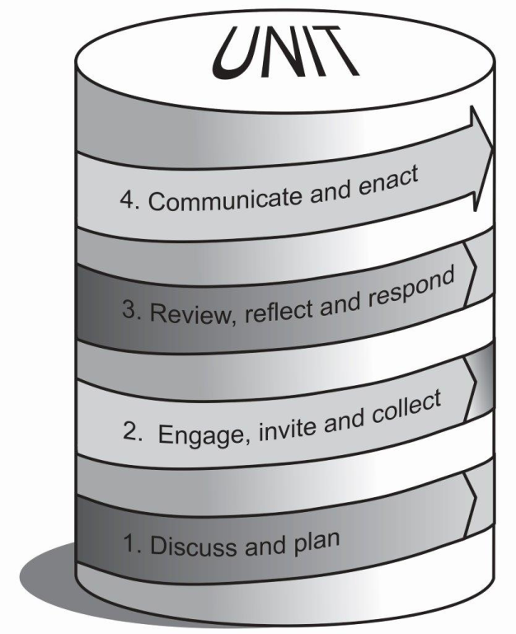
Figure 3 Four phases in PATS to transform student comments into feedback

Peer observation instruments - PATS Task 5
Peer observation of classroom or online practice is becoming a standard part of professional development practice in learning and teaching in Australian higher education, and is an integral part of PATS model. Task 5 ‘Peer Review’ invites both participants to complete a peer observation of teaching. Results from 42 peer observations across 5 institutions using 3 different types of formal instrument reveal that academics rarely focus on the development around goals set. Critical analysis of data from the peer observation phase of the PATS national trials suggests that PATS participants could be supported more effectively through the development and use of a peer observation instrument which is aligned with participants’ goal setting priorities for teaching improvement. The PATS data provides the springboard for a consideration of peer observation instruments used throughout Australian higher education, and the development of an innovative instrument, which will support the PATS process more effectively, but will also make a timely contribution to developments in peer observation practices in higher education more generally.

Challenges in change management in higher education
The choice and use of strategies for introducing, seeding and trialling, and embedding new developments such as PATS was investigated as part of the peer assisted teaching scheme in 2012. A review of the innovation dissemination literature identified three basic strategy types: top down, bottom up, and multi-level approaches. All three of these basic strategy types were represented by the varied approaches adopted for this trial. Whether co-ordinators at each institution pursued the top-down, bottom up, or multi-level approach to embedding the scheme at their higher education institute was dependant on the nature of their particular institutional conditions.
At this point in time, PATS has been seeded at 13 institutions and trialled across 11 of these. In some cases the scheme is embedded in a faculty and will continue without the OLT National Senior Teaching Fellow pushing it along, yet in other cases the PATS activities will cease because of various reasons such as: the setup time; discussions with senior executive; appointment of a PATS coordinator role; and whether or not the partners feel stigmatised if they are part of the scheme.
The best results we have seen for the sustainability of PATS is when leadership is distributed across the three key players in the PATS process:-
- Senior executive value teaching improvement, and have a strong response of responsibility to drive it forward;
- The PATS co-ordinator role is a valid and meaningful role, that is strongly endorsed and supported by the faculty, and that person engages with the institution’s central learning and teaching divisions; and
- The participants genuinely want to improve their teaching, and hence volunteer to be part of the scheme.
The findings of this analysis are presented in a paper currently in progress, and draw on the works of Ms Tilly Hinton’s OLT secondment program Influence Factor: understanding outcomes from Australian learning and teaching grants. Investigating the systematic inclusion of evidence based impact, change and dissemination concepts (Hinton, 2013), and two principal ALTC/OLT projects lead by Professor Sandra Jones, to develop distributed leadership approaches to build leadership capacity in learning and teaching across the Australian university sector:-
- Lessons learnt: identifying synergies in distributed leadership projects (Jones et al., 2012)
- Evidence-based benchmarking framework for a distributed leadership approach to capacity building in learning and teaching (Jones et al., 2014)

Unexpected outcomes
While not an intended part of the fellowship, it was expected that there would be some ongoing activities between PATS partners due to the relationships built through PATS. Examples of what some PATS partners have gone on to achieve are outlined below.

Teaching awards
- Dr Bonnie McBain received two teaching awards from The University of Newcastle in 2013:
Online Teacher of the Year Award - Newcastle Postgraduate Students' Association
Sessional Academic of the Year Award - Faculty of Science and Information Technology
- Dr Richard Oloruntoba, lecturer in the Business School at The University of Newcastle received the Vice-Chancellor's Teaching Excellence Award in 2013.

Grants and Awards
- Dr Bonnie McBain in conjunction with her PATS partner, Dr Liam Phelan, from The University of Newcastle were awarded an OLT Innovation and Development Grant in 2013: Learning and Teaching Academic Standards (LTAS) Project for Environment and Environmental Sustainability (http://www.olt.gov.au/project-learning-and-teaching-academic-standards-ltas-environment-and-environmental-sustainability-2).
- Associate Professor Robert Nelson and Dr Phil Dawson worked in a reciprocal relationship and were awarded an OLT seed grant to progress the idea of a conversation simulator, resulting in the Assessment as learning through conversation simulation (http://conversationsim.org).

Teaching innovation and extended experience
- Dr Laurence Orlando from the Faculty of Pharmacy and Pharmaceutical Sciences at Monash University introduced PATS to help develop the use of Wikis in collaborative student assessments. The resulting output was a student-led produced textbook.
- PATS allowed academics Associate Professor Robert Nelson and Dr Phil Dawson to build and strengthen their scholarly relationship through the development of the Assessment as learning through conversation simulation (http://conversationsim.org)
- Several mentees have now become mentors to others through the PATS scheme.
- Kaplan Higher Education used PATS as a change management tool to facilitate the merging of Carrick Higher Education and Kaplan Business School. PATS was used to assist in the following ways – integrate existing staff; orientate new staff; offer support mechanism for staff transition; align curriculum; align staff expectation; establish student expectations; build on a new culture; provide check points throughout the merger process; and provide triggers for management on progress.
- In addition to the outcomes outlined above, participation in PATS has led to career advancement opportunities and promotion prospects.

PATS goes abroad
Associate Professor Tony Clear from the Faculty of Design and Creative Technologies, Auckland University of Technology in New Zealand will embed the scheme within his faculties in semester 2, 2014. The initial pilot of the scheme will comprise five mentor/mentee pairs/teams. Participants will be solicited via a faculty-wide expression of interest process and encouragement for participation through school contacts. The pilot will address the five identified themes listed below:
- Developing research-led teaching;
- Improving teaching and learning resulting in increased student success and retention;
- Embedding Matauranga Maori within existing programs;
- Developing the skills and capabilities of teaching assistants and/or teaching teams comprising teaching assistants; and
- Improving student satisfaction.
The five pairs/teams will receive the following as incentives:

- Academic funding of $500 at end of semester (unconditional);
- Adjustment to workload to recognise 30 hours commitment to the program; and
- Coffee vouchers supplied by the faculty.

Emergent flavours of PATS: qPATS, sPATS, ePATS
The University of Tasmania is leading an exploration of furthering PATS ‘flavours’ with several other Australian higher education partners. These different streams of PATS have three focus areas: quality (qPATS), scholarship (sPATS) and online support (ePATS).

qPATS is a mechanism for quality improvement of units with a view to seeding scholarship in teaching practice. sPATS is a resource to support recruitment and engagement in scholarly practice of teaching. ePATS is a framework for establishing fully online peer assisted teaching support for off-campus academics and those teaching on-campus units.
Dr Jo-Anne Kelder received an OLT extension grant in November 2014, ‘Adapting and Extending PATS: Variations on purpose, people and process’. Extending on Associate Professor Angela Carbone’s National Teaching Senior Fellowship and Peer Assisted Teaching Scheme (PATS), work will be undertaken to produce a comprehensive and tested ‘Guide to Implementing PATS’ outlining the contexts in which PATS has been adapted and the process for designing, implementing and evaluating PATS variations for effectiveness and impact. The project will be led by Dr Jo-Anne Kelder (Faculty of Health, University of Tasmania) with Swinburne University, University of Newcastle, University of the Sunshine Coast and Victoria University collaborating to adapt PATS for varying contexts, needs and desired outcomes. Associate Professor Angela Carbone will act as an advisor on the project team.
In addition at least three of the partnerships combined the PATS process with the Learning Thermometer (https://www.learningthermometer.com.au/), developed by Dr Helen Stallman, formerly from University of Queensland. The Learning Thermometer is a tool to assist students with their learning and help teaching staff become more aware of some of the factors that may be influencing their students learning.
For students the Learning Thermometer measures their level of engagement and stress over the term of a semester and it encourages students to reflect upon their learning; get tailored feedback about strategies, resources, and support that might be useful to them doing well in their subject; and develop individual learning plans to optimise their success in the course.
For teaching staff, the Learning Thermometer provides them with group data at four time points during the semester to help them fine-tune the course to improve student learning outcomes. At the end of semester, teaching staff are provided with summary data that include: Teaching Value Index (TVI); level of student satisfaction and engagement; and the percentage of surveys completed by each student.

Scholarship of Learning and Teaching
One of the unexpected outcomes of PATS was that PATS coordinators and participants engaged in teaching scholarship and published their innovations in esteemed outlets:
Chandrakumara, A. & Wickramasinghe, A. (2013). You never know what question you are going to answer: creating effective tension for effective learning using business case studies. Proceedings of the 5th International Conference on Education and New Learning Technologies (Edulearn), 1-3 July 2013, Barcelona, Spain.
Cooper, S. Lindsay, K. & McComb, V. (2013). Supporting good first year course design: The FY PATI. Proceedings of the 16th International First Year in Higher Education (FYHE) Conference. 7-10 July 2013, Wellington, New Zealand.
D'Souza, D., Bauers, A., Carbone, A. & Ross, B. (2014). An experience with PATS - a Peer Assisted Teaching Scheme. International Conference on Learning and Teaching in Computing and Engineering (LaTiCE), 11-13 April 2014, Sarawak, Malaysia.
Nelson, R. & Dawson, P. (2014). A contribution to the history of assessment: how a conversation simulator redeems Socratic method. Assessment & Evaluation in Higher Education, 39 (2), 195-204.
Phelan, L. (2012). Interrogating students’ perceptions of their online learning experiences with Brookfield’s critical incident questionnaire. Distance Education, 33(1), 31-44.
Phelan, L., Cottman, C., Tout, D., Carbone, A., Drew, S., Ross, B., Stoney, S. & Lindsay, K. (2013) Creating collegial frameworks to tighten and close student feedback. Proceedings of the 6th International Conference of Education, Research and Innovation (ICERI), 18-20 November, 2013, Seville, Spain.

Summary
The Fellowship has produced a wide range of positive results which include improvements to SETU scores and valuable insights into the types of issues and challenges faced by teaching academics. The insights gained into the issues faced by academics can be summarised as follows:
- Academics’ perceived barriers to improving teaching were categorised into four areas: personal/individual, school/faculty/department level, institutional level, and student focussed. These findings contribute to our understanding of the issues faced by academics in a contemporary and changing higher education environment and may assist staff, departments, faculties and institutions in meeting the needs associated with improving teaching quality.
- Many academics struggle to formulate clear and achievable goals for improving their teaching practice. Academics set goals that related to improved: teaching practices, course outcomes, assessment, activities, administrative processes, resources and student engagement. The role of the PATS mentor is to assist in ensuring that academics set specific, measurable, achievable, results orientated and time-bound (SMART) goals that can realistically be achieved.
- PATS facilitates and further enhances the student feedback process in two important ways. Firstly, the scheme creates a collegial framework in which to embed student feedback loops. Secondly, the scheme creates a collegial setting in which to plan for, interpret and respond to comments, typically areas of teaching practice that have been highly individualised.
- Academics rarely focus on the development around their set goals when conducting peer observations. Our findings suggest that PATS participants could be supported more effectively through the use of a peer observation instrument that aligns with participants’ goal setting priorities for teaching improvement.
- Our findings suggest that engagement needs to fit individual institutions’ requirements and may be best achieved through a distributed leadership approach, with careful consideration to evidence based impact, change and dissemination.
- In addition to these insights, there were numerous unexpected outcomes.

How can faculty plans and processes meet national teaching standards?

Overview
In a higher education sector increasingly focussed on enhancing the student experience of learning and teaching, it is important to have measures of teaching quality or teaching standards that are applicable to the higher education sector generally: universities and faculties serious about improving teaching quality need a common language to talk about teaching quality. Teaching standards need to be informed by different perspectives: the student voice, the academic voice and the research literature. From these perspectives it is possible to create a framework toward building effective units. The fellowship addresses this need by analysing the research literature (section 5.1.1) and the student voice (section 5.1.2) in order to assist in the development of a unit effectiveness framework presented in section 5.1.3. In section 5.3 we draw on the survey presented to management to develop a picture of the plans, processes, polices and resources that are currently used to support teaching improvement.

Revisiting teaching quality
PATS contributes to the national discourse on higher education standards and in particular, the plans, practices and policies of faculties to support teaching standards. Teaching standards are needed for a variety of reasons:
- To provide the sector with a common language to discuss teaching quality;
- To facilitate benchmarking between institutions or across the sector; and
- To provide institutions with a structure and methodology to assess performance.
The fellowship was in part inspired by The Teaching Standards Framework (TSF) (Sachs, Mansfield & Kosman, 2011), a tool for assessing standards in institutional practices in learning and teaching, structured around three themes: teaching, learning environment and curriculum. Within each theme are seven focus areas – management responsibilities, planning, resources, policies and procedures, practices, outcomes, monitoring and evaluation. The TSF provides measures and indicators of teaching quality from a faculty and institution perspective, whereas PATS aims to ensure that the indicators measure those aspects critical to students. To do so, an analysis of student responses to the open-ended SETU question: ‘What aspects of this unit are most in need of improvement?’ was undertaken for units in need of attention that took part in the scheme.

Aspects of teaching that matters to students
Considerable research has been conducted into students’ views and opinions about areas for improvement in learning and teaching. A set of course quality attributes (CQA) were developed on the basis of student concerns at Monash University in ICT (Carbone & Ceddia, 2012) and physical sciences and in introductory programs across five universities (Carbone, Ceddia, Simon, D'Souza & Mason, 2013). Students were asked which areas of teaching that they perceived as needing attention for improvement (Carbone & Ceddia, 2013). This research resulted in the development of a comprehensive list of educational focus areas in university teaching.

The ten focus areas identified, in order of priority of student concern, are: course, lecturer, lecture, tutor, tutorial, lab, assessment, resources, LMS and off-campus delivery. See Figure 4 for a visual representation.

Figure 4 Teaching areas most in need of improvement

Towards a framework for unit effectiveness
The work conducted during the fellowship led to the development of a framework for analysing and describing the facets that make up an effective unit. This framework draws on several further sources:
- The course quality attributes (CQA) (Carbone & Ceddia, 2013) described in Figure 4,
- Findings from a systematic review of instruments that measure and report on teaching quality (Hughes-Warrington et al., 2010).
- Findings from this Fellowship regarding the types of barriers that academics face in their teaching (Carbone et al., under review), and the ways in which academics set performance goals for themselves (Ross et al., under review).
A start to our framework for unit effectiveness currently under development is provided in Figure 5.
This framework provides a common language and a set of standards for considering quality in units of study. It articulates a minimum standard that all units should meet with respect to five facets of unit: educator, learning outcomes, learning activities, assessment and resources.
An aspirational standard is also stated for each facet for academics to strive towards. The framework recognises that barriers that need to be addressed may exist, and that enablers such as technology, space and governance need to be harnessed for an effective unit. Potential uses of the framework include: self- or peer-review of unit effectiveness by individual academics; contribution to individual mentoring, performance and academic advancement discussions; communicating to students what they can expect from a unit; and guiding faculties in considering what quality looks like in their units.
Figure 5 is on the next page.
The five facets of the framework are described below:
- Educator (lecturer, tutor and facilitator) relates to the educator’s knowledge, organisation, presentation skills, support they provide to students, response time to queries, and control of class and non-class activities. The educator should aim to engage, enthuse and inspire students to learn.
- Learning outcomes refers to the selection and curation of purposeful content that will help students develop the knowledge, skills and attributes needed to achieve their learning outcomes. Learning outcomes describe what the student should be able to do at the completion of the unit and need to be clearly articulated, achievable and aligned to graduate destinations, Australian Qualifications Framework (AQF) levels and professional standards.
- Learning activities refers to the sequencing and allocation of time to learning. This provides students with experiences and activities to engage in the content in meaningful ways that help develop their knowledge, skills and attributes.
- Assessment/Feedback relates to the approaches for guiding and gathering evidence about learning. Assessment can either be used to help students learn (as learning), it can be used to provide feedback (for learning) and as evidence to show that students have attained learning outcomes (of learning).
- Resources include readings, referenced articles, worked examples, websites, YouTube, learning management systems (LMS) systems and learning spaces.

The underpinning foundations to support the effectiveness of the five different facets of a unit include:
- Technology. Technology needs to support all facets of a unit to be effective, with an emphasis on appropriate technology enablement.
- Space. Spaces must be fit-for-purpose to enhance the students’ learning experiences. Spaces such as libraries and external spaces should also be considered.
- Governance. Policies and procedures must be appropriate to support aspirational levels of unit effectiveness. Governance includes defining a structure for unit management, including items like a content review policy, equivalence of student experience across campuses and mark or grade moderation. Governance may also specify items that need to be considered for new unit design as well as a framework for the review of poorly performing units.
Although setting minimum and aspirational standards to measure unit effectiveness can be useful, our work has shown that there can be several barriers to making unit improvements, as outlined in section 4.4.1. This framework extends on Brookfield’s (1995) lenses of reflections by drawing on additional lenses to improve teaching quality such as: data analytics, the tutor lens, and an external moderator lens.

 |  |  |  |  |  |  | Levels of increasing effectiveness |  |  |  |  | Barriers to improvement |  |  |  |  |  | Evaluation Portfolio
 |  |  |  |  |  |  | Minimum Standard |  |  | Aspirational Standard |  |  |  |  |  |  |  | Evaluation Portfolio
 | Facets of a unit | Teaching | Educator | T e c h n o l o g y | S p a c e | G o v e r n a n c e | - Demonstrate a solid theoretical knowledge of the content.  - Create presentations that are socially engaging and intellectually stimulating.  - Respond to students’ queries in a timely manner.  - Cater for different individual and group needs of students.  - Offer support to students in flexible modes.  - Are organised and have good class management. |  |  |  | - Show a passion for their subject matter and make their content relevant and meaningful.  - Inspire and support their students to know more in the field.  - Create an encouraging conversational environment.  - Encourage students to form diverse perspectives or opinions, question frameworks and values and to seek a critical scholarly perspective of their own. |  | I n d i v I d u a l – confidence – knowledge – skill – motivation – stress | F a c u l t y – culture/support – workload/time – communication - resources | U n I v e r s I t y – training – class size – resources – administration/scheduling | S t u d e n t s – culture/attitude – language skills – knowledge & skills | - Self lens  - Peer lens  - Student lens  - Technology-driven analytical lens  - Scholarly literature
 | Facets of a unit | Unit | Learning outcomes | T e c h n o l o g y | S p a c e | G o v e r n a n c e | - Are aligned to the unit and course, professional body requirements, Monash graduate attributes, and at the appropriate AQF level.  - Show a clear relationship to the leaning activities and assessment tasks for the unit.  - Are clearly framed to ensure students develop knowledge, skills and attributes that the unit is intended to develop. |  |  |  | - Have an aspirational dimension which is unlikely to have achieved before beginning the unit.  - Are framed to remain aspirational and might contain expressions of future learning—the desire to learn more—which are not exhausted by the successful completion of the unit. |  |  |  |  |  | - Governance lens  - Student lens  - External moderation lens  - Scholarly literature
 | Facets of a unit | Unit | Learning activities | T e c h n o l o g y | S p a c e | G o v e r n a n c e | - Aligned with assessment and the learning outcomes  - Scaffolded to develop knowledge and skills towards achieving learning outcomes.  - Supplemented with up-to-date, fit-for-purpose, resources in multiple modes of access.  Strongly supported by discussions, stimulating peer interaction and extended expertise input in a timely manner. |  |  |  | - Designed to stimulate, extend, and service a range of student learning preferences inciting high levels of inquiry, new thinking and conceptual frameworks.  - Scaffolded to move the students towards goal setting, self-directed learning, and self-assessment against social, cultural and personally derived norms. |  |  |  |  |  | - Student lens  - Tutor lens  - Governance lens  - Self lens  - Scholarly literature
 | Facets of a unit | Unit | Assessment and  Feedback | T e c h n o l o g y | S p a c e | G o v e r n a n c e | - Alignment maintains a breadth and depth with clarity and authenticity across learning outcomes, tasks and assessment.  - Provides students with timely and constructive feedback on a balanced workload of meaningful tasks, clearly structured and scaffolded.  - Incorporate multiple feedback sources in exemplars and the specificity of assessment tasks  - Allows students self-assess prior to submission. |  |  |  | - Has multiple constructively framed feedback loops which lead students toward self-efficacy and responsible self-management, lead to growth in the students’ behaviours and knowledge. |  |  |  |  |  | - Governance lens  - Tutors lens  - Student lens  - Scholarly literature
 | Facets of a unit | Unit | Resources | T e c h n o l o g y | S p a c e | G o v e r n a n c e | - Are fit-for-purpose.  - Are organised to support learning and are easily accessible.  - Relate to the unit and are appropriate for the student level. |  |  |  | - Foster learning autonomy.  - Are dynamically added during the semester and directly incorporated into learning activities.  - Can be contributed to or evaluated |  |  |  |  |  | - Student lens  - Tutor lens  - Self lens  - Scholarly literature
Figure 5 A framework for unit effectiveness

Building teaching quality - management plans and processes
University management has a responsibility to enhance teaching quality and ensure teaching and unit quality standards are met. The Teaching Standards Framework (TSF) was not widely adopted by universities, however it does highlight the importance for universities in their teaching plans to demonstrate how they support and enhance teaching quality. These plans need to incorporate feedback from stakeholders, and PATS is one scheme which can assist in this endeavour.
In order to understand the current management structures in place for supporting teaching quality, we draw on the data collected as part of Survey 1 issued to management staff. In particular, we asked management staff to identify the structures in place that indicate support for teaching quality at an institutional and a faculty level.
Results in Table 24 reveal that at the institutional level central units, Deputy Vice-Chancellors / Pro Vice-Chancellors (DVC/PVC) and Offices of Learning and Teaching are the most common structures in place. At the faculty level, Deans of Learning and Teaching (L&T) followed by learning and teaching committees are the most commonly found structure. The responses categorised under ‘other’ include ‘unsure’, and ‘not much’. This was an opened-ended question (Survey 1, Question 10) that asked ‘what management structures are in place at your institution to support and enhance quality teaching practices (at an institutional and faculty level)?’ Comments were analysed for themes and not all participants responded to this question.
Table 24 Management structures in place that support teaching quality
Management structures | Institutional | Faculty
Central unit | 16 | 8
Deputy/Pro-Vice Chancellor | 12 | 0
Office of Learning and Teaching | 10 | 2
Deans of Learning and Teaching | 4 | 22
Grants | 3 | 2
Learning and Teaching committee | 3 | 10
Other | 7 | 6
None | 1 | 4
Total | 56 (86% response rate) | 54 (83% response rate)

Management staff members were asked how quality teaching practices were incorporated into strategic plans (Survey 1, Question 11). This was an opened-ended question and comments were analysed for themes and not all 65 participants responded to this question. The results in Table 25 are presented in descending order for ‘institutional level’ and reveal that planning processes are most commonly used at both the faculty and institutional levels. The high numbers of responses that could not be categorised are found in the ‘other’ category. These include ‘by using rhetoric – nothing about the practice’, ‘unclear’, ‘unsure’, ‘by words’, ‘n/a’ and ‘includes statements supporting quality teaching and learning’.
Of concern is the finding that a considerable number of responses to this question state that there are no quality teaching practices incorporated into strategic planning at either the institutional or faculty level.
Table 25 Incorporation of quality teaching practices into strategic planning
Ways of incorporating quality teaching into strategic planning | Institutional level | Faculty level
Planning processes | 15 | 13
Learning and Teaching unit/committee | 5 | 4
Awards/grants | 4 | 2
Student feedback | 4 | 3
Other | 13 | 20
None | 5 | 3
Total | 46 (71% response rate) | 45 (69% response rate)

Management staff members were asked (Survey 1, Question 12) which resources their institution provided to support learning and teaching. This was an opened-ended question and comments were analysed for themes and not all 65 participants responded to this question. The results reveal that at the institutional level, central learning and teaching units provided most support followed by grants and award and workshops, seminars and forums. The large number of ‘other’ (in Table 26) responses include ‘almost anything would be better than what we have now’, ‘uncertain’, ‘not a lot’ and ‘very varied across university, mostly informal’. PATS addresses the issue of resources by using both local and centrally based resources in the form of mentors and workshops. The scheme recognises experts as mentors and collegial peers.
Table 26 Resources to support teaching quality
Resources to support teaching quality | Institutional level | Faculty level
Central learning and teaching units | 16 | 0
Grants/awards | 12 | 8
Workshops/seminars/forums | 12 | 8
Online resources | 7 | 4
Graduate certificate | 2 | 3
Peer/mentoring programs | 2 | 3
Other | 9 | 20
None | 3 | 4
Total | 63 (97% response rate) | 50 (77% response rate)

Management staff members were asked about the policies and procedures available to support quality teaching (Survey 1, Question 13 – see Table 27). This was an opened-ended question and comments were analysed for themes. Not all 65 participants responded to this question.
The policies and procedures most available to support quality teaching are learning and teaching strategic plans and policies followed by student evaluations. The large proportion of ‘other’ is due to many academics not knowing what policies and procedures were in place in their institution. Answers include many ‘unsure’ and ‘uncertain’ responses. It is of concern that a considerable number of responses (collated under ‘none’ in Table 27) state that there are no (or they cannot recall) policies and procedures available to support quality teaching at the institutional and especially the faculty level. The lack of knowledge of the existing policies and practices to support quality teaching, as well as the responses that no such structures are in place, is an area that needs to be addressed. As outlined, the response rate and relying on participant knowledge and understanding of what their institution does needs to be taken into consideration when reviewing the data. PATS does provide a framework by which faculties can establish systematic and accessible policies (for example, coffee vouchers, $500 incentives and time relief).
Table 27 Policies and procedures to support quality teaching
Policies and procedures | Institutional level | Faculty level
Learning and teaching strategic plan/policies | 16 | 9
Student evaluations | 7 | 3
Teaching awards | 3 | 2
Quality assurance and quality innovation framework | 1 | 0
Other | 14 | 18
None | 3 | 7
Total | 44 (68% response rate) | 39 (60% response rate)

Management were asked how their institution and faculty shared quality teaching practices (Survey 1, Question 15). This was an opened-ended question and comments were analysed for themes. Not all participants responded to this question. The results in Table 28 reveal that the most common way to share quality teaching practice was through workshops, seminars and forums as well as annual expos and symposiums. The ‘other’ responses in Table 28 include ‘uncertain’, ‘varies dependent on faculty level’ and ‘the Dean is active in the OLT’. Many were unsure of the ways this was achieved. Again, the finding that many state there are no ways of sharing quality teaching practice at the faculty, and especially the institutional level, is of concern and needs to be addressed. Quality teaching practice is shared through PATS as collegial peers work through tasks centred on their own experiences of teaching.

Table 28 Sharing of quality teaching practice
Ways to share quality teaching practices | Institutional level | Faculty level
Workshop/seminar/forum | 19 | 16
Annual expo/symposium | 13 | 3
Awards | 6 | 3
Online resources | 5 | 1
Newsletters/emails/reports | 5 | 2
Communities of practice | 2 | 1
Peer/mentoring | 1 | 4
Other | 4 | 10
None | 6 | 3
Total | 61 (94% response rate) | 43 (66% response rate)

Finally, management staff members were asked how their institution recognises quality teaching (Survey 1, Question 16 – Table 29 shows the results). This was an opened-ended question and comments were analysed for themes. Not all participants responded to this question. For both institutional and faculty levels, grants and awards are the primary means of recognising quality teaching over promotion. What is concerning is that many responses state that there is no recognition for quality teaching in their faculty.
Table 29 Recognition of quality teaching
Forms of recognition | Institutional level | Faculty level
Grants/awards | 42 | 31
Promotion | 6 | 3
Other | 2 | 4
None | 1 | 4
Total | 51 (78% response rate) | 42 (65% response rate)

Summary
To investigate how faculty plans and processes can meet national teaching standards, the Fellow undertook research into how teaching quality is defined, measured and how teaching standards are applicable to the higher education sector generally. If universities are indeed serious about improving teaching quality there is a need for a common language to talk about and measure teaching quality. Teaching standards need to be informed by students, teaching academics and research literature.
Based on existing literature and surveys with management staff, a framework was developed to assist in creating a common language and standard for how to discuss effective units.
Most universities have management structures in place to ensure teaching quality and most have a vision that is outlined in their strategic plan.
Of interest is the high number of responses from management staff members that indicate that they either are not aware of the different forms of support for ensuring teaching quality or that there is little support in their faculty or institution. This is a key area that needs to be addressed in order to ensure quality teaching standards are met. PATS plays a role here in that the scheme offers support at both the management level and at the academic teaching level to support quality teaching practice.

Engagement and Dissemination

Overview
In this chapter we outline the stakeholders and the approaches we undertook to engage them in the PATS process. We highlight our dissemination avenues to engage a broad audience across the higher education sector, including: universities, higher education institutions and private providers. We conclude with a list of resources that are freely available on the PATS website for institutions wishing to adopt and tailor the scheme for their institution.

Participant engagement
To support the engaged-focused approach to dissemination, the following participants were engaged in the process:
- Directors of Academic Development Units and Academic Developers acted as initiators and support operators at their institutions. The National Senior Teaching Fellow was directly involved with these directors and developers who provided contacts to disseminate to a broader audience than Monash University. Academic developers were asked to liaise closely with Associate Deans (Education) and Heads of School, senior management and participants from their institutions wishing to engage in the scheme.
- High level Learning and Teaching Committees, PATS was brought to the attention of senior institutional management via announcements at high level education committees, dissemination of bi-monthly newsletters, and reporting of results. Throughout the scheme, reports of progress were delivered to members of the university’s Learning and Teaching Committee and Associate Deans of Education, as they were responsible for endorsing plans and policies for implementation of PATS.
- Associate Deans (Education) and Heads of Schools were involved in the fellowship as the positional leaders responsible for teaching and unit quality in their faculty/school. They were invited to assess the performance of the units within their faculty, recruit participants and offer incentives for improvements as part of the fellowship work.
- PATS Co-ordinators were responsible for recruiting participants for the scheme and liaising with senior management. The PATS Co-ordinator conducted initial briefing sessions with participants and outlined the policies and procedures of their faculty. During semester, the PATS co-ordinator met with the partners to ensure that the partnership was working successfully and to offer ongoing support. Post semester, the co-ordinator held a debriefing session, and distributed acknowledgement letters.
- Participants (mentors and mentees) actioned the scheme suitably adapted for their institution. They attended an initial briefing and mid-semester briefing session, along with a debrief session with their co-ordinator after completion of the teaching semester. They were invited to attend workshops in their faculties or central learning and teaching units.

Dissemination strategies
The original aim of the fellowship was to engage eight higher education institutions to participate in PATS, however, in total 13 institutions were recruited. Dissemination of the fellowship outcomes across the 13 participating institutions is inherent in the program of activities.

In addition, the development, methodology and outcomes of this program, including recommendations and suggested enhancements, was disseminated during 2012 through relevant networks and at relevant national and international conferences and in peer reviewed academic journals. The fellowship team used a variety of strategies to disseminate the findings and output of the fellowship. These strategies are outlined in the following sections.

Seminars and workshops
During the Fellowship from October 2012 to December 2014, there were over 40 presentations with six keynote speeches. See Table 30 for details.
Table 30 PATS events October 2012- December 2014
Date | Location | Description
2014
16 Dec | Melbourne | Presentation: ‘Towards a Higher Education Learning and Teaching Research Agenda’, Monash Educational Excellence Research Group (MEERG) Symposium.
12 Dec | Hobart | Workshop: PATS Extension Grant, Faculty of Health, University of Tasmania.
11 Dec | Hobart | Attendance: Vic-Tas Promoting Excellence Network event, University of Tasmania.
8 Dec | Melbourne | Presentation: ‘Education technology and the student experience of technology-based learning’ Department of Physiology Retreat, Monash University
5 Dec | Brisbane | Award: Receiving Australian Learning and Teaching Fellowship, Griffith University.
4 Dec | Melbourne | Presentation: Mixed Sector Symposium, Box Hill Institute.
1 Dec | Melbourne | Presentation: National Summit for Distributed Leadership, RMIT University.
30 Nov | Brisbane | Presentation: AARE-NZARE 2014 conference, Queensland University of Technology
27 Nov | Melbourne | Roundtable presentation: Office of Learning and Teaching National Forum on Employability, RMIT University.
21 Nov | Melbourne | Panel chair: ‘New Frontiers in Tertiary Education: Coping with Reforms and Challenges’ 25th Australian Association of Institutional Researchers and Australian Higher Education Evaluation Forum.
18 Nov | Sydney | Attendance: National Promoting Excellence Network event at the University of New England.
6 Nov | Melbourne | Panel Chair: ‘Creative forms of Teaching Evidence’, Victoria University.
5 Nov | Brisbane | Presentation: ‘Peer Partnerships and Peer Review’, CQUniversity
22-25 Oct | Québec, Canada | Attendance: ISSoTL conference 2014
17-18 Oct | Brisbane | Panel chair: Higher Education Vision and Leadership for Graduate Employability.
15-16 Oct | Sydney | Keynote: IQPC's 3rd Blended Learning Summit 2014
19 Sept | Melbourne | Presentation: ‘Practitioner capabilities and Peer Assisted Teaching Scheme’, Holmesglen College
14 Aug | Melbourne | Presentation: ‘Improving learning and teaching through a Peer Assisted Learning Scheme’ for the Learning and Teaching Seminar Series, Victoria University
8 Aug | Brisbane | Presentation: Queensland University of Technology
4 Aug | Sydney | Presentation: Orientation on mentoring for new Fellows, OLT
21 July | Melbourne | Workshop: Faculty of Health, Arts and design, Swinburne University of Technology
16 July | Melbourne and New Zealand | Presentation: Blended Learning webinar
7-10 July | Hong Kong | Presentation and workshop: 2014 HERDSA conference
23-25 June | Uppsala, Sweden | Panellist: ’Integrating Research and Teaching, a Global Challenge for Higher Education’: ITiCSE 2014
16-18 June | Stockholm, Sweden | Presentation: Conference of the International Consortium for Educational Development (ICED)
4 June | Rockhampton | Presentation: Central Queensland University
2 June | Melbourne | Presentation: ‘PATS: Supporting academics to invigorate units’ for the Faculty of Medicine, Nursing and Health Sciences, Monash University.
30 May | Melbourne | Keynote: ‘Building Bridges using a Peer Assisted Teaching Scheme’, Homesglen Quality Teaching conference
2013
5-6 Dec | Sydney | Attendance: OLT Fellows Forum - Australian Learning and Teaching Fellows network
4 Dec | Melbourne | Presentation: OLT National Senior Teaching Fellowship symposium
3 Dec | Melbourne | Keynote presentation: Monash University School of Primary Health Care Education & Research Conference
6 Nov | Newcastle | Workshop: University of Newcastle, Faculty of Business & Law
2 Oct | Sydney | Workshop: 9th National PASS Forum
20 Sep | Waikato, NZ | Invited workshop: University of Waikato
19 Sep | Auckland, NZ | Keynote: Auckland University of Technology Learning & Teaching Forum
18 Sep | Auckland, NZ | Planning Workshop: AUT L&T planning day
4 Sep | Melbourne | Keynote: RMIT Learning & Teaching Expo
26 Aug | Townsville | Invited Presentation: James Cook University
16 Aug | Melbourne | Attendance: National Think Tank: Professionalising the Academic Workforce 2020
25 Jul | Sydney | Invited Presentation: Orientation for new OLT Fellows
11 Jul | Perth | Invited Presentation: PATS to Australian Business Deans' Council
1-4 Jul | Auckland, NZ | Conference presentation: 2013 HERDSA Conference, AUT
1-3 Jul | London, UK | Conference presentation: 18th Innovation and Technology in Computer Science Education (ITiCSE) Conference
24 Jun | Oxford, UK | Attendance: HEA Discipline Lead - Business & Management
21 Jun | Warwick, UK | Presentation: University of Warwick
17 Jun | Adelaide | Invited Presentation: Flinders University
12-13 Jun | Sydney | Attendance: OLT Fellows Forum - Australian Learning and Teaching Fellows network
11 Jun | Hobart | Invited Presentation: University of Tasmania, Faculty of Health Sciences
5 Jun | Melbourne | Attendance: Vic-Tas Promoting Excellence Network
3 Jun | Canberra | Invited presentation: College Strategy Group, UNSW Canberra
27 May | Sippy Downs | Invited workshop: University of the Sunshine Coast
9 May | Melbourne | Presentation (via phone): Associate Deans (L&T) from various Sydney Business schools
4-5 Apr | Melbourne | Attendance: Australian Council of Deans (ICT) Learning & Teaching Forum, Victoria University
4-5 Apr | Melbourne | Presentation: CADAD meeting, Victoria University
22-24 Mar | Macau | Conference presentation: LaTICE conference
20 Mar | Melbourne | Roundtable: MEERG symposium, Monash University
19-20 Mar | Melbourne | Invited presentation: Assessing & Reporting Learning & Teaching Outcomes conference, Rydges Hotel
15 Mar | Newcastle | Invited presentation: University of Newcastle
14 Mar | Hobart | Invited presentation: University of Tasmania
29 Jan - 1 Feb | Adelaide | Presentation: Fifteenth ACE Conference
2012
9 Nov | Melbourne | Keynote presentation: RMIT Business retreat
1-2 Nov | Melbourne | Attendance: OLT Fellows Forum - Australian Learning and Teaching Fellows network
29 Oct | Melbourne | Attendance: Vic-Tas Promoting Excellence Network
25-26 Oct | Adelaide | Invited presentation: CADAD meeting
17 Oct | Melbourne | Invited presentation: Monash Faculty of Education
Fellowship commenced 1 Sept 2012

Refereed journal and conference papers
The journals which have been targeted have included: Studies in Higher Education (ERA ranking A*), Educational Researcher (A*), Journal of Higher Education (A), Higher Education (A), Quality in Higher Education (A), Higher Education Research & Development (A), Assessment & Evaluation in Higher Education (A) and International Journal for Academic Development (B).
Carbone, A. (2013). Opportunities and Challenges Faced in Attempting to Improve Units with Critically Low Student Satisfaction, Higher Education Research and Development (HERD) 33(3), 425-439.
Carbone, A. & Ceddia, J. (2013). Common Areas for Improvement in Physical Science Units that have Critically Low Student Satisfaction. Learning and Teaching in Computing and Engineering (LaTiCE), Macau, 22-24 March 2013.
Carbone, A., Ceddia, J., Simon, Mason, R. & D’Souza, D. (2013). Student Concerns in Introductory Programming Courses. Fifteenth Australasian Computing Education (ACE) Conference, University South Australia, 29-1 Feb 2013.
Carbone, A., Ross, B, Phelan, L., Lindsay, K., Drew, S., Stoney, S. & Cottman, C. (2014). Course Evaluation Matters: Improving Students’ Learning Experiences with a Peer Assisted Teaching Program. Assessment and Evaluation in Higher Education, 2014, 1-16
Carbone, A., Ross, B. & Ceddia, J. (2013). Five Years of Taps on Shoulders to PATS on Backs in ICT. Conference on Innovation and Technology in Computer Science Education (ITiCSE 2013), University of Kent, UK, 1-3 July 2013.
Carbone, A., Ross, B., Lindsay, K., Drew, S., Stoney, S., Cottman, C. & Phelan, L. (2014). A multi-institutional trial of a peer assisted teaching scheme: Positive changes in course evaluation scores. International Consortium for Educational Development (ICED) Conference, 16-18 June 2014, Stockholm, Sweden.
Carbone, A., Ross, B., Tout, D., Lindsay, K., Phelan, L., Cottman, C., Readman, K., Drew, S. & Stoney, S. (2013). A Peer Assisted Teaching Scheme. HERDSA showcase, 1-4 July, Auckland, NZ.
D'Souza, D., Bauers, A., Carbone, A. & Ross, B. (2014). An experience with PATS - a Peer Assisted Teaching Scheme. International Conference on Learning and Teaching in Computing and Engineering (LaTiCE), 11-13 April 2014, Sarawak, Malaysia.
Phelan, L., Cottman, C., Tout, D., Carbone, A., Drew, S., Ross, B., Stoney, S. & Lindsay, K. (2013). Creating collegial frameworks to tighten and close student feedbacks. Proceedings of the 6th International Conference of Education, Research and Innovation (ICERI), 18-20 November, 2013, Seville, Spain.
Earlier papers have included:
Carbone, A. & Ceddia, J. (2012). Common Areas for Improvement in ICT Units that have Critically Low Student Satisfaction. In de Raadt, M. & Carbone, A. (Eds.), Proceedings of the Fourteenth Australasian Computing Education Conference (ACE2012), CRPIT. 123. Melbourne, Australia, ACS, 167-176.
Carbone, A. (2012). Peer Assisted Teaching Scheme – A Way of Creating, Sustaining and Developing New Connections. In Brown, N., Jones, S. M. & Adam, A. (Eds.), Proceedings of the 35th Higher Education Research and Development Society of Australasia (HERDSA) Annual International Conference. Hobart, Australia, 2-5 July 2012, 1-10.
Carbone, A., Wong J. & Ceddia, J. (2011). A Scheme for Improving ICT Units with Critically Low Student Satisfaction. In Proceedings of the 16th Annual Joint Conference on Innovation and Technology in Computer Science Education (ITiCSE). Darmstadt, Germany, 27-29 June, 253-257.
Carbone, A. (2011). Building Peer Assistance Capacity in Faculties to Improve Student Satisfaction of Units. In Krause, K., Buckridge, M., Grimmer, C. & Purbrick-Illek, S. (Eds.), Proceedings of the 34th Higher Education Research and Development Society of Australasia (HERDSA) Annual International Conference. Gold Coast, Australia, 4-7 July, 83-94.
Under review/in progress:
Carbone, A., Evans, J., Phelan, L., Drew, S., Ross, B., Lindsay, K., Cottman, C. & Stoney, S. (under review). The Peer Assisted Teaching Scheme: Enabling distributed leadership for improving leadership in higher education.
Carbone, A., Lindsay, K., Ross, B., Drew, S., Phelan, L., Cottman, C., Stoney, S. & Evans, J. (Under review). A framework for analysing contemporary barriers to teaching improvements in higher education: Evidence from the Peer Assisted Teaching Scheme.
Carbone, A., Phelan, L., Ross, B., Cottman, C., Drew, S., Stoney, S., Lindsay, K. & Readman, K. (Under review). Strategies for disseminating teaching innovations: a multi-institutional case study of a peer assisted teaching scheme.
Drew, S., Lindsay, K., Carbone, A., Ross, B., Phelan, L., Stoney, S., Cottman, C. & Readman, K. (Under review). Creating a smarter observation instrument: focusing PATS peers on developmental goals.
Phelan, L., Tout, D., Cottman, C., Carbone, A., Ross, B., Lindsay, K., Drew, S. & Stoney, S. (Under review). Creating collegial frameworks to tighten and close student feedback loops.
Ross, B., Carbone, A., Lindsay, K., Drew, S., Phelan, L., Cottman, C., Stoney, S. & Evans, J. (Under review). Developing educational goals: Insights from a Peer Assisted Teaching Scheme

Monash Memo
PATS has been included in the Monash Memo (internal e-newsletter) four times:
- #1 February 2013: Outlining the launch of the PATS Fellowship
- #2 October 2013: Advertising the upcoming PATS Symposium
- #3 January 2014: Reporting on the success of the PATS Symposium
- #4 November 2014: Reporting on the University of Tasmania extension grant

Informational flyers
The following instructional flyers were made available in the Participant Instructional Workbook, on the PATS website under the Resources heading, and were printed and distributed at selected events.
- PATS Overview Postcard (see Appendix D)
- Course Quality Attributes
- Challenging the type of activity
- Breaking down the barriers
- A framework for setting goals
- Closing the student feedback loop
- Peer observation of teaching

Online PATS workbook
The online workbook (under ‘PATS Resources’ from www.monash.edu/pats) was developed for several key reasons. It was seen as a way of easily capturing participants’ workbook entries in an electronic format, minimising paper wastage, and allowing participants to work from tablets, laptops and mobile devices. It was also a means of minimising the time spent by the researchers collecting and collating workbook tasks. The workbook contains the following:
- Introduction
- Timetable of activities
- The PATS process
- Meetings with PATS Co-ordinator
- Pre-semester tasks
  - Meet and greet
  - Break down the barriers
  - Set goals
- During semester tasks
- Listen to your students - Gather informal student feedback
- Listen to your peers - Perform a peer observation of teaching
- Post-semester tasks
  - Critical reflection
  - Performance planning and strategies
- Appendix
- Informal student feedback form
- Example of a summary of feedback session
- Peer Observation of Teaching Template (Macquarie University only)
- Course quality attributes
- Educational research journals
- References
The workbook captures an individual's responses to each task, as replicated from the original hard copy of the workbook. Responses are stored in a simple online database and can be accessed by date, institution, coordinator, task, or any combination thereof, and downloaded into Excel for further analysis. A PATS website user guide for participants and co-ordinators can be found on the PATS website in the relevant Resources section.
At any point in time a PATS coordinator can log in and view the progress of the participants by getting an overview of tasks not attempted/incomplete/complete for each partnership under their jurisdiction. Co-ordinators can also drill down into an individual task worksheet to view participant responses. This has been very useful in keeping track of multiple partnerships from multiple institutions and has enabled partners to work together on tasks even when based at different locations. It has also facilitated data analysis, for example by enabling cross tabulation of tasks by faculty. A sample co-ordinator’s view of the task progress of their PATS participants is shown in Figure 6 below.
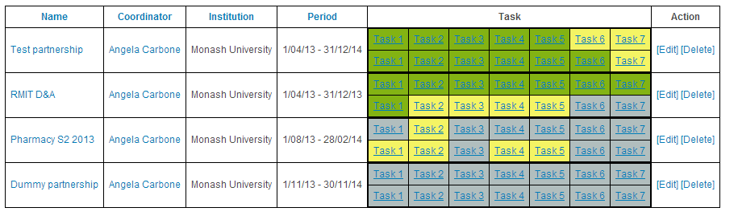

Figure 6 Example of a co-ordinator's view of their participants' task progress

PATS newsletters
To date there have been five issues of the PATS newsletter funded by the NSTF distributed via e-mail and uploaded to website (‘News & Events’ tab from PATS website). Earlier newsletters were funded by the ALTC and CADAD grants. There is an overlap of newsletters in late 2012 and early 2013, as the CADAD project was in the final stages of completion as the NSTF commenced.
Volume 3, OLT sponsorship
  - Issue 1, December 2012 – Overview of the three key questions of the fellowship program; program and research officers introduced.
  - Issue 2, April 2013 – PATS Co-ordinators from CADAD trial introduced; online PATS workbook available.
  - Issue 3, May 2013 – Report on focus areas for goals set by PATS participants; overview of the critical success factors for embedding PATS.
  - Issue 4, August 2013 – Report on PATS showcase at HERDSA conference; report on findings from debrief sessions with academics; combining PATS with the Learning Thermometer.
  - Issue 5, March 2014 – Report on the success of the OLT NSTF Symposium; participants’ success recognised.
Volume 2, CADAD sponsorship
  - Issue 1, May 2012 – External evaluator appointment; PATS project group members introduced.
  - Issue 2, October 2012 – Outline of the aims of the CADAD project; PATS project group members introduced.
  - Issue 3, February 2013 – Report on preliminary findings of the scheme for the five universities in the CADAD trial; investigative themes to emerge: barriers faced by academics, aligning peer review with academics’ needs, goals and strategies to improving teaching, and using informal student feedback.
Volume 1, ALTC sponsorship
  - Issue 1, August 2010 – Welcome and introduction to PATS and Associate Professor Angela Carbone.
  - Issue 2, October 2010 – Overview of the project aims; external reference group introduced.
  - Issue 3, December 2010 – Overview of the PATS process; report on changes to unit evaluations; PATS mentors introduced.
  - Issue 4, February 2011 – PATS mentors introduced; update on Monash participants.
  - Issue 5, April 2011 – Details provided of keynote speakers at upcoming ALTC Symposium; update on publications; extension grant received to further PATS project.
  - Issue 6, June 2011 – Report on success of ALTC Symposium.
  - Issue 7, August 2011 – Report on positive unit evaluation results; report of data analysis of student concerns.
  - Issue 8, October 2011 – Recommendations in the final ALTC report; introduction of the reciprocal partnership type.

The OLT NSTF PATS Symposium
The OLT National Senior Teaching Fellowship PATS Symposium held at Monash University, Caulfield campus on December 4, 2013, was attended by 90 participants from 27 institutions across Australia.
The symposium opened with an address by:
- Professor Adam Shoemaker, Deputy Vice-Chancellor (Education), Monash University and
- Associate Professor Angela Carbone, the National Senior Teaching Fellow, followed with an overview of the Fellowship and some of the key insights gained through the Fellowship.
Experiences of embedding PATS at different universities were presented by:
- Dr Steve Drew, Director of Learning & Teaching SEET Group (Griffith University),
- Mrs Kate Lindsay, Senior Lecturer, Newcastle Law School (The University of Newcastle), and
- Professor Sue Stoney, Head, Centre for Learning & Development (Edith Cowan University).

A panel answered audience questions regarding their experiences embedding PATS at their universities. The panel consisted of Dr Liam Phelan and Ms Bonnie McBain (The University of Newcastle), Dr Daryl D’Souza and Ms Astrid Bauers (RMIT University), Ms Helen Naug and Dr Eugene du Toit (Griffith University) and Dr Laurence Orlando and Dr Kris Ryan (Monash University).
Innovative approaches to embedding PATS were presented by:
- Dr Jo-Anne Kelder, Lecturer, Learning and Teaching Quality (University of Tasmania), and
- Dr Jacinta Ryan, Academic Head - Management (Kaplan Business School).
The day closed with presentations by Associate Professor Arnold Pears (Uppsala University) on measuring university learning in Swedish higher education and Ms Suzi Hewlett (Office for Learning and Teaching) on the future of OLT fellowships.
Over half the attendees were looking for ways to improve their organisation’s creativity and innovation in teaching and networking opportunities. The day was a great success with 80% of delegates rating the program and calibre of speakers as ‘very good’ or ‘excellent’. One participant stated:
’By hearing about all the different experiences [of PATS] I realised how big an impact can be made by codifying some relatively simple ideas into a well packaged program.’
and another stated:
‘Inspired by the different versions of PATS being implemented – not just a remedial process!’
See the PATS Symposium website (www.monash.edu/pats) for further information and Appendix E for program details.

Reference group meetings
Three reference group meetings were held in total during the Fellowship on the following dates:
- Initial Meeting: 4 December 2012
- Mid Fellowship program: 16 April 2013
- Towards the conclusion of the fellowship: 15 October 2013

Reporting to Monash University’s Learning and Teaching Committee
The progress of the PATS Fellowship has been reported on at three learning and teaching and education university level committees. Key recommendations included:
6 May 2014 - Minutes 3/2014 of the Learning and Teaching Committee, Introducing the item, Associate Professor Angela Carbone outlined the key findings of her OLT National Senior Teaching Fellowship, and sought the approval of LTC on the approval of the adoption of PATS being a strategic unit enhancement program at Monash University, which includes a unit effectiveness framework.
Professor Darrell Evans emphasised that PATS is the only strategic enhancement program currently available at Monash, although additional programs of activity were being developed.

Resolution:
- The Learning and Teaching Committee approved PATS as a strategic unit enhancement program at Monash University.

3 June 2013 - Minutes 3/2013 of the Learning and Teaching Committee, Associate Professor Angela Carbone provided Monash’ Learning and Teaching Committee with an update on the progress of the OLT National Senior Teaching Fellowship (NSTF), in particular the engagement with PATS across the sector;
Resolutions:
Learning and Teaching Committee:
- Approved the introduction of a Peer Assisted Teaching Scheme as a faculty-wide strategy to assist teaching improvement and curriculum enhancement for:
  - Early Career Development Fellows (ECDF);
  - new staff;
  - academics with units that are perceived as needing critical attention or improvement.
- Recommended that Associate Deans support implementation of the PATS process in their faculty via nomination of a PATS coordinator (preferably someone in an education focused role) and by supplying coffee vouchers, funding incentives, and time relief to engage in the process. PATS coordinators can play an advocacy role to engage Heads of Schools and Directors of Educational Quality in the process.

19 September 2012 - Meeting 6/2012 of the Education Committee, Associate Professor Angela Carbone presented to the Committee on the use of PATS as an initiative to improve unit quality and sought feedback from faculties on various proposals around program organisation and participation. Whilst a number of issues around implementation were raised, members were generally very supportive of the scheme, with a number indicating that similar initiatives were already embedded in faculty teaching practice. Promotion of the scheme as a positive, rather than punitive process was recommended and the importance of recognition of great teachers and teaching was emphasised.

Reporting to TEQSA – Provider registration
Monash University noted four references to the Peer Assisted Teaching Scheme (PATS) in their renewal for Provider Registration 2012. This included:
Section 3: The higher education provider shows sound corporate and academic governance of its higher education operations. Effective quality assurance arrangements for all the higher education provider’s higher education operations, encompassing systematic monitoring, review and improvement.

- Part 3 Evidence in Respect of Provider Registration Standards
Data shows how the Faculty of Information Technology has responded to low SETU scores in some units by referring staff to the Peer Assisted Teaching Scheme (PATS) and how this has resulted in improved SETU outcomes.

Section 2/4 Part 4: The higher education provider shows sound corporate and academic governance of its higher education operations. The higher education provider identifies and implements good practices in student teaching and learning, including those that have the potential for wider dissemination nationally.

- Part 4 Evidence in Respect of Provider Category Standards
Peer Assisted Teaching Scheme (PATS) facilitates two or more colleagues within the same faculty, to collaborate to improve the quality and student satisfaction within identified units. It also aims to build leadership capacity in currently recognised outstanding teachers. The program has been informed by current research that highlights the benefits of peer assisted learning programs.

Section 3 Part 6 - The higher education provider ensures that staff who teach students in the course of study are appropriately qualified in the relevant discipline for their level of teaching (qualified to at least one Qualification Standards level higher than the course of study being taught or with equivalent professional experience).

- Part 6 Bachelor of Early Childhood Studies
Teaching evaluations through Student Evaluation of Teaching and Unit (SETU) are confidential to the staff member. Staff are required by the University to share the teaching outcomes with the supervisor who assists the staff member with any professional development needs and refers staff to support options as appropriate. Part 3.3, Provider Registration Standard 3.8 provides a summary of the Student Evaluation of Teaching and Units improvement process which applies to the Bachelor of Early Childhood Studies. Should any staff present with units in the “red band” on more than one occasion, they are referred to the University’s Peer Assisted Teaching Program for support and professional development. See pp. 17-18 of the Self Review report for recent responses to student feedback at Attachment 6.1b: Course Review of the Bachelor of Early Childhood Studies.

Section 3 Part 6 The higher education provider ensures that staff who teach students in the course of study are advised of student and other feedback on the quality of their teaching and have opportunities to improve their teaching.

- Part 6 Bachelor of Engineering.
Informal mentoring occurs across the Faculty. More formal mentoring is provided through the Peer Assisted Teaching Scheme (PATS).

Social media
There is a @EduPATS Twitter account (http://twitter.com/EduPATS) which has been used to disseminate information about the scheme, highlight achievements of participants, share stories from the Symposium (using #PATSymp) and allow participants to network cross-institutionally.

PATS resources
In order to facilitate ongoing participation of PATS by universities around Australia, both a PATS Co-ordinator and a PATS Mentor Starter Kit were created. These and other resources are available online (‘PATS Resources’ on www.monash.edu/pats) and provide co-ordinators and mentors with the requirements, timeline, available support, and resources necessary to implement and use PATS in their institutions.

PATS Co-ordinator Starter Kit
The PATS Co-ordinator Starter Kit consists of the following:
- PATS Co-ordinator checklist
- The PATS process diagram
- Website user guide
- Invitation to participate flyer
- PATS initial briefing PowerPoint
- Mid-semester catch up question guide
- End of semester debrief question guide
- Relevant workshops for PATS participants (Monash University only)
- Acknowledgement letters
- Resources for mentors

PATS Mentor Starter Kit
The PATS Mentor Starter Kit consists of the following:
- PATS overview and process
- PATS mentoring responsibilities
- Task 2 – Identifying the barriers
- Task 3 – Setting achievable goals
- Task 4 – Closing the student feedback loop
- Task 5 – Peer review of teaching
- List of workshops (Monash University only)
- Literature on mentoring
- Resources for mentors: mental health and counselling (Monash University only)

PATS Participant Instructional Workbook
- Website user guide for participants
- Timetable for scheme
- Task description, instructions and resources
- Course Quality Attributes – flyer
- Challenging the type of activity – flyer
- Breaking down the barriers – flyer
- A framework for setting goals – flyer
- Closing the student feedback loop – flyer
- Peer observation of teaching – flyer

PATS website
The information available on the PATS website (www.monash.edu/pats) is summarised in Table 31, where each cell represents separate pages. Appendix H shows a screen capture of the homepage of the PATS website, while Appendix I shows one of the tasks from the online workbook.
Table 31 Outline of the PATS website structure
Home | OLT Fellowship | About the OLT Fellowship: Fellowship objectives, reference group members
About PATS | What is PATS? | Describes the scheme, includes video introduction from Fellow
About PATS | Background | Initial inception of scheme, previous projects which underpin Fellowship
About PATS | PATS Partnerships | Modes of operation for partnerships
About PATS | PATS Process | Clickable image of PATS process encompassing pre-semester, during semester and post-semester tasks
About PATS | PATS Resources | Resources for ADEs/HoS, PATS Co-ordinators, PATS mentors, PATS participants
Impact of PATS | Changes in UE Results | Changes in unit evaluation scores for units undertaking PATS, include Monash and external institutions
Impact of PATS | PATS Experiences | Videos from a range of PATS participants exploring: embedding PATS; building collaborative relationships; and PATS in action
Impact of PATS | Unintended Outcomes | Grants, awards, events and papers from previous PATS participants
Impact of PATS | Outreach | Lists the range of institutions involved in PATS since its inception in 2009
Impact of PATS | Publications | Journal articles, conference papers and other reports published about PATS
News & Events | Newsletters | All issues of the PATS newsletter including those from previously funded projects, e.g. CADAD, ALTC
News & Events | Events | Dissemination activities and conferences attended to present on PATS
News & Events | PATS Symposia | Details of the OLT and ALTC symposia including programs, posters, recordings of presentations and speaker details
Contact Us |  | PATS team contact details


To date (as at 7 August 2015) the website has attracted nearly 5,100 visitors mainly from Australia, but with countries including the United States, Canada, the United Kingdom, Russia, Malaysia, Brazil, India, Singapore and Sweden as shown in Figure 7.

Figure 7 Locations where the PATS website has been accessed (as at 7 August 2015)

PATS resources for faculty executive
- Decision points for Senior Management (Appendix F)
- Sample Policy for Management (Appendix G)

PATS ongoing support
- Fellowship consultancy has started with Swinburne University of Technology and Holmesglen Institute of TAFE.
Following on the successful OLT National Senior Teaching Fellowship, Associate Professor Angela Carbone is pleased to offer the Peer Assisted Teaching Scheme (PATS) for institutions wishing to:
- enhance the student learning experience
- improve unit evaluation scores
- share teaching innovations
- overcome educational barriers in a supportive, collegial environment
Further information, including past results, about the scheme can be found at www.monash.edu/pats
We are contacting you as a result of previous participation in PATS or through expressions of interest registered with us directly or at the recent PATS Symposium.
Feedback throughout 2013 suggests that the most sustainable way to introduce and embed PATS in your institution is through appointing a series of PATS Coordinators at faculty level (often a staff member in a senior education focussed role, e.g. Director Education Quality or equivalent). The PATS team at Monash can provide resources to support implementation including PowerPoint presentations, workbooks and checklists.
Ange is also available to deliver tailored face-to-face workshops introducing the PATS process and outlining an implementation plan for your institution/faculty.
Please contact Associate Professor Angela Carbone for further information.

Conclusion and Future Work

Overview
The final chapter of the fellowship program reports on the impact of the fellowship on three key individuals: the Fellow, the Project Officer and the Research Assistant. It highlights potential areas for future work and some key lessons learnt from the experience.

Reflections

Reflections from the National Senior Teaching Fellow (Associate Professor Angela Carbone)
‘My fellowship has been a rewarding experience. I am particularly grateful to the Australian Government’s Office for Learning and Teaching and the Australian Learning and Teaching Fellows – a network of talented academics that are geographically dispersed across the country. It has been an honour to have engaged with them and their projects and develop a rich understanding of opportunities and challenges that face the higher education sector.
I am particularly pleased that the prestigious OLT fellowship programs have been formally recognised by the Australian Government as Category 1 type funding - now on par with the Australian Research Council in terms of providing funding. This is a significant issue for several reasons: first, it raises the status of learning and teaching nationally; second it provides teaching fellows with the capacity to claim the national competitive status of their fellowship and third, it limits the possibility of individual fellows being branded as research inactive by their home institution.
There is fair evidence of impact through the high take-up of the PATS idea from other institutions in the country, with other overseas institutions (Auckland University of Technology, New Zealand) and Australian TAFEs (such as, Holmesglen Institute of TAFE) more recently coming on board. Given the distinctive employment landscape in Australian Higher Education (large casual/sessional workforce that handles a lot of the teaching), my work is an enabler for our tertiary institutions to be internationally competitive through systemic improvement of teaching outcomes.’
More specific opportunities that my fellowship has offered include:-
Research
- Strengthened my research and that of others (applying peer-learning frameworks to improve academic practices; new knowledge developing unit effectiveness framework)
- Invitations to be a reference group member for two potential OLT Teaching fellowship programs in 2014, of which one was successful:
Dr Elizabeth Beckmann’s (Australian National University) project Professional Recognition and Self-Efficacy in University Teachers as Tools to Enhance Teaching Quality (2014).
This National Teaching Fellowship explored the potential for a broad-based professional recognition strategy to foster reflective practice, peer engagement and innovation in university teaching (successful OL Teaching Fellowship 2014).
- Invitations to participate in promoting the OLT fellowship scheme (New fellows Orientation; HERDSA showcase, 2014)
- Invitation to be on OLT commissioned projects including: Developing graduate employability through partnerships with industry and professional associations (2013) and Plagiarism and related issues in assessments not involving text (2012).
- Recruited a student interested in undertaking a doctorate (PhD) on how academics learn to teach. She approached me after my HERDSA presentation (Ms Cathryn McCormack, PhD admission to Monash University, May 2013).
Education
- Invited to be on a number of several course review panels (CQUniversity’s Graduate Certificate in Tertiary Education, 2014; Northern Melbourne Institute of TAFE’s Teaching and Learning Committee, 2013) and advisory roles (Deakin Graduate Certificate in Higher Education, 2014).
- Accepted as a Tertiary Education Quality Standards Association (TEQSA) expert assessor (completed two accreditations and renewals in 2013 and 2014).
- Empowering academics to become effective teachers through the developed understanding of a teaching and unit effectiveness framework.
- Developing a new form of professional development at a time of increased casualisation of the academic workforce.
Service
- A strengthened relationship with OLT and the Australian Learning and Teaching Fellows network.
- Invited to be Head of Monash’s first non-residential college, Pegasus College.
- Invited to lead one of the major conferences concerned with advancing the Scholarship of Teaching and Learning movement globally - the International Society for the Scholarship of Teaching and Learning (ISSoTL) Conference 2015.
- Invited to be on Editorial Advisory Board, ACM Inroads Magazine
- Act as a mentor for new OLT National Teaching Fellow (2014).
- Assisted in the program development of the interactive sessions for the Office for Learning and Teaching’s (OLT) inaugural two-day conference ‘Learning and teaching for our times – higher education in the digital era’ at Dockside Pavilion, Darling Harbour in Sydney on 10 and 11 June 2014.

A letter of support
I just wanted to drop you a note to say that I really appreciate you inviting Griffith University to engage with the PATS program and ALTC fellowship activities that you have created. Since your original presentation to ACDICT a number of years ago, and your kind invitation to attend your symposium on peer assistance strategies in Higher Education, I have promoted the possibility and value to Griffith of adopting the PATS program.
Since undertaking the PATS trials in 2012 the program has gained immense popularity from the DVC(A) and at every level down to our hard working academics. The trial of 7 academic pairs in 2012 expanded to 22 academic pairs in 2013 and looks to grow again into the next semester. It is apparent that it has potential for great impact on courses/units and teaching improvement as well as the students experience of learning. There are early indications that there will be improvements across the board in student evaluations. At debriefing with two academics yesterday there was an improvement of 0.8/5 in the course where PATS was undertaken. Students felt that they owned the course and evaluated it accordingly. In the same course with the same teacher running at another campus there was no discernible improvement so PATS creates a positive social dynamic from the student and peer perspectives.
In particular I want to thank you for your invaluable support and enthusiasm in assisting us to progress the adoption and embedding of PATS (our PACES). Your presentation was instrumental in gaining management and L&T portfolio engagement.
I would also like to thank you for your strong leadership in our fortnightly collaborations on scholarly articles to disseminate practices, philosophy and experiences in stages of the PATS development. Apart from the scholarship, which is important, engagement in analysis and reflection on scholarly outputs provides a valuable depth of knowledge into the PATS process that further assists its effective implementation at Griffith University.
I hope that this finds you well and I look forward to our ongoing discussions about peer led development.
Kindest regards,
Dr Steve Drew
Director, Learning and Teaching
Griffith Sciences, Griffith University

Reflections from Project Officer (Ms Joanne Rae)
‘The NST Fellowship has been extremely interesting and rewarding to work on and has enabled me to understand some of the challenges facing university teachers today. Management of the project logistics was often challenging especially in a climate where so many excellent initiatives are competing for academics' already stretched time. It was, however, very valuable to be able to interact with academics from across Australia, many of whom are passionate about quality teaching and learning.
I have gained several new skills including experiences with Moodle, through the development of the PATS website.
The highlight for me was the 2013 PATS Symposium which not only enabled me to meet the interstate colleagues whom I had been corresponding with throughout the year, but also honed my event management skills. The latter has enabled me to progress to a role as Event Coordinator for the 2015 ISSOTL conference in Melbourne.’

Reflections from Research Officer (Dr Bella Ross)
‘The opportunity to work as a research officer on such a project has afforded me with rich opportunities to explore the issues faced by teaching academics across Australia. I have gained valuable insights into the various aspects of teaching that academics focus on and the challenges they face on an everyday basis.
In addition to the exposure to academic teachers from a wide range of disciplines across Australia, I have been exposed to the research literature on the topics covered, which has enhanced my thinking on various topics within higher education.
The experience has been of great value personally and had a direct impact on my career prospects – most notably in my recent appointment as a full time researcher in learning and teaching in higher education at a different university.’

Future work
Around 36 higher education institutions, including those who have already trialled PATS in the past, have expressed interest in undertaking their own version of PATS in 2014 and beyond. These providers include amongst others CQUniversity, Queensland University of Technology, Australian Catholic University, University of Western Sydney, Victoria University, Murdoch University, Auckland University of Technology (New Zealand) and Holmesglen Institute of TAFE.
Feedback throughout 2013 suggests that the most sustainable way to introduce and embed PATS in an institution is through the appointment of a PATS Co-ordinator at faculty level (often a staff member in a senior education focussed role, for example, Director Education Quality or equivalent). The PATS team at Monash can provide resources to support implementation including PowerPoint presentations, workbooks and checklists. The model of external implementation will be similar to Monash with training and support provided to local PATS Co-ordinators who will be responsible for in-house implementation. The Fellow is available to deliver a tailored face-to-face workshops introducing the PATS process and outlining an implementation plan. These local workshops/training for interested institutions will be on a fee-for-service basis and the PATS website is already available to external users.
Publications: Several publications are currently under review and in progress, as outlined in section 6.3.2 – Refereed journal and conference papers.
Book: A book on Maintaining High Quality Teaching and Subject/Unit Standards is planned, but will depend on whether the fellow can apply for six months study leave after the Fellowship, to provide the necessary time to complete a draft.

The Fellow is also providing advice to the TAFE Sector, which includes the Holmesglen, Melbourne Polytechnic (formally NMIT), Chisholm TAFE, Box Hill Institute of TAFE, William Angliss Institute, VET Development Centre. A Mixed Sector Symposium is scheduled in December at Box Hill Institute of TAFE. This event will address the challenges, opportunities, practicalities and philosophies of higher education in TAFE.

Research directions
Trialling new flavours of PATS
PATS has been trialled across 11 institutions and for many it is the only strategic unit enhancement program. For those faculties that have taken ownership of the scheme, it will be run ‘in-house’ by a nominated PATS co-ordinator and supported by colleagues from the university’s central unit. For others, PATS will need to be customised for their specific context in order to accommodate different purposes, diversity of teaching staff participants and variations in the PATS process.
The variations of PATS can relate to:
- Variations in purpose (quality improvement, quality assurance, SOTL).
- Variations in people (peer partnership model, employment category, mode).
- Variations in process (timeframe, scope, deliverables).

As a result of 2014 OLT Extension Grant, the University of Tasmania will lead an exploration of further PATS ‘flavours’ with several other Australian higher education partners to produce a set of guides that outlines how PATS can be used to:-
- Reinvigorate large complex units (uPATS)
- Engage academics in the scholarly practice of teaching and learning (sPATS)
- Improve unit and teaching quality (qPATS), and
- Provide support for online teaching (ePATS); sessional staff teaching online postgrad course (popPATS) and course teams (cPATS).

In addition, Auckland University of Technology (AUT) in New Zealand, are looking to embed the scheme within their Design and Creative Technologies faculty. Their intention is to:-
- Develop research-led teaching
- Improve teaching and learning resulting in increased student success and retention
- Embed Matauranga Maori indigenous culture within existing programs
- Develop the skills and capabilities of teaching assistants and/or teaching teams comprising teaching assistants, and
- Improve student satisfaction.
More locally, Holmesglen Institute of TAFE, has expressed interest in applying PATS to develop capacity in their staff around the themes outlined in the VET Practitioner Capability Framework: Systems and compliance; industry and community collaboration; teaching and assessment.
Measuring the depth of change
There is much discussion within the sector around the value of current teacher preparation programs and forms of professional development. From the Australian government’s perspective, they want to see that measures are being taken by universities to ensure quality teaching is maintained and enhanced. PATS is described as a unit enhancement scheme aimed at fostering reflective practice, peer engagement and innovation in university teaching. However further investigation is required to explore the depth of change, that is, has PATS improved academics’ pedagogical knowledge capabilities, skills and values, and does it encourage greater self-efficacy in their roles as teaching professionals.
Frameworks for teaching and unit quality
There are many ways to teach well, and many contingencies to be dealt with, including: students engaging part-time versus full-time, the impact of the widening participation agenda, students’ preparedness for study, and the increasing use of on-line and blended learning, that put different burdens on teaching practice. As a consequence, the sector does not have a unified picture of teaching and unit quality, and is in need of conversations that tighten our understanding of teaching and unit quality.
This fellowship makes a small contribution in developing a common language in which quality units can be described, however further discourse is needed within the sector.

Lessons Learnt
Many lessons were learnt from undertaking the fellowship. These include measuring the impact of PATS, hosting and developing the PATS website, gathering data from busy academic and planning considerations for senior management.

Measuring the impact of PATS
When reporting on the impact of PATS, attention needs to be directed to a number of dimensions of impact. By focusing on impact in terms of scaling up (that is, number of institutions trialling the scheme) alone can neglect other qualitative measures that may be fundamental to measuring the true impact of the scheme. Expanding PATS into multiple settings is a necessary but insufficient condition for impact, and scaling up not only requires spread to additional sites, but also consequential change in units and endurance over time. Given the duration of the fellowship, changes in units are reported in points of time without deeper considerations to the other elements that define impact.

There is a growing body of work that raises questions about traditional definitions of impact, suggesting, among other things, the need for greater attention to the depth of implementation and a shift in reform ownership. Consequently, further work is needed in assessing the impact of PATS across four interrelated dimensions proposed by Coburn (2003):
- Depth. Meaning change that goes beyond surface structures or procedures (such as changes in materials, classroom organisation, or the addition of specific activities) to alter teachers’ beliefs, norms of social interaction, and pedagogical principles.
- Sustainability. Change must be sustained. The concept of scale primarily has meaning over time. The distribution and adoption of an innovation are only significant if its use can be sustained.
Spread. Rather than thinking of spread solely in terms of expanding outward to more and more institutions, emphasis on the normative highlights the potential to spread reform-related norms and pedagogical principles within a faculty of institution. For example, at the faculty level, spread not only involves increasing the number of schools/departments that participate, but also the ways in which reform norms and principles influence faculty policies, procedures, and professional development
- Shift in reform ownership. Ownership over the reform must shift so that it is no longer an ’external’ reform, controlled by a reformer, but rather becomes an ‘internal’ reform with authority for the reform held by institutions, faculties, schools, and teachers who have the capacity to sustain, spread, and deepen reform principles themselves.

Website hosting – externally or internally?
A key decision in any fellowship or grant project is whether to purchase an external domain name and whether to host the site internally within the current institution or externally. In seeking advice from four previous fellowship holders (Professor Les Kirkup, Professor Geoff Crisp, Professor Betty Leask, Dr Keith Willey), all advised to host the website externally for a number of reasons. I list the benefits and considerations of external hosting versus internal hosting.
Benefits of External Hosting
- Get an easy and simple URL that would not change over time.
- Easier to get the website set up.
- Rapid response time to getting things changed.
- More freedom to have the website the way you want it, universities generally put a lot of restrictions on what you can and cannot do if they ‘own’ your website.
- Backup services and upgrades are provided by the server company.
- One university does not ’own’ the domain which is a definite consideration if you are planning to move to other universities in the future.
- Gives you the potential to use the domain name for consultancy otherwise it can get messy legally and financially if the university has an interest in your domain name and website.
- The wheels turn too slowly to get a website up and running within a reasonable time period.
- You do not need to use university staff or resources to build the website.
Considerations
- The fellow will be responsible for ongoing costs, which, although not huge, might be an issue at a later stage.
- The fellow can pay their domain name costs several years in advance, (five years is not expensive). It also possible to prepay your server company while you have project money, however this can be more problematic should the company go out of business.
Having sought the advice, I decided to host the website internally (within Monash) and did not purchase a public domain name. In hindsight, I should have followed the advice from the previous fellows for the reasons I list below:
- Receiving permission from Monash University to have the PATS website hosted on a Monash University server was a long and drawn out process.
- The PATS URL which I had envisaged to remain unchanged, was forced to change due to a university-wide change in domain naming conventions.
- The appointment process for a casual web-developer was an administratively cumbersome process.
- There was a security breach which required a Moodle upgrade that was not supported by the institution (as PATS was not seen as its core business) so I had to re-appoint my web-developer whose contract had expired, to fix the issue otherwise the whole website would be taken off-line within 2 days.

Gathering data from busy academics over the duration of the semester
Prior to the online workbook being developed, academics were asked to submit their completed tasks as part of the data collection exercise. The data was submitted in various formats including: emails, text messages, scanned sheets, complete workbook tasks. Managing the data became difficult prior to the online repository being developed. However, although the data is currently captured in the same format and easier to manage, the difficultly lies in getting academics to find the time to log into the online workbook and complete the tasks online. As such it has been a challenging process to ensure that all PATS participants provide the necessary completed tasks for analysis and engage with the research component of the fellowship.

Planning considerations for senior management
One of the biggest considerations for most senior management is how to invite participants to contribute when demands facing academics are increasing. This is mainly overcome by institutions confidently communicating their structures, policy and resources to support and reward the scheme. For example:
- Establishing a faculty program oversight structure and policy, this might include a suitable steering committee and forum for the program.
- Resourcing identified and committed, for example a PATS co-ordinator role is established, school contact, initial pilot of PATS to will address the pertinent themes;
- A plan for how the scheme might be launched within each school with key steps and milestones identified and a viable timeline established.

Recommendations
Recommendation 1: Senior leaders in higher education should consider PATS (or adaptions of PATS) as a strategic program aimed at improving units and teaching quality. PATS can be promoted as a form of teaching quality support that is endorsed within the faculty and centrally within the institution. Underlying this is the need to train staff and performance supervisors in mentoring techniques and how to establish educational/teaching goals that are specific, measurable, attainable, relevant and timely. PATS tasks require discussion and support around how goals would be achieved and measured.
Recommendation 2: A distributed leadership approach is recommended to ensure the longevity of the scheme. This requires a healthy mix of senior manager support through policy reform and implementation, an appointed PATS Co-ordinator to ensure the momentum continues and quality is ensured, and participants to engage and benefit from the scheme.
Recommendation 3: Higher education institutions should adopt a multi-lens approach to measuring improvements in unit quality, teaching excellence and scholarly teaching. Student feedback should not be the only lens in which teaching is evaluated. Institutions need to support a multi-lens approach, which includes peer observation and ongoing student feedback. Peer observation needs reconsideration, and in-flow peer review should be considered and applied to multiple deliverables and stages as teaching is still in progress. Student feedback should not be left to the end of semester. Student comments and ideas should be captured and closed off (closing the feedback loop) within the teaching semester timeframe.

Appendix A: Survey 1, PATS Management Survey
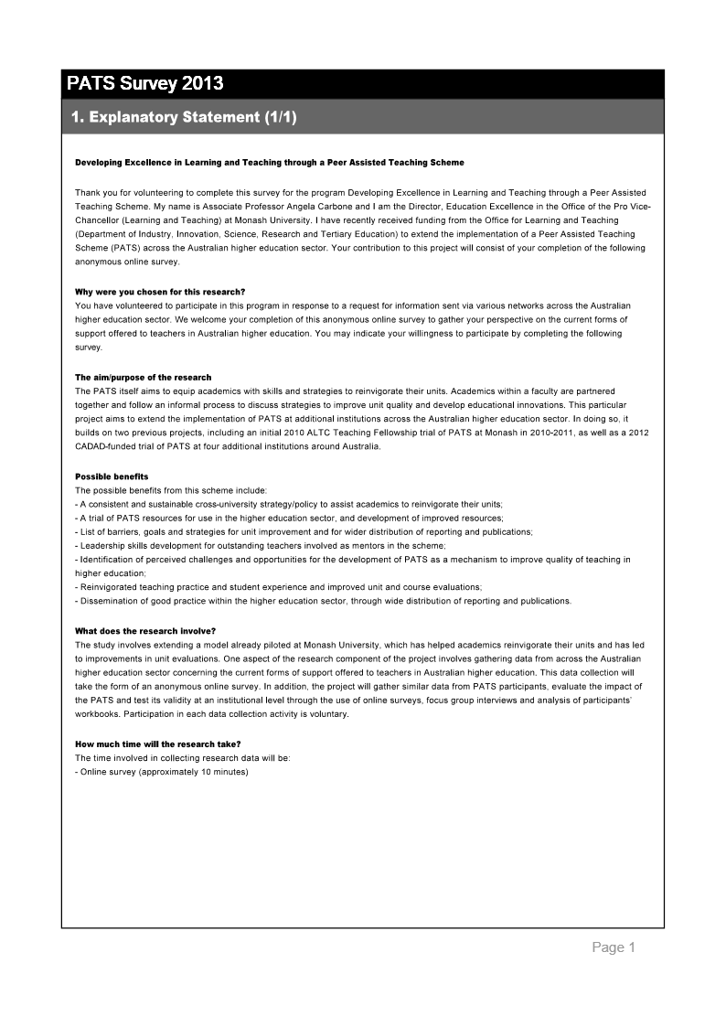
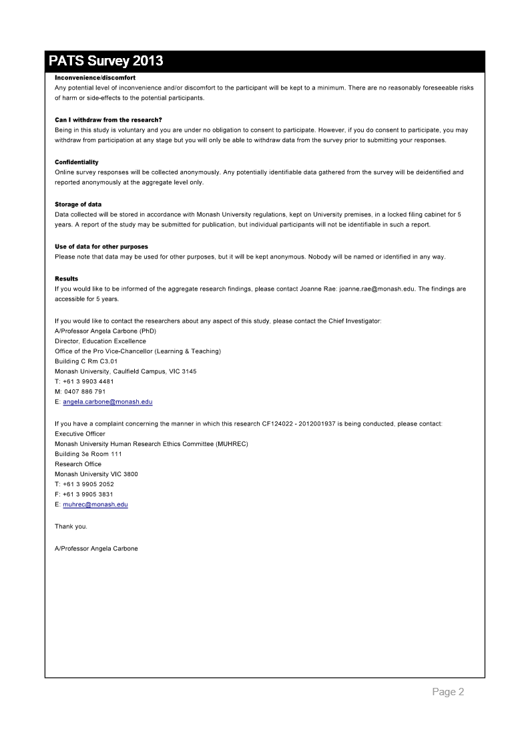

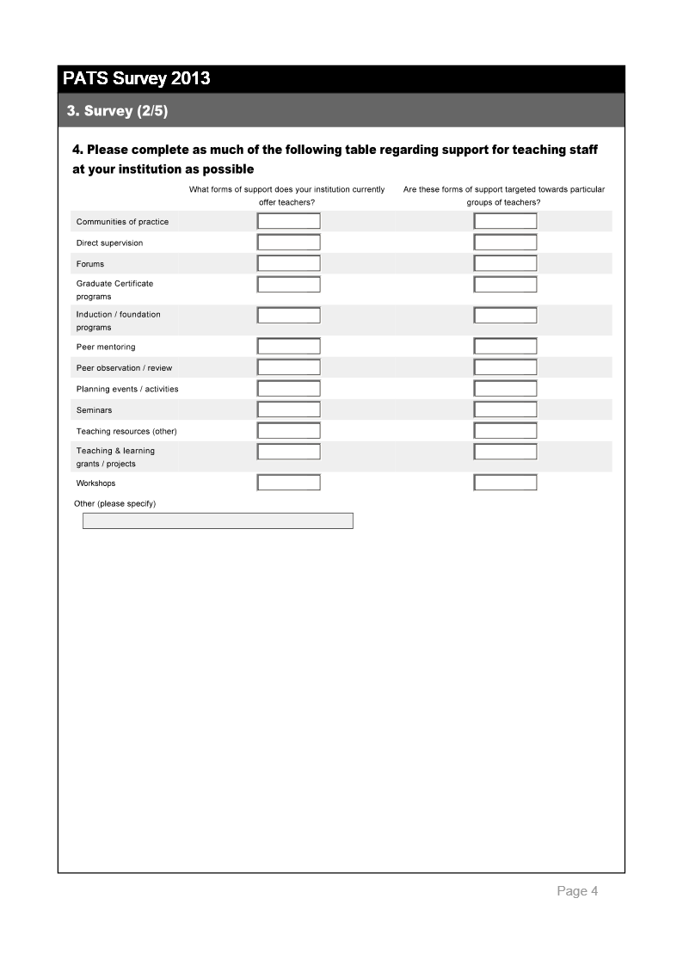

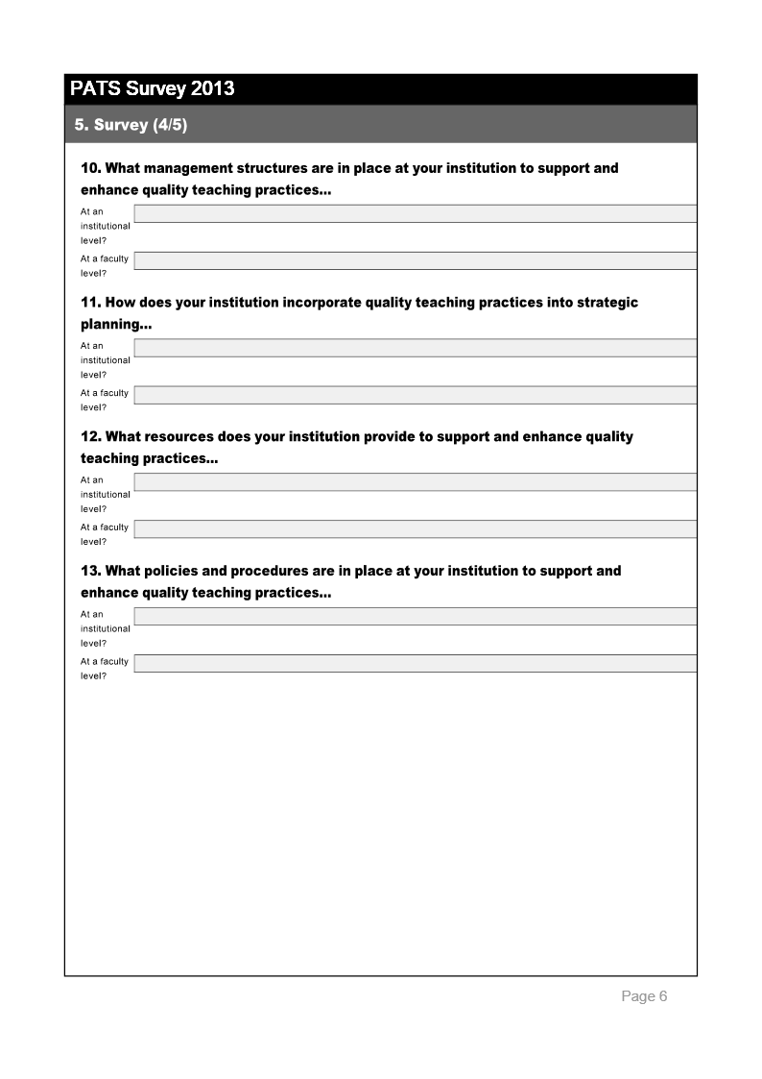
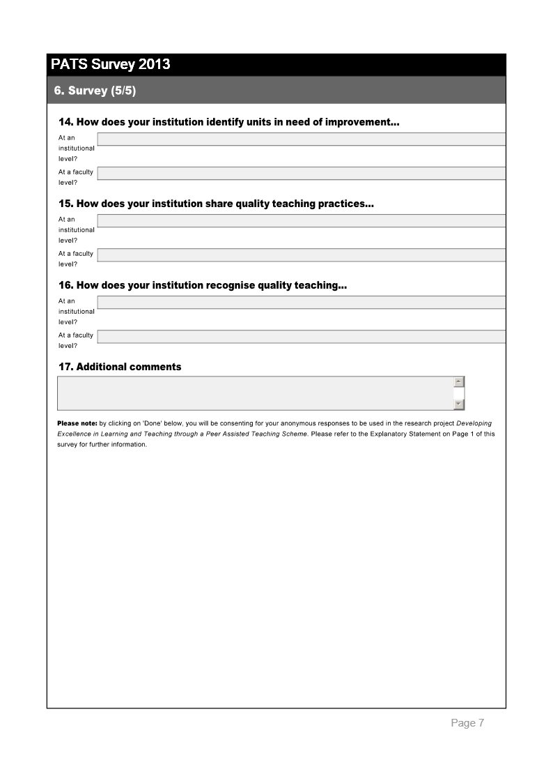

Appendix B: Survey 2, PATS Participant Survey
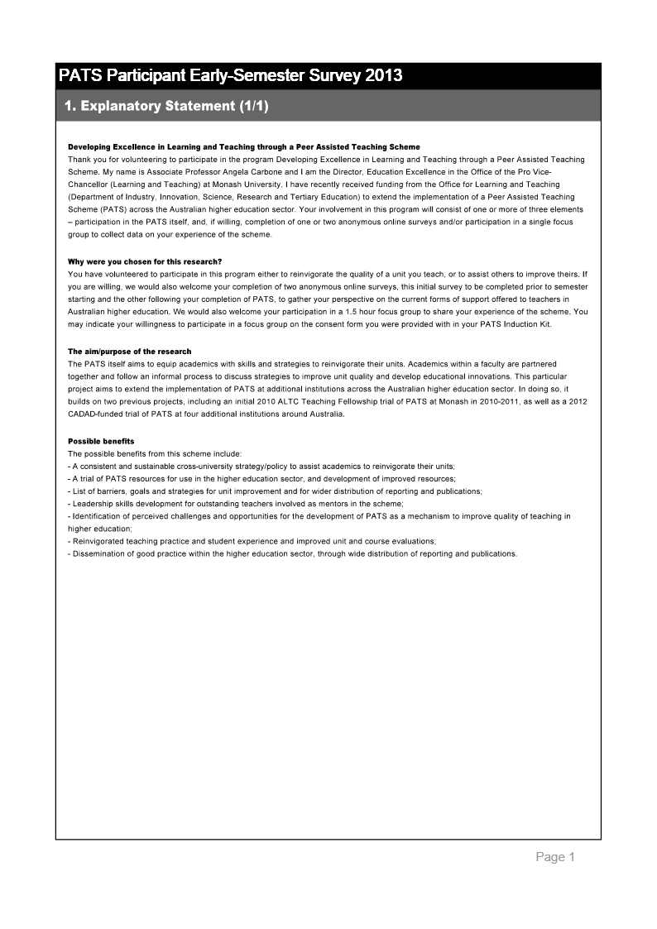
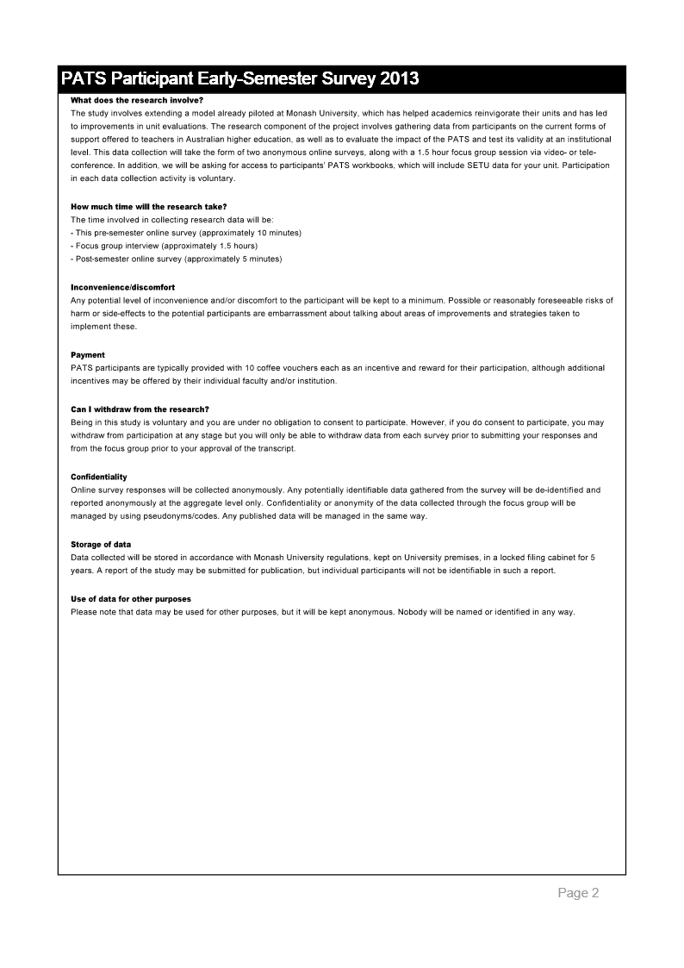
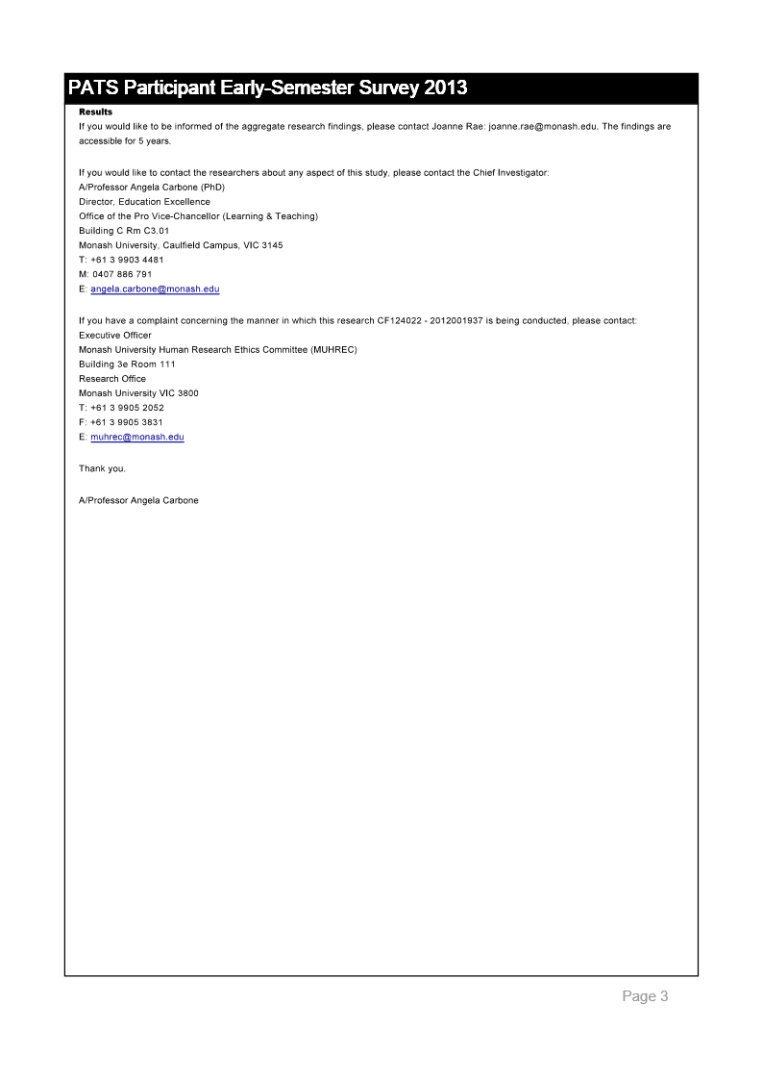
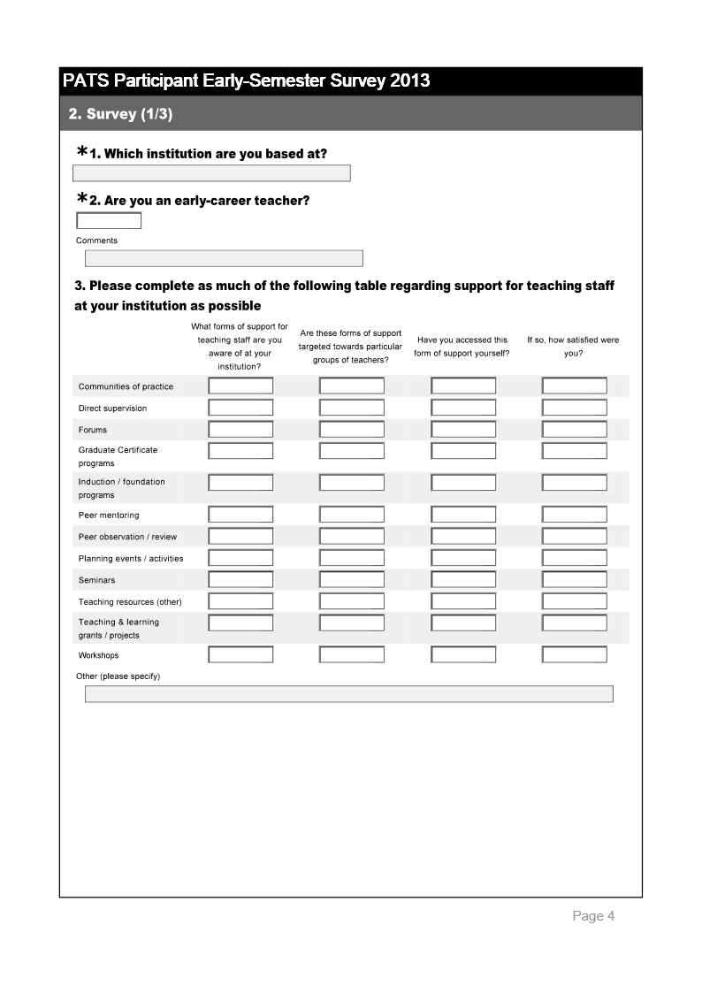

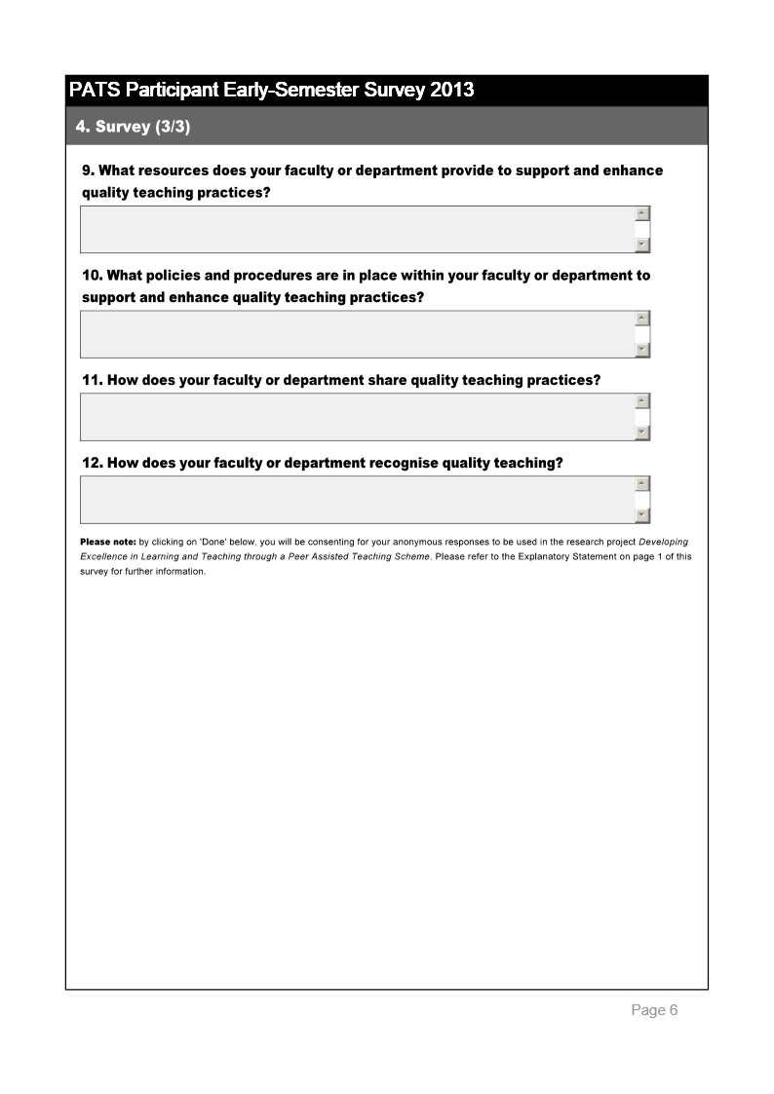

Appendix C: Progress Results for the PATS 2013 Trial
Institution | Unit | Task 1 | Task 2 | Task 3 | Task 4 | Task 5 | Task 6 | Task 7
Charles Sturt University | SCI101-SAWS | X | X | X | X |  | X | X
Charles Sturt University | PSC102-WI | X | X | X | X | X | X
Charles Sturt University | PSC102-WD | X | X | X | X | X | X
Griffith University | 2008MSC-MS | X | X | X | X |  | X | X
Griffith University | 2008BPS-BPS | X | X | X | X | X | X | X
Monash University | MGX9720-BE | X | X | X
Monash University | PSC3201-PPS | X | X | X | X | X | X | X
Monash University | MKF1120-BE | X | X | X | X |  | X | X
Monash University | MGW2601-BE | X | X | X | X | X | X | X
Monash University | MKW1120-BE | X | X | X | X |  | X
Monash University | MEC4456-ENG | X | X |  | X | X |  | X
Monash University | TRC4800-ENG | X | X |  | X | X |  | X
Monash University | FIT5086-FIT | None | None | None | None | None | None | None
Monash University | ATS2705-ART | X | X | X | X | X | X | X
Monash University | ATS3705-ART | X | X | X | X | X | X | X
Monash University | ATS2743-ART | X | X | X | X |  | X | X
Monash University | PSC3202-PPS | X | X |  | X | X
Monash University | PSC2232-PPS |  | x
Monash University | FIT4005/ (5185)-FIT | X | X | X | X | X | X
Monash University | FIT5185/ (4005)-FIT | X | X | X | X | X | X
RMIT University | COSC1073-CSIT | X | X | X | X | X | X | X
RMIT University | COSC2362-CSIT | X | X | X | X | X | X | X
RMIT University | ISYS1108-CSIT | X | X | X | X |  | X
Think Education | TOU101 | X | X | X | X | X | X
Think Education | MGT102 | X | X | X | X | X | X
Think Education | HOS203 | X | X | X
Think Education | HOS201 | X | X | X
Think Education | MKT102 | X | X | X
University of the Sunshine Coast | NUR341 | X | X | X | X | X | X | X
University of the Sunshine Coast | PSY101 | X |  | X |  | X
University of the Sunshine Coast | SWK401/2 | X | X | X | X | X | X | X
University of the Sunshine Coast | NUR121 | X | X | X | X | X
University of South Australia | INFT1012-ITMS | X | X | X | X |  | X | X
University of South Australia | INFS5057 |  | X | X | X |  | X
Kaplan Higher Education | EAP100 | X | X | X
Kaplan Higher Education | MAN1000 | X | X | X
Kaplan Higher Education | ECO1003 | X | X | X
Macquarie University, City Campus | ACCG224 | X | X
Macquarie University, City Campus | BUSL301 | X | X | X | X | X | X | X
University of Tasmania | CNA765 | X | X | X | X | X | X | X
University of Tasmania | CNA767 | X | X | X | X | X | X | X
University of Tasmania | CNA699 | X | X | X | X | X | X | X
University of Tasmania | CNA111 | X | X | X | X | X | X | X
University of Tasmania | CNA319 | X | X | X | X | X | X | X
University of Wollongong | TBS984 | X | X | X | X | X | X | X
University of Wollongong | TBS950 | X | X | X | X | X | X | X

Appendix D: PATS Overview Postcard

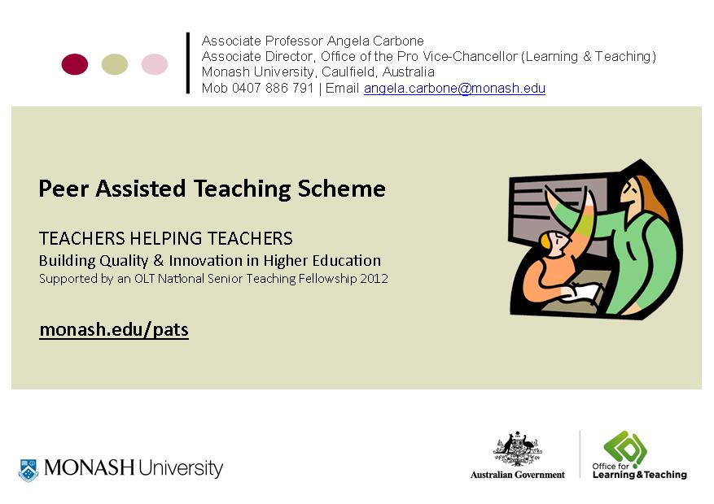
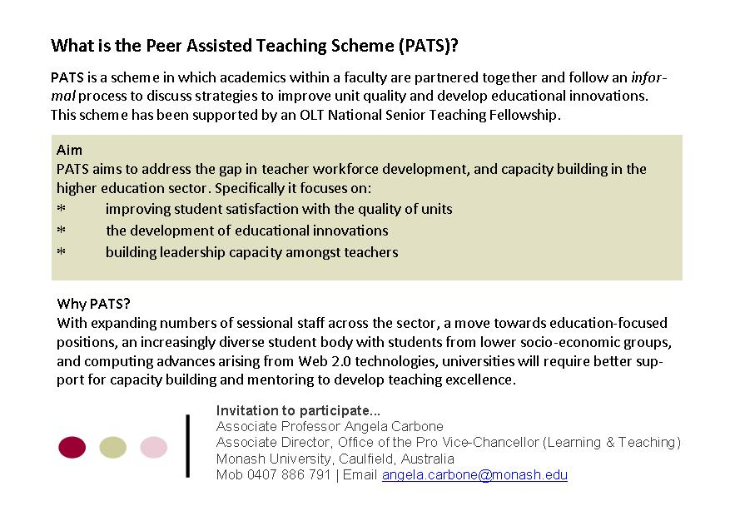

Appendix E: PATS Symposium Program
Wednesday 4 December, 11.00am - 5.00pm, Monash University, Caulfield
The symposium showcased results from the OLT National Senior Teaching Fellowship -Developing Excellence in Teaching and Learning through a Peer Assisted Teaching Scheme. and provided opportunities to learn more about participants' experiences of PATS, share ideas and innovations in teaching and learning and discuss potential collaborations around the scholarship of teaching and learning.
Introduction
- Opening address - Professor Adam Shoemaker, Deputy Vice-Chancellor (Education), Monash University.
- Developing Excellence in Learning and Teaching through a Peer Assisted Teaching Scheme (PATS) - Associate Professor Angela Carbone, Monash University.
Embedding PATS
- The PATS experience in the Faculty of Business and Law at The University of Newcastle: Supporting professional development and building collegiality - Ms Katherine Lindsay, Newcastle Law School.
- PACES is PATS with a course enhancement spin - Dr Steve Drew, Griffith University.
- PebblePATS - Professor Sue Stoney, Edith Cowan University.
Q&A Panel: PATS participants’ experiences
- Dr Liam Phelan and Dr Bonnie McBain, The University of Newcastle
- Dr Daryl D’Souza and MsAstrid Bauers, RMIT University
- Dr Helen Naug and Dr Eugene du Toit, Griffith University
- Dr Laurence Orlando and Dr Kris Ryan, Monash University
PATS Initiatives
- PATS and the Learning Thermometer - Dr Glen Croy, Monash University.
- The different flavours of PATS - Dr Jo-Anne Kelder, University of Tasmania.
- The different flavours of PATS - Dr Jacinta Ryan and Ms Jacqui O'Toole, Kaplan Higher Education.
Closing
- Measuring university learning: Reflections on the recent review of degree programs in Swedish higher education – Associate Professor Arnold Pears, Uppsala University.
- The future of OLT fellowships – Ms Suzi Hewlett, Office for Learning and Teaching.

Appendix F: PATS Senior Management Decision Points

Who will participate?
- All staff – new staff – sessional staff – tutors – staff with low UEs – ECDF – other

What will be the policy regarding participation?
- Optional – strongly encouraged – mandatory

What form will the process take?
- Mentor/mentee – reciprocal partnership

Who will act as mentors?
- Teachers with education focus – outstanding teachers – colleagues within same organisational unit – colleagues within same discipline – other

How will program participation be supported?
- Coffee vouchers – conditional/unconditional funding – time relief – credit for other academic development programs

What type of reporting will take place?
- Submission of workbook – changes to UE – other

Who is notified when the scheme is complete?
- Performance Development Plan supervisor – Head of School – Associate Dean of Education – Dean – Director Education Quality

What type of follow up will occur after completion of PATS?
- Focus group – performance development review

Appendix G: FIT PATS Policy
The Faculty of Information Technology at Monash University implemented a policy in recognition of the time and support required by PATS and the value of the scheme to teachers and students alike.
The Faculty has endorsed the scheme by offering the following incentives:
- Coffee vouchers supplied to both mentees and mentors;
- Academic funding of $500 per mentee and mentor; and
- Adjustment of workload to recognise 30 hours commitment to program during the semester.
This policy is discussed and the effects are reported in several papers (Carbone, Ross, et al., 2013; Carbone et al., 2011).

Appendix H: The PATS Website Homepage

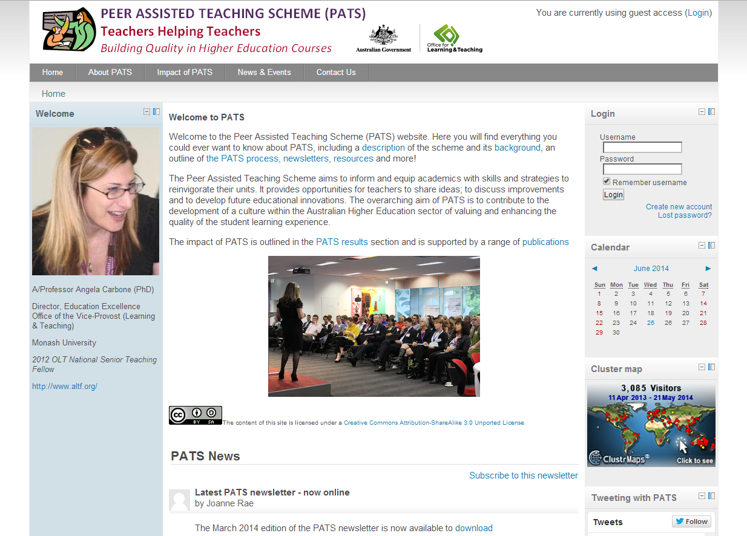

Appendix I: Task 3 from the PATS Workbook



References
Arendale, D. R. (2004). Pathways of persistence: A review of postsecondary peer cooperative learning programs. In I. M. Duranczyk, J. L. Higbee & D. B. Lundell (Eds.), Best Practices for Access and Retention in Higher Education (pp. 27-42). Minneapolis, MN: Center for Research on Developmental Education and Urban Literacy, General College, University of Minnesota.
Ashwin, P. (2003). Peer facilitation and how it contributes to the development. Research in Post-Compulsory Education, 8(1), 5-18.
Bexley, E., James, R., & Arkoudis, S. (2011). The Australian academic profession in transition - Addressing the challenge of reconceptualising academic work and regenerating the academic workforce. Center for the Study of Higher Education: University of Melbourne.
Boud, D. (2001). Introduction: making the move to peer learning. In D. Boud, R. Cohen & J. Sampson (Eds.), Peer learning in higher education. Learning from and with each other. London: Kogan Page.
Brookfield, S. (1995). Becoming a Critically Reflective Teacher. San-Francisco, CA: Jossey-Bass
Canadian Council on Learning (2006). Measuring quality in post-secondary education: British Columbia Ministry of Advanced Education.
Carbone, A. (2011). Peer Assisted Teaching Scheme. Final Report for the Australian Learning and Teaching Council.
Carbone, A., & Ceddia, J. (2012). Common areas for improvement in ICT units that have critically low student satisfaction. Paper presented at the Fourteenth Australasian Computing Education Conference (ACE2012), 31 January - 3 February, Melbourne, Australia.
Carbone, A., & Ceddia, J. (2013). Common areas for improvement in physical science units that have critically low student satisfaction Paper presented at the International Computing Education Research Conference (LaTICE2013).
Carbone, A., Ceddia, J., Simon, D'Souza, D., & Mason, R. (2013). Common concerns in introductory programming courses. Paper presented at the Fifteenth Australasian Computing Education Conference (ACE2013), 29 January - 1 February, Adelaide, South Australia.Carbone, A., Lindsay, K., Ross, B., Drew, S., Phelan, L., Cottman, C., Stoney, S. & Evans, J. (Under review). A framework for analysing contemporary barriers to teaching improvements in higher education: Evidence from the Peer Assisted Teaching Scheme.
Carbone, A., Ross, B., & Ceddia, J. (2013). Five years of Taps on Shoulders To PATS on Backs In ICT. Paper presented at the 18th Annual Innovation and Technology in Computer Science Education (ITiCSE'13), 1 - 3 July, University of Kent, Canterbury, England.
Carbone, A., Ross, B., Phelan, L., Lindsay, K., Drew, S., Stoney, S., & Cottman, C. (2014). Course evaluation matters: Improving students’ learning experiences with a peer-assisted teaching programme. Assessment & Evaluation in Higher Education 2014, 1-16
Carbone, A., Wong, J., & Ceddia, J. (2011). A scheme for improving ICT units with critically low student satisfaction. Paper presented at the 16th Annual Joint Conference on Innovation and Technology in Computer Science Education (ITiCSE), 27-29 June, Darmstadt, Germany.
Chalmers, D. (2007). A review of Australian and international quality systems and indicators of learning and teaching. Carrick Instititute for Learning and Teaching in Higher Education

Chalmers, D., Stoney, S., Goody, A., Goerke, V., & Gardiner, D. (2012). Measuring the effectiveness of academic professional development: Identification and implementation of indicators and measures of effectiveness of teaching preparation programs for academics in higher education. Final Report for the Australian Government Office for Learning and Teaching.
Cheng, D. & Walters, M. (2009). Peer-assisted learning in mathematics: an observational study of student success. Australasian Journal of Peer Learning, 2, 23-39.
Coburn, C. (2003). Rethinking Scale: Moving Beyond Numbers to Deep and Lasting Change. Educational Researcher, 32(6), 3-12.
Cummings, R., Chalmers, D., Elliott, S., Stoney, S., Tucker B., Wicking, R. & de St Jorre, T. (2014). Australian University Teaching Criteira and Standards Project. Final Report for the Australian Government Office for Learning and Teaching.
Cummings, R., Chalmers, D., Stoney, S., Herrington, A., & Elliott, S. (2012). Professionalisation of the Academic Workforce Project. Final Report for the Australian Government Office for Learning and Teaching.
Day, T., & Tosey, P. (2011). Beyond SMART? A new framework for goal setting. The Curriculum Journal, 22(4), 515-534.
Devlin, M., Kift, S., Nelson, K., Smith, L., & McKay, J. (2012). Effective teaching and support of students from low socioeconomic status backgrounds: Resources for Australian higher education. Final Report for the Australian Government Office for Learning and Teaching.
Dowell, D. A., & Neal, J., A. (1983). The validity and accuracy of student ratings of instruction: A reply to Peter A. Cohen. The Journal of Higher Education, 54(4), 459-463.
Edwards, D., Bexley, E. & Richardson, S. (2011) Regenerating the academic workforce: The careers, intentions and motivations of higher degree research students in Australia: Findings of the National Research Student Survey (NRSS), ACER
Galbraith, C., Merrill, G., & Kline, D. (2012). Are student evaluations of teaching effectiveness valid for measuring student learning outcomes in business related classes? A neural network and bayesian analyses. Research in Higher Education, 53(3), 353-374.
Gratch, A. (1998). Beginning teacher and mentor relationships. Journal of Teacher Education, 49(3), 220-228.
Hall, K. M., Smith, L. K., Draper, R. J., Bullough Jr., R. V., & Sudweeks, R. (2005). Measuring the self-efficacy of mentor teachers. Academic Exchange Quarterly, 9(4), 188-192.
Hinton, T. (2013). Influence Factor: understanding outcomes from Australian learning and teaching grants. Final Report for the Australian Government Office of Learning and Training .
Hodgson, Y. M. (2009). Students prefer lectures to peer teaching. Paper presented at the HERDSA Conference,6 - 9 July, Darwin
Hughes-Warrington, M., Bearman, M., Carbone, A., Baik, C., & Krause, K.-L. (2010). Measuring and reporting teaching quality. Australian Government Office for Learning and Teaching.
Israel, M. (2011). The key to the door: Teaching awards in Australian higher education. Australian Learning and Teaching Council.
Jacobs, G., Hurley, M., & Unite, C. (2008). How learning creates a foundation for S1 leader training. Australasian Journal of Peer Learning, 1, 6-12.
James, R., Baik, C., Krause, K.-L., Sadler, D., Booth, S., Hughes-Warrington, M., Bexley, E. & Kennedy, G. (2013). Academic Workforce 2020: framing a national agenda for professionalising university teaching. Final Report for the Australian Government Office for Learning and Teaching.
Jones, S. J., Harvey, M., Lefoe, G. & Ryland, K. (2012). Lessons learnt: identifying synergies in distributed leadership projects. Final Report for the Australian Government Office for Learning and Teaching.
Jones, S., Hadgaft, R., Harvey, M., Lefoe, G. and Ryland, K. (2014). Evidence-based benchmarking framework for a distributed leadership approach to capacity building in learning and teaching. Final Report for the Australian Government Office for Learning and Teaching.
Lave, J. (1988). Cognition in Practice: Mind, mathematics, and culture in everyday life. Cambridge, UK: Cambridge University Press.
Lave, J. (2009). The Practice of Learning. In K. Illeris (Ed.), Contemporary Theories of Learning: Learning Theorists … In Their Own Words (pp. 200-208). Oxon, UK: Routledge.
Leidenfrost, B., Strassnig, B., Schabmann, A., Spiel, C. & Carbon, C. (2011). Peer mentoring styles and their contribution to academic success among mentees: A person-oriented study in higher education. Peer Mentoring & Tutoring: Partnership in Learning, 19(3), 347-364.
Loke, A. J. T., & Chow, F. L. W. (2007). Learning partnership- the experience of peer tutoring amongst nursing students: A qualitative study. International Journal of Nursing Studies, 44,(No), 237-244.
Marsh, H. W., & Hocevar, D. (1991). Students’ evaluations of teaching effectiveness: the stability of mean ratings of the same teachers over a 13-year period. Teaching and Teacher Education, 7, (No), 303–314.
Norton, A., Sonnemann, J., & Cherastidtham, I. (2013). Taking university teaching seriously. Melbourne: The Grattan Institute.
Pascarella, E. T., & Terenzini, P. T. (1991). How College Affects Students: Findings and Insights from Twenty Years of Research. San Francisco: Jossey-Bass.
Pleschová, G., Simon, E., Quinlan, K., Murphy, J., Roxa, T. & Szabó, M. (2012). The professionalisation of academics as teachers in higher education. Standing Committee for the Social Sciences, European Science Foundation.
Probert, B. (2014 ). Discussion Paper 2: Why scholarship matters in higher education. Australian Government Office for Learning and Teaching.
Ramsden, P. (1991). A Performance Indicator of Teaching Quality in Higher Education: The Course Experience Questionnaire. Studies in Higher Education, 16(2), 129-150.
Richardson, J. T. E. (2005). Instruments for obtaining student feedback: a review of the literature. Assessment & Evaluation in Higher Education, 30(4), 387-415.
Sachs, J., Mansfield, N., & Kosman, B. (2011). Teaching Standards Framework Project. Australian Learning and Teaching Council.
Sitzmann, T., Brown, K. G., Casper, W. J., Ely, K., & Zimmerman, R. D. (2008). A review and meta-analysis of the nomological network of trainee reactions. Journal of Applied Psychology, 93(2), 280-295.
Stehle, S., Spinath, B., & Kadmon, M. (2012). Measuring teaching effectiveness: correspondence between students’ evaluations of teaching and different measures of student learning. Research in Higher Education, 53(No), 888–904.
Tang, S. Y. F., & Choi, P. L. (2005). Connecting theory and practice in mentor preparation: mentoring for the improvement of teaching and learning. Mentoring & Tutoring: Partnership in Learning, 13(3), 383-401.

The University of Newcastle. (2013). Building Distinction: Strategic Plan 2011-2015. Available from http://www.newcastle.edu.au/Resources/Divisions/Academic/Planning Quality and Reporting/Planning/2011-2015 Council Approved Strategic Plan.pdf
Topping, K. J. (2001). Peer assisted learning: A practical guide for teachers. Cambridge, MA: Brookline Books.
Trigwell, K., & Michael, P. (1991). Improving the quality of student learning: the influence of learning context and student approaches to learning on learning outcomes. Higher Education, 22 (3), 251-266.
Vygotsky, L. S. (1978). Mind in Society. Cambridge, MA: Harvard University Press.

